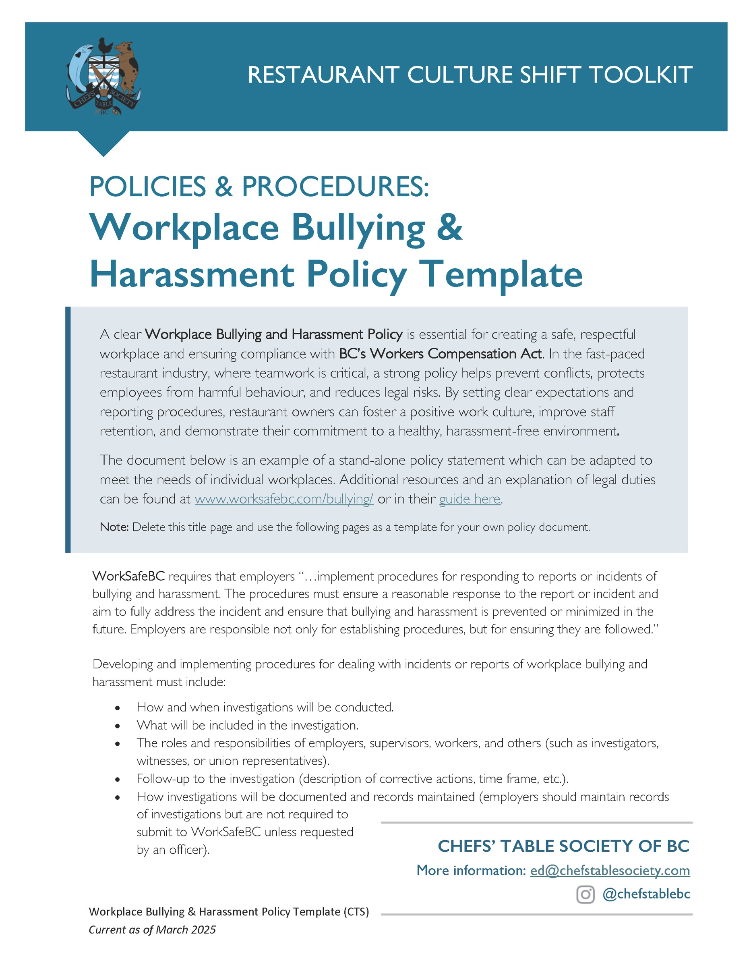

[Restaurant Name]
Workplace Bullying and Harassment Policy
Created: ________________ Updated: ________________
Purpose
At [Restaurant Name], we are committed to providing a work environment that is free from bullying, harassment, and discrimination in compliance with Workers Compensation Act Occupational Health and Safety Regulations. This policy outlines the expectations and procedures for addressing bullying and harassment in this workplace and must be followed at all times.

Scope
This policy statement applies to all workers, including permanent, temporary, casual, contract, and student workers. It also applies to third-party individuals who interact with our staff on restaurant premises, including customers, suppliers, and vendors. In-person and electronic communications, such as email and messaging platforms are all subject to this policy.

Definitions

Bullying and Harassment is defined as any inappropriate action, conduct or comment by a person towards an individual that the person knew—or reasonably ought to have known—would cause that worker to be humiliated or intimidated.

Excluding any reasonable actions relating to the management and direction of workers, including instructions or expectations, communicated professionally, concerning matters such as:
- Job duties and work to be performed;
- Workloads and deadlines;
- Layoffs, transfers, promotions, and reorganizations;
- Work instruction, supervision, or feedback;
- Performance evaluation and management; and
- Discipline, suspensions, or terminations.

Examples of conduct or comments that might constitute bullying and harassment include:
- spreading malicious rumours of false information;
- verbal aggression, insults or derogatory comments;
- potentially harmful hazing or initiation practices;
- vandalizing personal belongings; and
- micro-aggressions and cyber-bullying.

Discriminatory Harassment is harassing conduct or communication directed at an individual and based on the following prohibited grounds: gender, gender identity, gender expression, sex, marital status, sexual orientation, race, colour, religious beliefs, origin, ancestry, age, source of income, family status, disability, political belief or conviction on a criminal or summary conviction offence that is unrelated to the employment or to the intended employment of an individual.

Sexual Harassment is harassing conduct that includes any offensive and/or unwelcome sexual comment, gesture, physical contact or demand of a sexual nature that is likely to cause offence or humiliation to an individual or that might on reasonable grounds be perceived by an individual as placing a condition of sexual nature on employment, or an opportunity for training or promotion. Sexual Harassment can take various forms and includes any unwanted sexual attention or sexually oriented conduct.

Employee Rights
- Every employee has the right to work in an environment that is free from bullying, harassment, and discrimination.
- Employees who experience or witness bullying, harassment or discrimination have the right to report the issue without fear of retaliation or negative consequences.
- Employees are entitled to support and resources throughout the reporting process, including access to external resources if necessary.

Employee Responsibilities
- Employees must not engage in the bullying and harassment of other workers.
- Employees must treat colleagues, customers and vendors with fairness and respect.
- Employees must report any observed or experienced bullying, harassment or discrimination.
- Employees must apply and comply with this policy and related procedures.

Reporting and Resolution Process

EMPLOYEE STEPS
Step 1: Speak Up (Optional)
If you feel safe and comfortable doing so, speak directly with the individual(s) involved. Let them know their behaviour is unwelcome and must stop. This step is encouraged but not required.

Step 2: Report the incident
If the behaviour continues or if you prefer not to address the individual directly, report the incident to your [immediate supervisor or manager] either verbally or in writing. If the complaint involves your [immediate supervisor or manager], you may report it to [list designated individual, such as HR or the restaurant owner]. When submitting a written complaint, please use the workplace bullying and harassment complaint form. When reporting verbally, fill in the form with your supervisor.
EMPLOYER STEPS
Step 3: Investigate the report
Management will investigate all reports of bullying and harassment promptly, fairly, and with discretion. The investigation process includes:
- Listening to the employee’s concerns without judgment.
- Reviewing the complaint form and any relevant evidence (emails, notes, photos, etc.).
- Speaking confidentially with the people involved and any witnesses.
- Documenting what was said, including dates, times, and key details.
- Keeping the process as confidential as possible, sharing information only on a need-to-know basis.
- Offering support or external help to the complainant or respondent, if needed.

If both parties agree on what happened, a full investigation may not be necessary.

Once the investigation is complete, management will:
- Decide if the policy was violated and what actions to take.
- Consider options such as mediation, training, or disciplinary measures.
- Communicate the outcome to those involved and keep a written record.

Step 4: Determine corrective actions
If bullying or harassment are confirmed, management will implement appropriate corrective actions, which may include: mediation or conflict resolution, additional training or retraining, disciplinary measures, up to and including termination, policy updates or workplace adjustments.

Step 5: Follow up to ensure resolution
Management will check in with affected employee(s) to confirm the issue has been resolved. Management will continue to reinforce a respectful workplace through ongoing training, policy reviews, and leadership accountability.

Confidentiality and Non-retaliation
All reports of bullying and harassment will be handled with confidentiality. Information will be shared only on a need-to-know basis as part of Step 3 above. Retaliation against an employee for making a complaint in good faith is strictly prohibited and may result in disciplinary action.

Consequences of Violating this Policy
Employees found to have engaged in bullying or harassment will face disciplinary action, up to and including termination of employment. Disciplinary actions will be consistent with the severity of the incident and may include counselling, mediation, suspension, or dismissal, in accordance with WorkSafeBC's guidelines.

Prevention and Training
[Restaurant Name] will provide regular training for all employees on the prevention of bullying, harassment and discrimination in the workplace. Training will cover:
  - Recognizing inappropriate behaviour.
  - The reporting process.
  - How to contribute to a respectful workplace.

All employees will be introduced to this policy during onboarding and are encouraged to review it regularly.

Review and Updates
This policy will be reviewed annually or as needed to ensure compliance with Workers Compensation Act. New employees will be provided a copy of this policy as soon as they are hired. Any changes will be communicated to all employees.
[Restaurant Name]
Bullying and Harassment Complaint Form
Created: ________________. Updated: ________________
Complainant Information:
Name
Phone |  | Email

Person(s) Involved:
Name(s) of the alleged bully/bullies
Name(s) of any witnesses

Incident Details:
Date(s) of incident(s) |  | Time(s)
Location(s) |  | Is this a one-time incident or ongoing?
Have you reported this incident before? |  | If yes, to whom and when?

Please describe the incident(s) in detail, with as much details as possible, including:

- What happened?
- Who was involved?
- When and where did the incident(s) occur?
- How did the incident affect you?
- What behaviour or words were used that led to the complaint?
- Any additional details that would help with an investigation

Supporting Documents:
Please attach any supporting documents, such as emails, handwritten notes, and photographs. Physical evidence, such as vandalized personal belongings, can also be submitted.
Acknowledgment & Signature:
By signing below, I confirm that the information provided is accurate to the best of my knowledge.
Signature | Date

