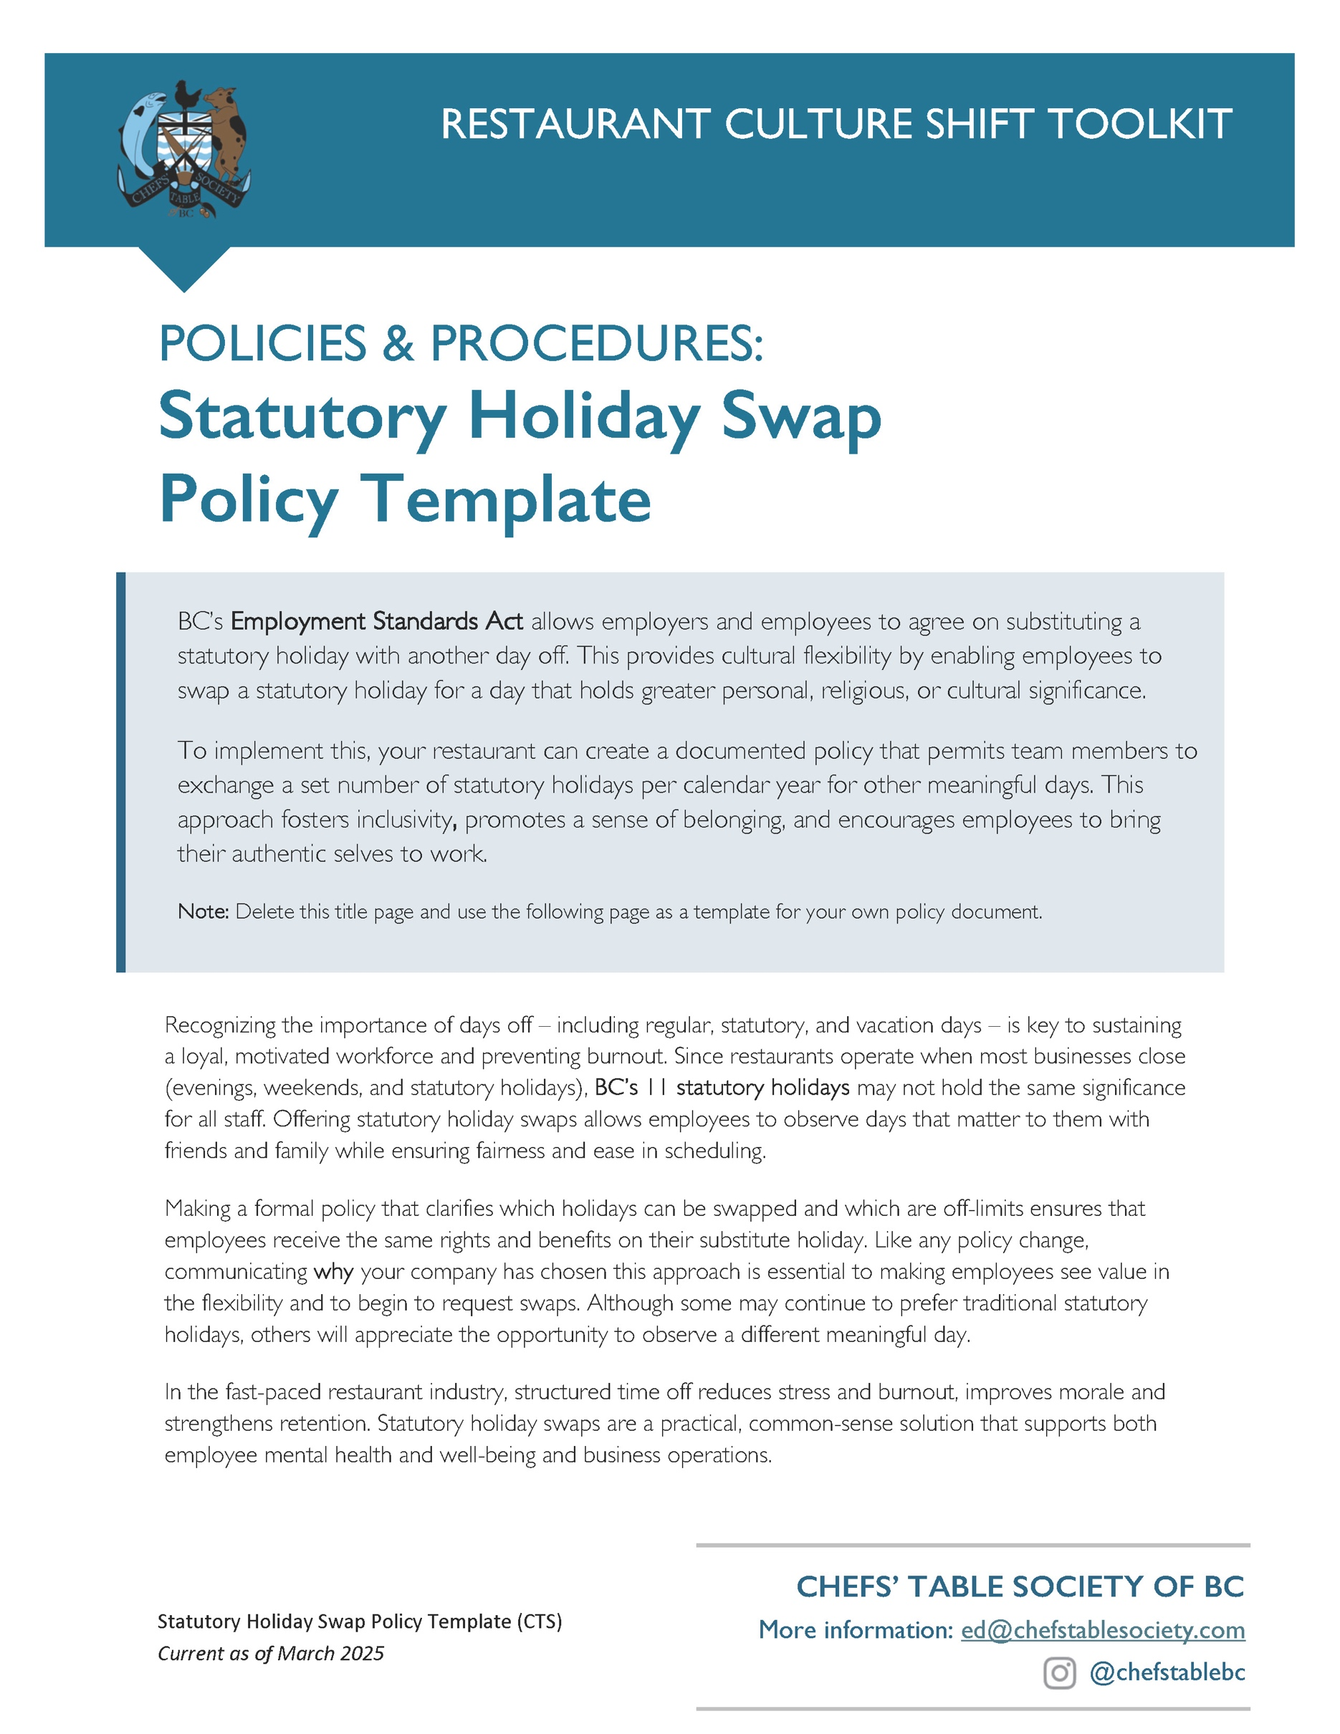

LEGAL REQUIREMENTS FOR
STATUTORY HOLIDAYS:

An hourly employee is eligible for statutory holiday pay if they have been employed for 30 days prior to the holiday AND worked 15 of the last 30 days. Those who meet this criteria are entitled to the day off with pay. If they work the holiday, they earn time and a half for the first 11 hours worked or double-time for the hours worked over 12 hours PLUS the pay for an “average day” that they earned off.

IN BC, THERE ARE 11 STATUTORY HOLIDAYS:

New Years Day – January 1
Family Day – 3rd Monday in February
Good Friday – Friday before Easter Sunday
Victoria Day – Monday before May 25
Canada Day – July 1
BC Day – 1st Monday in August
Labour Day – 1st Monday in September
National Day for Truth and Reconciliation
– September 30th
Thanksgiving – 2nd Monday in October
Remembrance Day – November 11
Christmas Day – December 25

SETTING YOUR POLICY FOR
STATUTORY HOLIDAY SWAPS:

- Consider how many days per year and which days you are prepared to offer as a substitution.
- Determine who the policy applies to and an order of priority for accepting the change requests. For example, does this only apply to full time employees over 30 hours a week? Or can part time people record their holiday swap preferences as well to facilitate your scheduling?
- Inform employees annually that they may request substitute days in exchange for your approved list of statutory holidays.
- Create a statutory holiday substitution form for employees to submit their requests in advance, preferably at the beginning of the year, to enable certainty in scheduling.
- Determine your locking in policy: for example, once employees submit their form, are those days locked in or can they change them?
- Decide how you will advise people whether their change has been accepted and how much notice you give them if a change hasn’t been accepted because of the business’ needs.
- Outline how statutory holidays are treated if a swap is not requested.
- List days when your business is closed in observance of a particular statutory holiday.

Note: As an employer in BC, you can require an employee to work on a statutory holiday, but you must provide applicable entitlements to those people that are required to work if they haven’t made a swap.
TIME OFF &
DELETE FROM HERE UP
[Restaurant Name]
Statutory Holiday Swap Policy
Effective Date: ________________
Last Updated: ________________

Purpose:
[Restaurant Name] recognizes the diverse cultural, religious, and personal beliefs of our employees. In compliance with BC’s Employment Standards Act, we allow eligible team members to request a substitution of certain statutory holidays for a day of personal significance.

Eligibility:
This policy applies to [full-time employees working 30+ hours per week / all employees, including part-time staff] who wish to substitute a statutory holiday with another meaningful day. Requests will be approved based on [business needs, seniority, or first-come, first-served basis].

Approved Substitutions:
Employees may request to substitute the following statutory holidays: [List eligible statutory holidays, e.g., Canada Day, Thanksgiving, Christmas Day]
Substituted days should be of cultural, religious, or personal significance and cannot be used as an extra vacation day (e.g., swapping Canada Day for the day after Victoria Day to create a long weekend).

Request Process:
- Submission Deadline – Employees must submit a Statutory Holiday Substitution Form by [date, e.g., January 15 of each year].
- Approval Process – Requests will be reviewed and approved based on [business needs, scheduling feasibility, and fairness]. Employees will be notified of their request status by [response time, e.g., February 1].
- Lock-in Policy – Once approved, statutory holiday swaps [can/cannot] be changed unless exceptional circumstances arise.

Scheduling & Business Needs:
- Since our restaurant operates on statutory holidays, requests are subject to business requirements. If a substitution request cannot be accommodated due to scheduling conflicts, employees will be given [X days/weeks] notice.
- If no swap is requested, the employee will observe the statutory holiday as scheduled.
- Restaurant Closures – We will remain closed on the following statutory holidays: [list any holidays your business is closed, if applicable].

Compliance & Questions:
This policy aligns with BC labour laws, ensuring compliance with statutory holiday regulations. If you have questions or need further clarification, please contact [Manager/HR Representative] at [email or phone].

