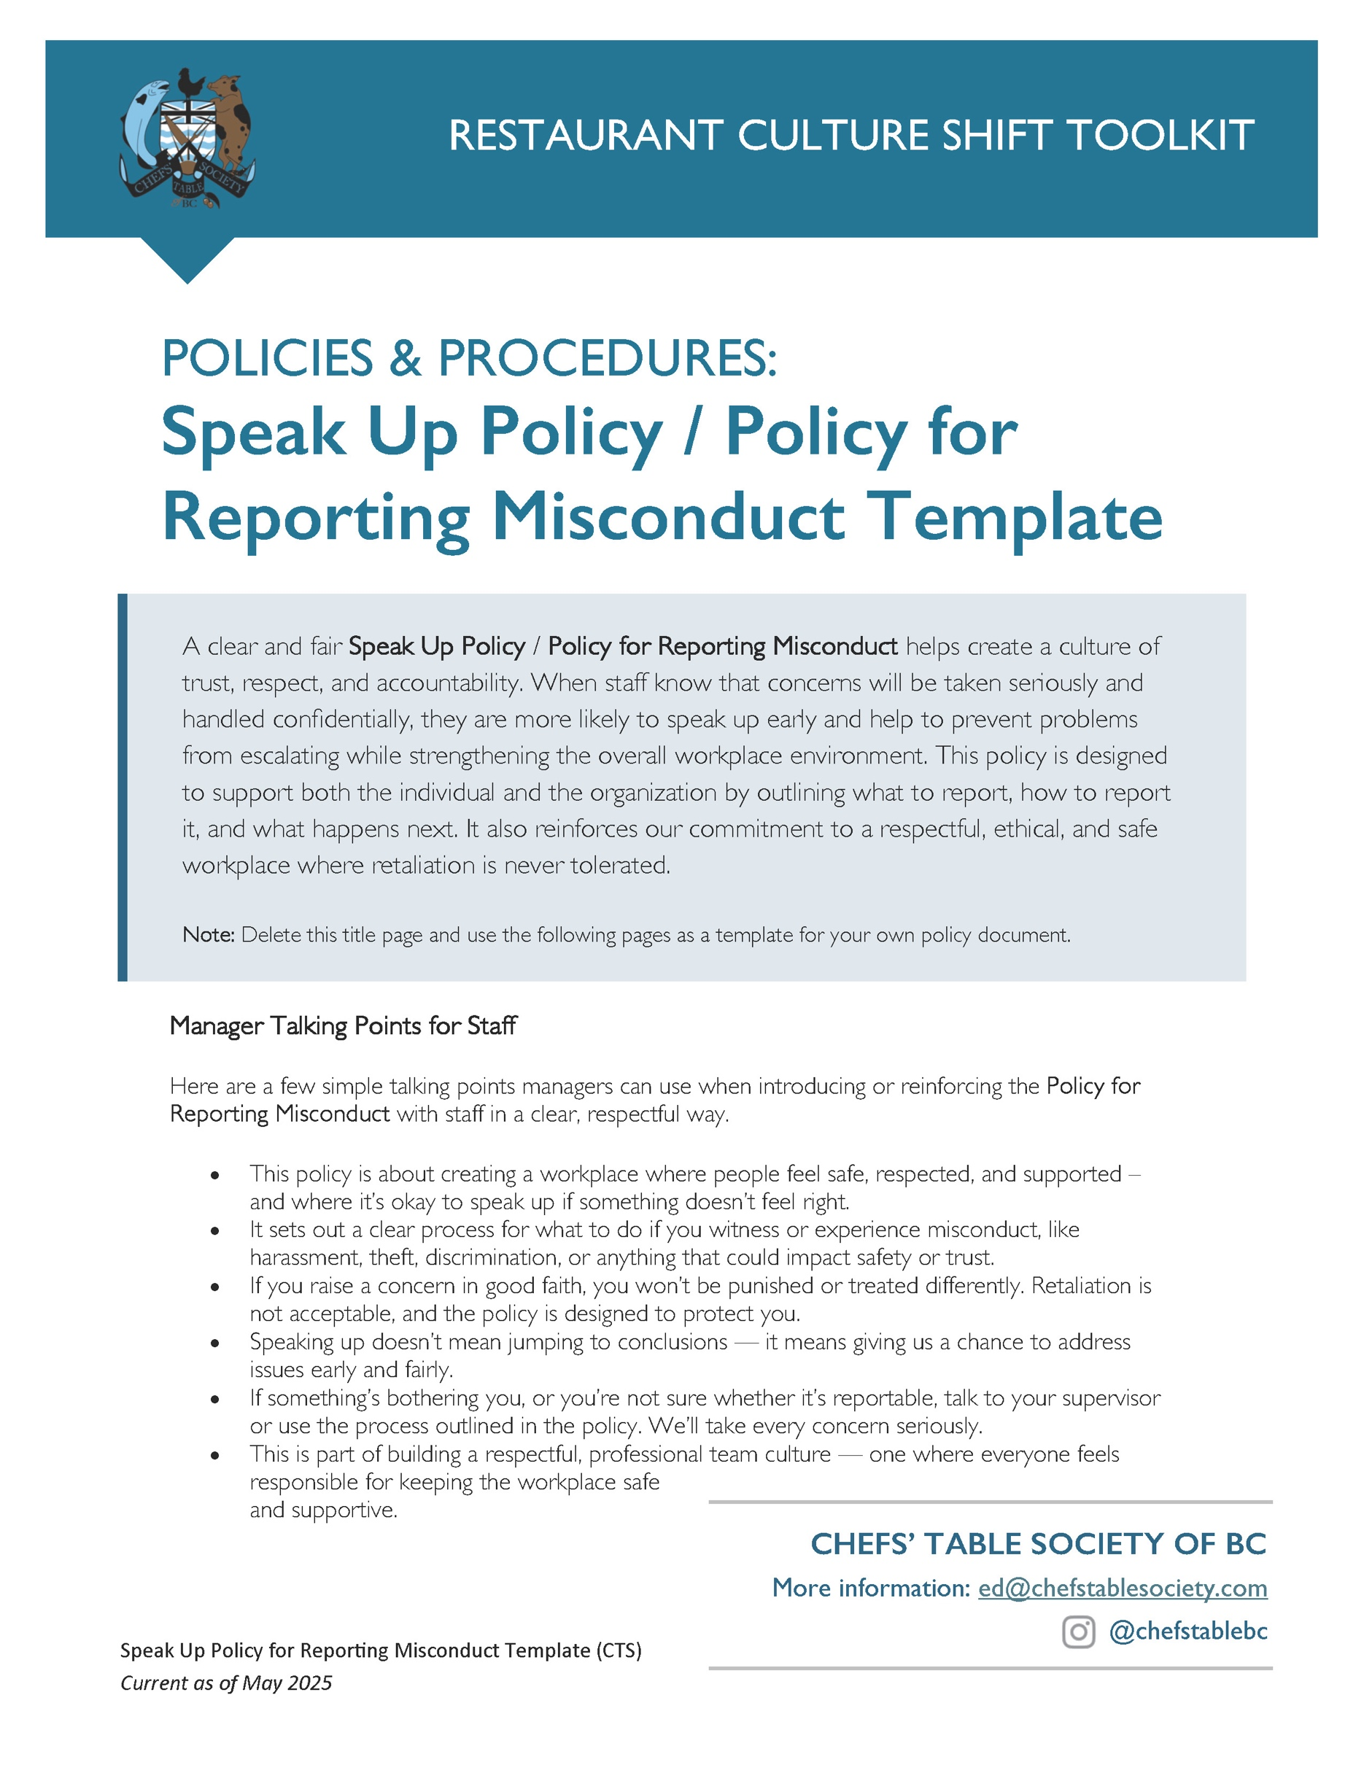

[Restaurant Name]
Speak Up Policy [OR] Policy for Reporting Misconduct
Created: ________________ Updated: ________________
PURPOSE
This Policy sets out the reporting and investigation procedures for identifying and preventing misconduct, including but not limited to fraudulent or unethical conduct. We are committed to supporting a culture where everyone is empowered to speak up and to maintaining the highest standards of ethical and responsible conduct in all business activities.
[RESTAURANT NAME] (the “Company”) strives to maintain the highest standards of ethical and responsible conduct in all its business activities. For that purpose, we have created this Policy to ensure that any reports or complaints of misconduct, including but not limited to fraudulent or unethical conduct, are promptly and thoroughly reviewed, investigated, and resolved, in accordance with confidentiality obligations and any applicable legislation.
To achieve this goal, we are committed to ensuring that employees or other individuals who make a report or complaint under this Policy in good faith will not be penalized or face retaliation for making such report or complaint.
SCOPE
This Policy applies to all employees, including management. It will also apply to former employees and members of the public to the extent that any such individual may wish to make a report or complaint to the Company.
GUIDELINES
The Company requires all employees to observe high standards of business and personal ethics in the performance of their duties and responsibilities. All employees and representatives of the Company must conduct themselves with honesty, respect, and integrity, in compliance with all applicable laws and regulations.
Reportable Activity
For the purposes of this Policy, reportable activity includes any conduct that could reasonably constitute or be perceived as:
- bullying, harassment or discrimination;
- theft, violence or threats of violence;
- accounting, auditing, or other financial fraud or misrepresentation;
- violation of any laws that could result in fines or other monetary penalties being levied against the Company, or that could otherwise cause harm to the Company’s reputation;
- unethical business conduct in violation of any laws or Company policy; or
- conduct that poses danger to the health, safety, or well-being of our employees and/or the general public.
Reporting Procedures
- If you reasonably believe that a Reportable Activity has occurred or is occurring, you are encouraged to immediately make a report or complaint to Human Resources or a member of management. If you do not feel comfortable bringing an issue to your manager, or if you have concerns about whether an issue has been adequately addressed, Human Resources should be your first point of contact.
- When making a report or complaint, you may indicate that you wish to remain anonymous for any follow-up procedures, including throughout the investigation process and in relation to any corrective actions taken to address your report or complaint. Regardless of whether a report or complaint is submitted anonymously, we will protect the confidentiality of the individuals involved to the greatest extent possible, subject to our obligation to conduct an adequate investigation.
- Reports and complaints should be factual, rather than speculative, and should contain as much specific detail as possible to allow for adequate investigation. If the report or complaint does not sufficiently particularize any allegations, the Company may decide that further investigation is not required
Investigation Procedures
- Upon receiving a report or complaint alleging a Reportable Activity, Human Resources, or a designated member of management, will determine whether a reasonable basis exists to commence an investigation into the allegations.
- If it is determined that an investigation is warranted, we will commence an investigation into the report or complaint. Depending on the nature and severity of the allegations, the investigation may be conducted internally, or outside professional counsel may be retained to conduct or assist with the investigation.
- All investigations will be carried out confidentially and we will disclose information about the investigation or speak with other individuals only as required to conduct the investigation. All necessary steps will be taken to ensure that allegations are thoroughly investigated, including interviewing relevant witnesses and reviewing all documentary, video, or other available evidence.
- After completing their investigation, the investigator will determine whether any or all of the allegations are substantiated and, with the input of management and other advisors as necessary, will make recommendations for appropriate corrective action. The investigator will also report any legal or regulatory non-compliance to management, and management will ensure that appropriate corrective action is taken to address same, including any required reporting to governmental authorities.

Corrective Actions
Any employee found to have committed a Reportable Activity may be subject to disciplinary action, up to and including termination of employment.
Reports and complaints made under this Policy constitute serious allegations of misconduct and must be made in good faith on reasonable grounds for believing that a Reportable Activity has occurred or is occurring. Any employee found to have made frivolous, malicious, or knowingly false allegations may be subject to disciplinary action, up to and including termination of employment.
NO RETALIATION
The Company will not tolerate retaliation, threats, or discrimination of any kind against any individual who makes a report or complaint under this Policy in good faith, or who assists in the investigation of a Reportable Activity.
Any employees engaging in retaliatory conduct under this Policy will be subject to disciplinary action, up to and including termination of employment.
ACKNOWLEDGEMENT
I have read and understand the “Misconduct Prevention Policy” and agree to abide by its contents.

________________________ _______________________ _______________________
Employee Signature Employee Name (print) Date

