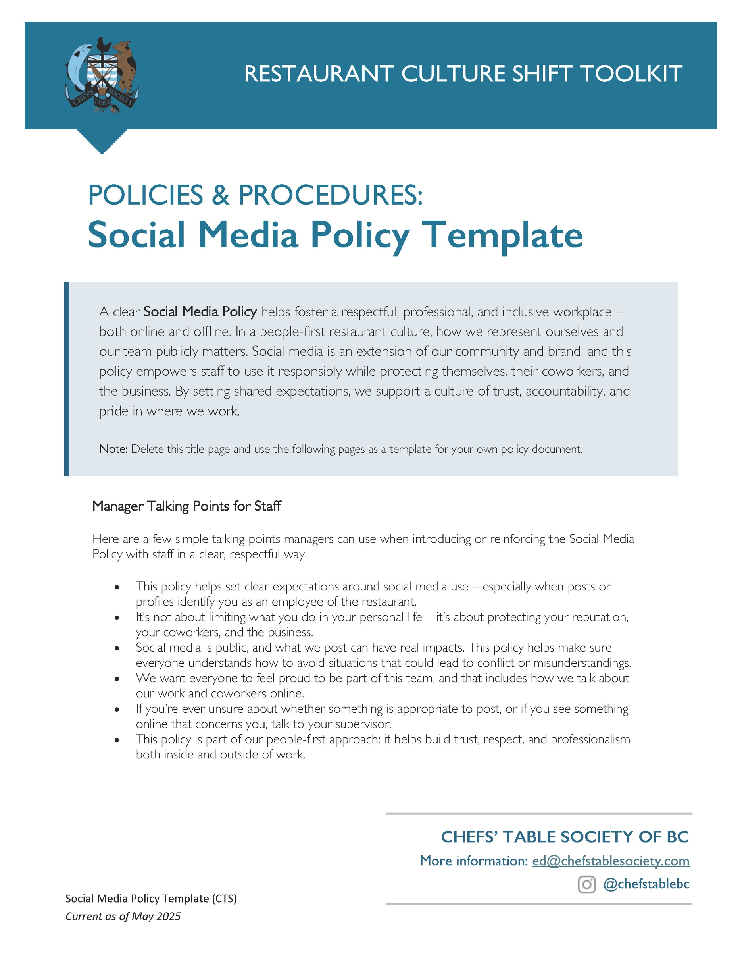

[Restaurant Name]
Social Media Policy
Created: ________________ Updated: ________________
PURPOSE
This Policy provides guidelines and expectations for employees regarding the use of social media.
[RESTAURANT NAME] (the “Company”) strives to maintain a positive public image and protect the online reputation of its business and staff. While we recognize that social media can be a powerful tool for communication and engagement, employees can expose both themselves and the Company to legal and other risks by using social media inappropriately or irresponsibly. All employees are expected to remain respectful in their online interactions and use good judgement when sharing information through social media, particularly when their social media activity identifies them as an employee of the Company.
SCOPE
This Policy applies to all employees, including management, both during and after work hours.
DEFINITION
Social media comprises all forms of electronic communication, including online applications and platforms, including but not limited to:
- Networking sites (Meta/Facebook, LinkedIn)
- Video and photo sharing platforms (YouTube, TikTok, Instagram, Snapchat, Pinterest)
- Blogs (X, Tumblr, personal websites)
- Forums and discussion boards (Reddit, comments sections)
- Messaging applications (Messenger, WhatsApp, Discord)
GUIDELINES
The Company understands that most employees use social media for a variety of purposes and in both professional and personal settings. While our intention is not to interfere with employees’ private lives, the reality is that inappropriate online conduct, whether it occurs during or after work hours, can have serious impacts on the workplace.
To protect the safety, reputation, and well-being of yourself, your colleagues, and the Company, we ask that you observe the following guidelines when conducting yourself online:
- Privacy and Confidentiality. Assume that anything you post or send through electronic means, even if it is in a private chat, can be made public, and refrain from sharing any private or sensitive information. Never share any proprietary or confidential information relating to the Company.
- Professionalism. Postings on social media should be honest, respectful, and mindful of how the posted content could reflect on both you and the Company. If you are not prepared to take responsibility or accountability for the content of the posting, do not post it.
- Use of Social Media at Work. Employees are expected to focus on work during work hours and may only check social media applications during personal time, such as on breaks or at the end of their shift.
- Not a Representative. Unless specifically authorized by the Company, employees are not permitted to speak or communicate on behalf of the Company or otherwise hold themselves out as representing the Company.
- No Use of Company Name or Logo. Employees are not permitted to use the Company’s name, logo, or any of the Company’s intellectual property in social media postings, without the Company’s express consent.
- No Bullying, Harassment or Discrimination. In accordance with the Company’s policies and procedures regarding the maintenance of a respectful workplace, employees are prohibited from engaging in any online activity that may be perceived as bullying, harassment, or discrimination. Any such activities, whether directed at a colleague or otherwise, may constitute serious misconduct under this Policy and any other Company policies relating to bullying, harassment and discrimination.
NON-COMPLIANCE
Failure to comply with this Policy may result in disciplinary action, up to and including termination of employment. Employees are encouraged to report any observed violations of this Policy to their manager.
If you have any questions regarding this Policy, including whether certain conduct falls within its scope, please speak with your manager.
ACKNOWLEDGEMENT
I have read and understand the “Social Media Policy” and agree to abide by its contents.

________________________ _______________________ ________________________
Signature Name (print) Date

