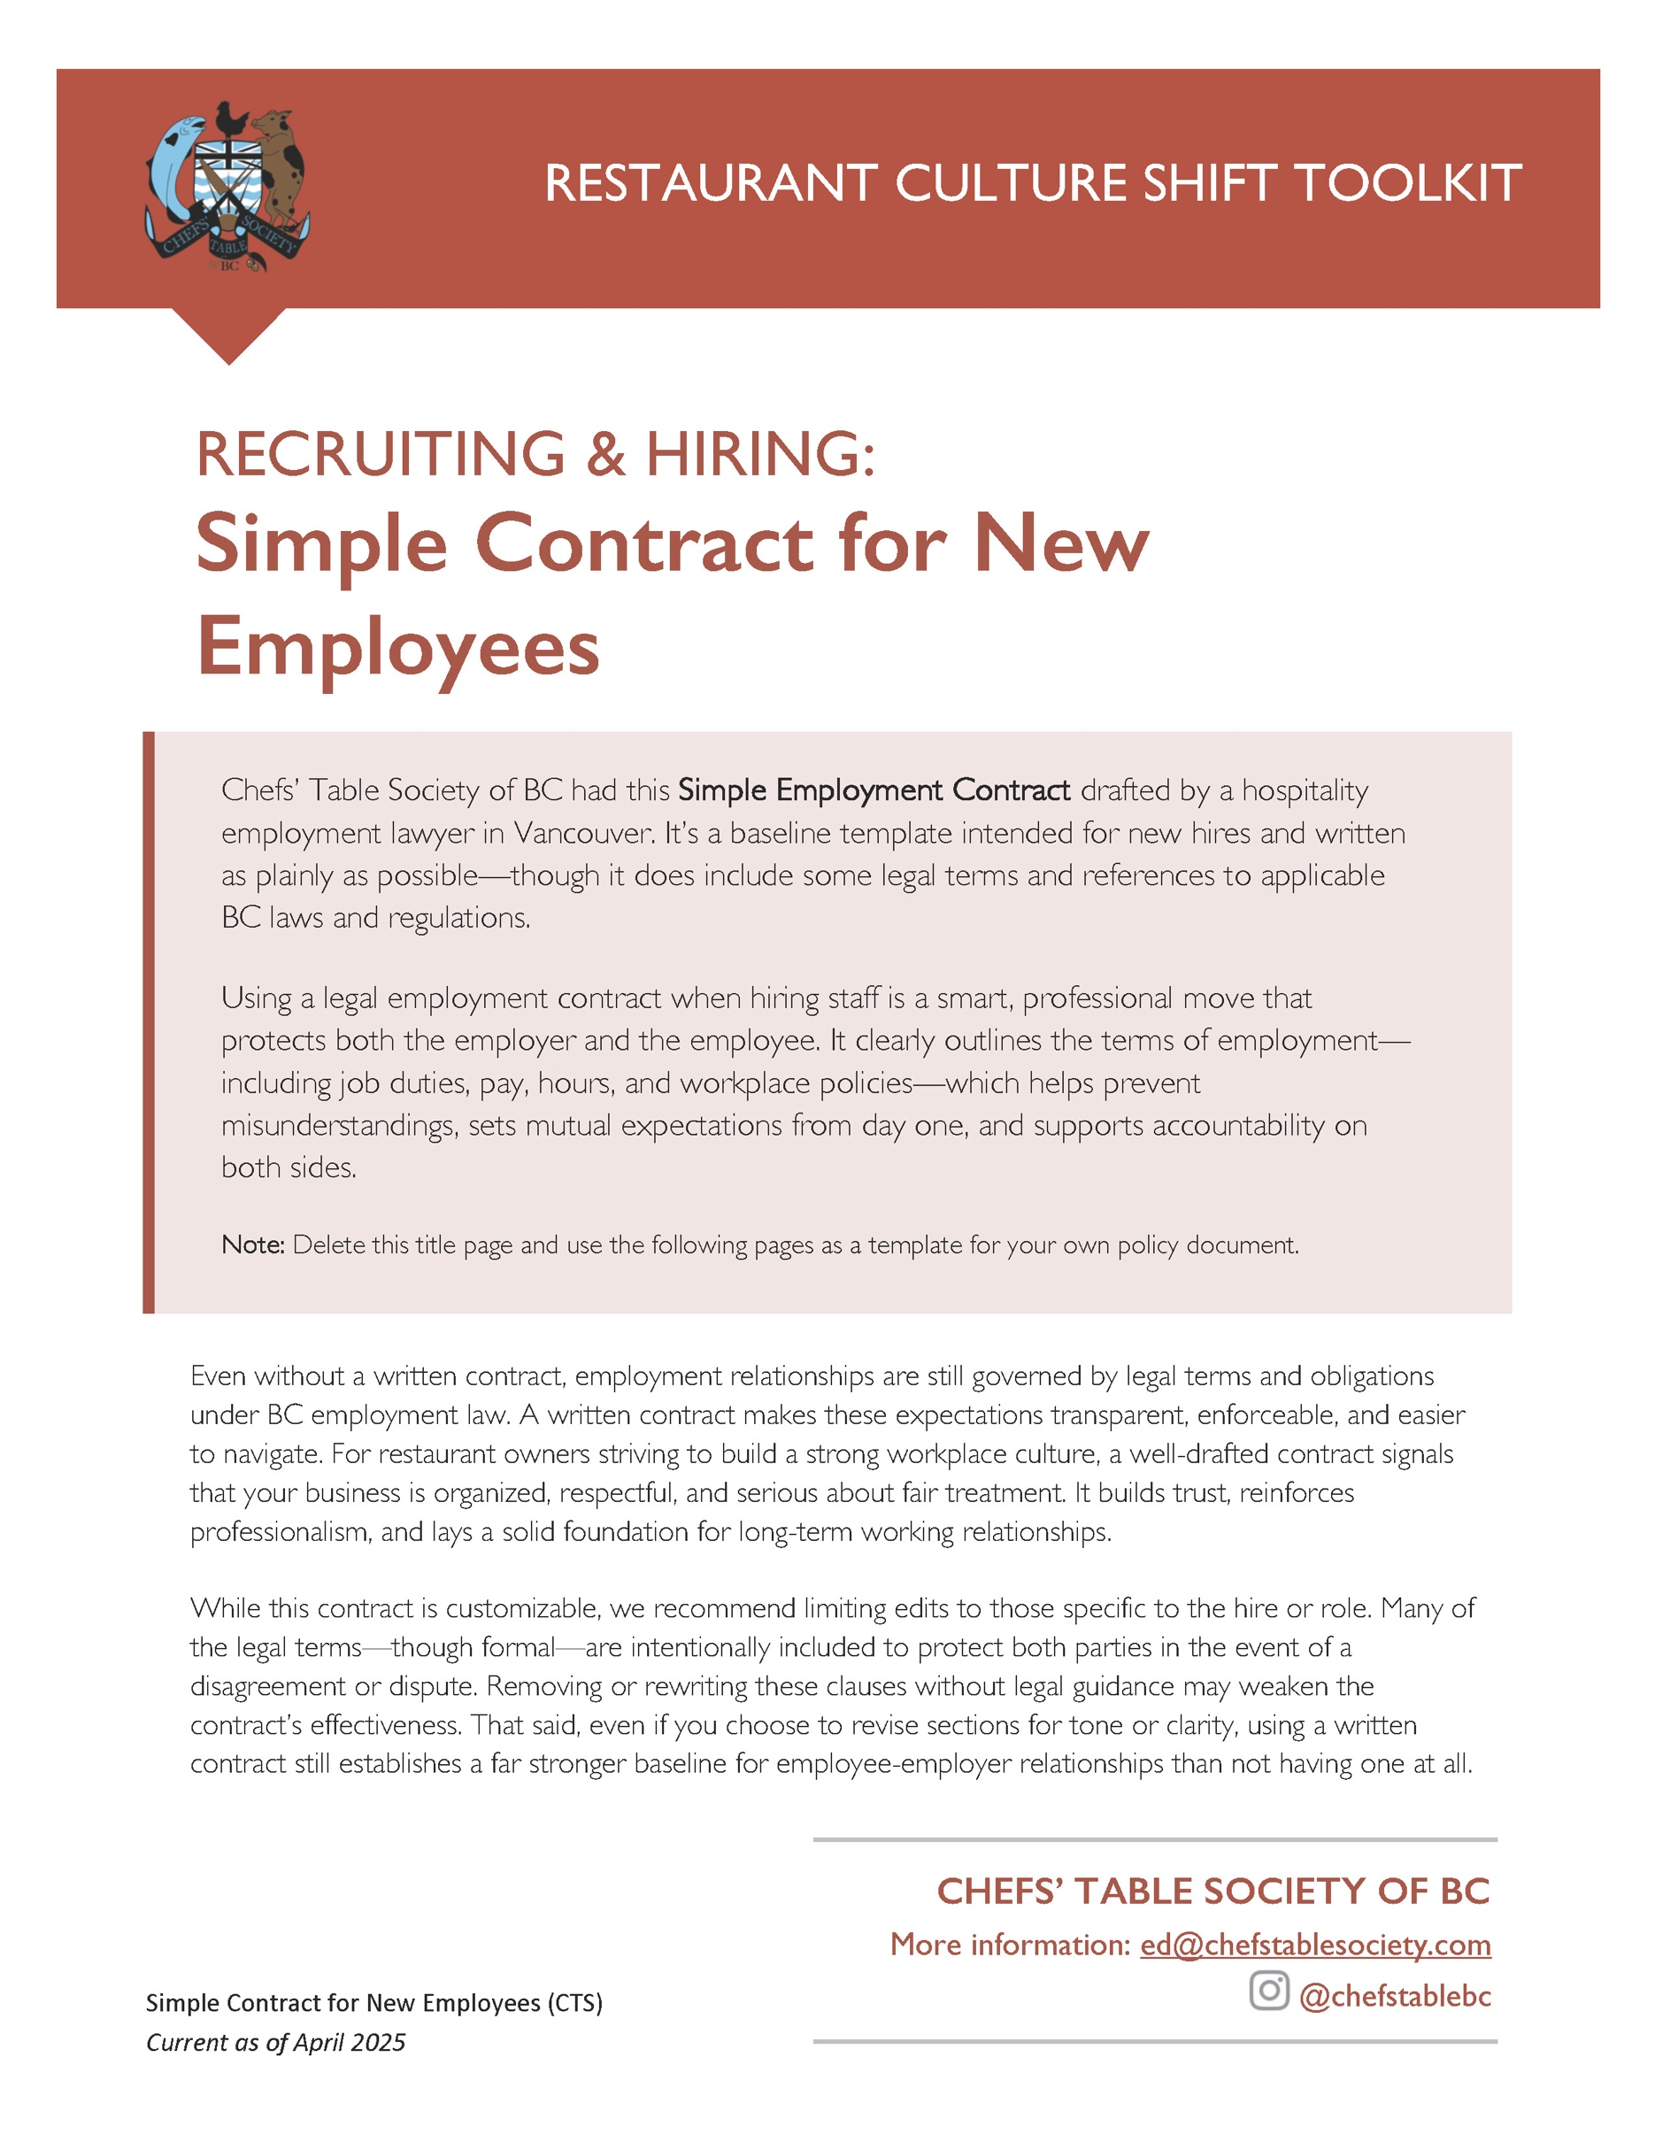

______________, 2025
Private & Confidential
Hand Delivered
[Employee Name]
[Address]
[Email]
Dear ______________:
Re: Employment Agreement
We are pleased to offer you employment with ____________________ (the “Company”), upon the following terms (the “Employment Agreement”).
Employment and Duties
- Your employment with the Company will commence on ______________________(the Start Date) and will continue indefinitely until terminated in accordance with this Employment Agreement.
- You will begin your employment in the position of ______________________. Your primary duties and responsibilities include, but are not limited to, [list tasks OR “those traditionally associated with this position”]. In addition, you shall be required to perform other tasks and assignments reasonably consistent with your qualifications, skills and experience, as directed by the Company.
Probationary Period
- You will be on probation for the first three (3) months of your employment with the Company (the “Probationary Period”). The Company shall utilize the Probationary Period to assess your progress and job performance to determine your suitability for the position and your continued employment by the Company.
Compensation, Hours of Work and Vacation
- Your rate of pay shall be $__________.00 per hour, less required deductions. Any overtime hours, which shall be paid in accordance with the BC Employment Standards Act, must be authorized in advance by a member of the Company’s management team.
- The nature of this position requires flexibility with respect to your availability and typical hours of work. You will be requested to work on an as-needed basis. There are no minimum hours or guaranteed hours of work. [Note: If this position has set hours, is full time or has a guaranteed minimum of hours, replace the copy here with that information.]
- You will be provided with vacation and vacation pay in accordance with the BC Employment Standards Act.
Termination of Employment
- The Company may terminate your employment by providing to you (if and as applicable) the minimum notice or pay in lieu thereof, or a combination thereof, as required by the BC Employment Standards Act. For added clarity, you will be entitled to no more and no less than all the minimum entitlements under the BC Employment Standards Act, and it is understood and agreed that this contractual provision is intended to supersede and replace any entitlement to common law notice
- You may resign from your employment by providing the Company with two (2) weeks' notice.
- The Company may temporarily lay you off, without pay, at any time for the maximum period of time permitted by the BC Employment Standards Act, without such layoff constituting constructive dismissal.
Policies
- Other terms and conditions of your employment may be set out in the Company’s Policies, copies of which you will receive and must review as a condition of your employment. You agree to comply with the policies and procedures set out in the Company’s Policies, and any other Company policies that may be issued from time to time. It is agreed that the introduction, amendment and administration of the Company Policies are within the sole discretion of the Company. If the Company introduces, amends or deletes the Company Policies or other such policies as conditions warrant, such introduction, deletion or amendment shall not constitute a breach of this Employment Agreement. If there is a direct conflict between this Employment Agreement and the Company Policies or any such policy, this Employment Agreement shall prevail to the extent of the inconsistency.
Confidential Information (OPTIONAL SECTION)
- Employment Agreement, “Confidential Information” means information disclosed to, used by, developed by, or made known to you in the course of your employment with the Company which is not generally known by persons outside the Company.
- Without limiting the generality of the foregoing, “Confidential Information” also includes “Intellectual Property” which, in this Employment Agreement means all trade secrets and all associated documentation and information therein or relating thereto, including but not limited to food or beverage recipes, formulas, instructions and/or preparation procedures and associated documentation and training materials, menu designs and strategies, which may be disclosed to you or created, developed, improved, enhanced or modified by you in the course of your employment with the Company.
- You acknowledge that you will have access to and be entrusted with Confidential Information (which includes Intellectual Property) and in the course of your employment with the Company, and that the Company’s business would be irreparably harmed if such Confidential Information was disclosed to, or used by, any person outside the Company.
- You agree that you will not, except as required by law, either during the term of your employment with the Company or at any time thereafter, directly or indirectly, by any means whatsoever, disclose, provide access to, or use for any purpose other than the purposes of the Company, any Confidential Information or Intellectual Property.
- If, either during the term of your employment with the Company or at any time thereafter, you lose or misplace Confidential Information (including Intellectual Property), or disclose Confidential Information to any person or entity outside the Company, directly or indirectly, by any means whatsoever, for any purpose other than the purposes of the Company, you must immediately report such loss, misplacement or disclosure to the Company.
Entire Agreement
- This Employment Agreement describes your entire employment agreement with the Company, and it supersedes and replaces any prior agreements or representations, whether oral or written. The terms of this Employment Agreement shall remain in effect throughout your employment with the Company, notwithstanding any changes to your title, position, duties, responsibilities, salary or compensation.
We encourage you to review this Employment Agreement carefully and if you have any questions or concerns, please let us know.
If this Employment Agreement is acceptable to you, please sign a copy in the designated space below and return it to us prior to the Start Date.
We are very hopeful that you will join our team, and we look forward to working with you.
Sincerely,
______________________
Name
______________________
Title
I, ______________________ (Employee name; print), have read and agree to the terms of this Employment Agreement.
__________________________ __________________________
Signature Date

