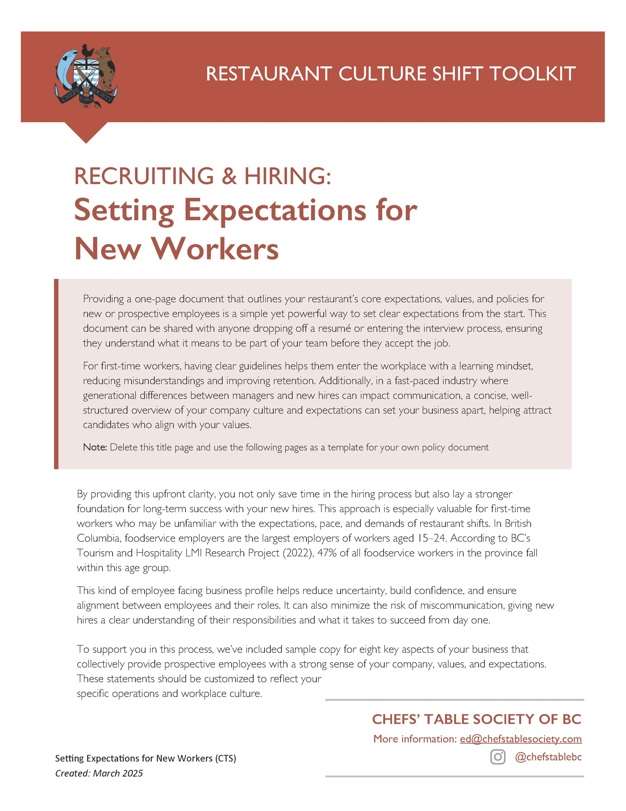
SAMPLE 1-PAGER ON YOUR COMPANY
FOR NEW OR PROSPECTIVE EMPLOYEES

Two potential titles:

Your Guide to Working at
[Restaurant Name]
or
[Restaurant Name]
Joining Our Team: What You Should Know

Company Profile
Example statement:
Our restaurant is a family run restaurant with 50 seats and table service. We are open 6 days a week and serve breakfast, lunch and dinner. We are closed on Mondays.

We offer employees free car parking in the back section of our parking lot. We have a bike rack for folks who bike to work. Tips are offered by customers and we have a tip pool coordinated by staff members where kitchen team members get a share of customer tips. We pay team members every other Friday by direct deposit. Tips are paid out daily. We offer dental and glasses* benefits for full-time positions.
Note: For benefits in this sentence, promote any tangible benefits that attract talent. If you offer medical, dental or glasses every two years or reimbursements for monthly yoga/gym memberships, talk about them here.

Company Values
Example statement:
Our company values [Integrity, Innovation and Community].
Integrity – We believe in people first and strive to treat staff and customers respectfully, honestly and with compassion.
Innovation – We believe that passion and love for your work comes from being able to be creative and innovative and we encourage our team to explore new ways to cook, serve and share.
Community – We believe hospitality is about caring for people so we are active in our community by supporting community charities [list names if appropriate] and hosting community fundraisers in our business.

About Our Workplace Culture
Example statement:
We work as a team to achieve success in our fast-paced workplace. We offer on the job training and value continuing education and leadership development. Every team member is part of our success every day and our leaders actively celebrate the contributions of our team members as we strive for service and culinary excellence. We endeavour to provide a culture of trust and honest feedback that helps us succeed at work and help our business be profitable. We encourage staff to want to grow with our company. If you want to consider a bigger role with our company, please speak to your manager about what is involved to make that happen!

Code Of Conduct
Example statement:
We are a welcoming workplace and provide training for new employees that covers front and back of house as well as a safety orientation. We respect chosen names [OPTION: and have nametags for staff that have space for preferred pronouns, as desired]. We do not tolerate bullying and harassment between staff or from customers. Discrimination of any kind towards other staff or guests is not accepted. Drinking or consuming marijuana at work or coming to work under the influence is not allowed. Cellphones are allowed to be used during breaks but should not be visible to guests. Our full code of conduct is available to staff at the time of training.

Clothing Standards
Example statement:
Our restaurant has clothing standards for all employees.
FRONT OF HOUSE:
We provide branded short and long sleeve shirts options for front of house staff including hosts, servers and bartenders and we require that team members wear their own clean black pants or skirts. Aprons are available for those who wish to wear them. Minimal jewelry is permitted.
BACK OF HOUSE/KITCHEN:
Long sleeve chef coats, aprons and chef pants are required and provided as part of our commitment to safety. Dishwashers are provided branded t-shirts and aprons. Food handlers must wear a chef hat or other form of hair covering. Beard covers may be required. Artificial nails are not permitted and jewelry should be removed for kitchen team members.
MANAGERS:
Managers are able to wear their own personal clothing. The dress code is business casual. Navy and black pants or skirts are preferred.
FOOTWEAR:
For safety reasons, all employees are required to wear their own non-slip, close-toed footwear.
If you require an exception from our dress code for religious expression, cultural dress requirements, and disabilities, please speak to a manager.

Shift Work
Example statement:
Our business is open from 7:00 am to 10:00 pm Tuesday to Sunday. We have morning shifts and afternoon shifts. Friday afternoon to Sunday evening are our busiest times.
For our business to be successful, team members must be available for weekend and evening work. Full-time is 40 hours per week. Part-time depends on the individual. Team members who work 4 hours get a 15-minute paid break and those working 8 hours get a 30-minute paid lunch.

Scheduling
Example statement:
We have an online scheduling program and schedules are posted online 2 weeks before the shifts. Staff are responsible to check their schedules. If you are only available certain days or certain shifts due to other obligations (school/sports/etc), or if your availability changes over time, please be transparent with our hiring team or your manager. Shifts can be changed but require the approval of your manager. If you are unwell and unable to work a scheduled shift, we ask that you advise your manager by text AND phone as soon as possible.

Contact Us
Example statement:
Our managers screen our job applicants and conduct interviews in person. If you have dropped off a resumé, and haven’t heard from our team within 48 hours, please send us an email and let us know what position you are interested in applying for: [manager@samplerestaurant.ca]. Please do not call the restaurant.
For

