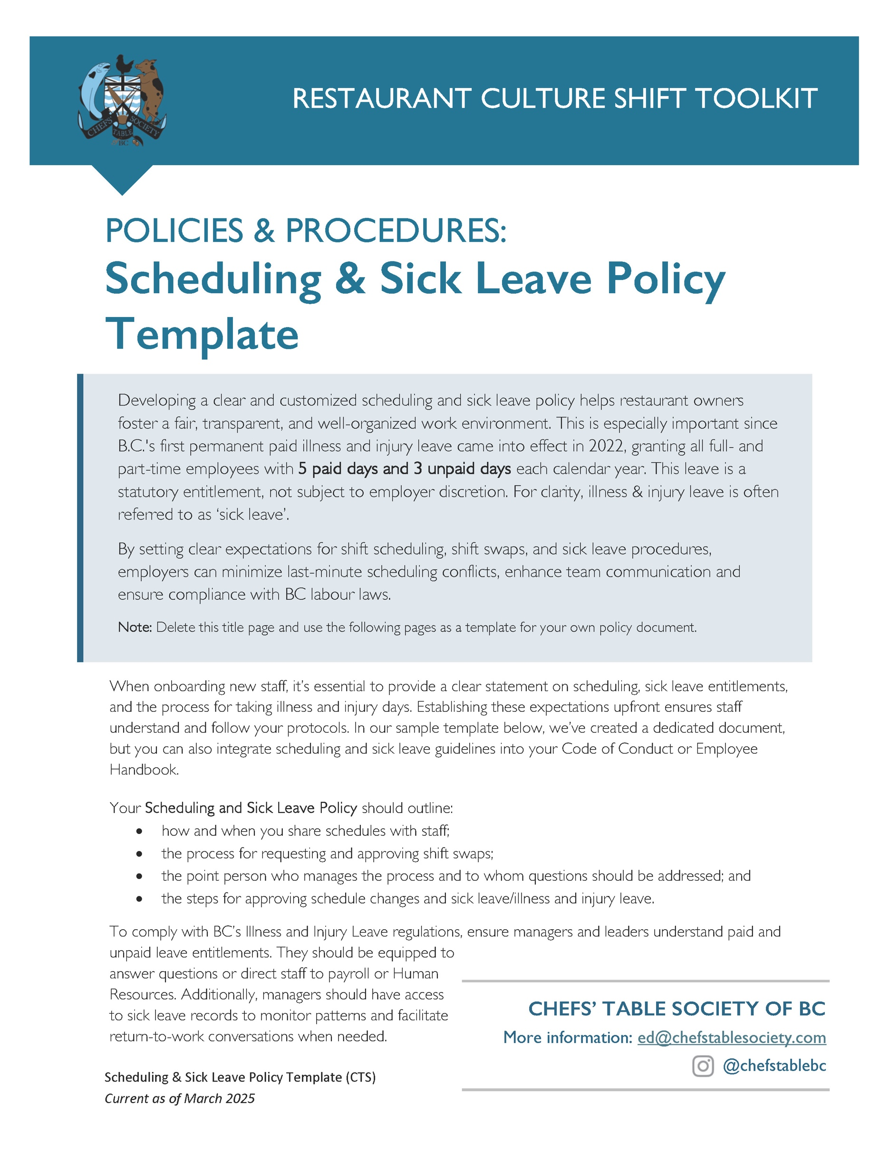

[Restaurant Name]
Employee Scheduling & Sick Leave Policy
Created: ________________
Updated: ________________

At [Restaurant Name], we prioritize fair and predictable scheduling to support work-life balance, A well-rested and engaged team creates a stronger workplace. This policy ensures a clear, consistent approach to scheduling and sick leave while complying with BC’s employment laws.
Scheduling & Shift Changes
We [email/text] schedules at least [10 day-2 weeks] in advance [DEFINE FREQUENCY e.g. every other Wednesday or 15th and 30th]. Should you not be able for a scheduled shift, our system allows you to request an online shift swap but the swap must be approved by [your manager] before it is finalized.
Call In Process
If you are unable to work due to illness or injury, follow these steps:
- Notify Early – Inform [your manager or other contact you designate] as soon as you know you cannot work, ideally at least [X] hours before your shift starts.
- Direct Communication – Call [your manager or designated contact] directly. Do not text or email to ensure the message is received promptly.
- Provide Relevant Details – Briefly state the reason for your absence.
- Follow Up – If your absence extends beyond one day, provide regular updates to [your manager or designated contact].
- Shift Coverage Collaboration – While finding a replacement is not your responsibility, we encourage you to assist by suggesting available coworkers to help cover your shift.
Eligibility for Illness and Injury Leave (Sick Leave)
Under BC law, all employees are entitled to 5 paid days and 3 unpaid days per calendar year. Both full- and part-time employees qualify for this benefit, starting from 90 days after the start of employment here. An employee’s sick leave entitlement renews annually on January 1.

At [Restaurant Name], these days can be used for:
- personal illness and injury
- Medical appointments that cannot be scheduled outside work hours.

Illness or injury/sick leave does not carry over from year to year if unused.

Illness & Injury Pay
To request paid illness and injury/sick leave:
- Complete [X] form or email [Y].
- If you have used all 5 paid leave days, you may take up to 3 additional unpaid leave days as allowed under BC law.

Sick leave is recorded by [payroll/manager/Human Resources]. If you have questions about your sick leave balance, contact [email address or phone number].

Additional Support
Employees requiring extended time off due to serious illness or injury may be eligible for additional leave through other workplace policies or government programs. If you need to explore these options for support, please speak with your [manager/leader or Human Resources].

ELIGIBILITY FOR STATUTORY ILLNESS & INJURY PAY
A worker who joins your company at any time during the year is eligible for all 5 “average days” of paid illness or injury leave plus the 3 days of unpaid leave for that calendar year after 90 days consecutive days of employment. This sick leave cannot be prorated for an employee who starts after January 1. Days are also not accumulated over the year based on service. This means that a person who leaves your company after the first 5 months of the year, but started the year already having 90 days with the company, could use all 5 paid days before they leave.

CALCULATING ILLNESS & INJURY PAY
Sick pay in BC is not based upon scheduled hours missed due to illness or injury – rather, the entitlement is to an “average day’s pay” for each of the 5 paid sick days per year. This means, for example, if an employee always works 8 hours a shift, their entitlement to an “average day’s pay” will require that they receive 8 hours pay on a paid sick day, regardless of how many hours they were scheduled to work on the sick day. For employees who work varying shift lengths, the Employment Standards Act calculates an average day's pay by dividing the amount paid or payable in the 30 calendar days before the leave by the number of days worked during that 30-day period. This does not include overtime but does include vacation pay, statutory holiday pay or sick pay.

ILLNESS & INJURY LEAVE NOTES
While it may seem important to require employees to provide reasonable documentation, such as a doctor’s note or therapist’s letter, most doctors now refuse to write these for 2 reasons. First, most people with cold or flu or even COVID don’t need a doctor visit BUT do spread disease by going to a doctor office. Second, writing the notes takes valuable away time from patient care. The best practice around sick leave is not to require notes and to trust that people are taking time in order not to spread their sickness.

MORE INFO on ILLNESS & INJURY LEAVE in BC:
https://www2.gov.bc.ca/gov/content/employment-business/employment-standards-advice/employment-standards/forms-resources/igm/esa-part-6-section-49-1

