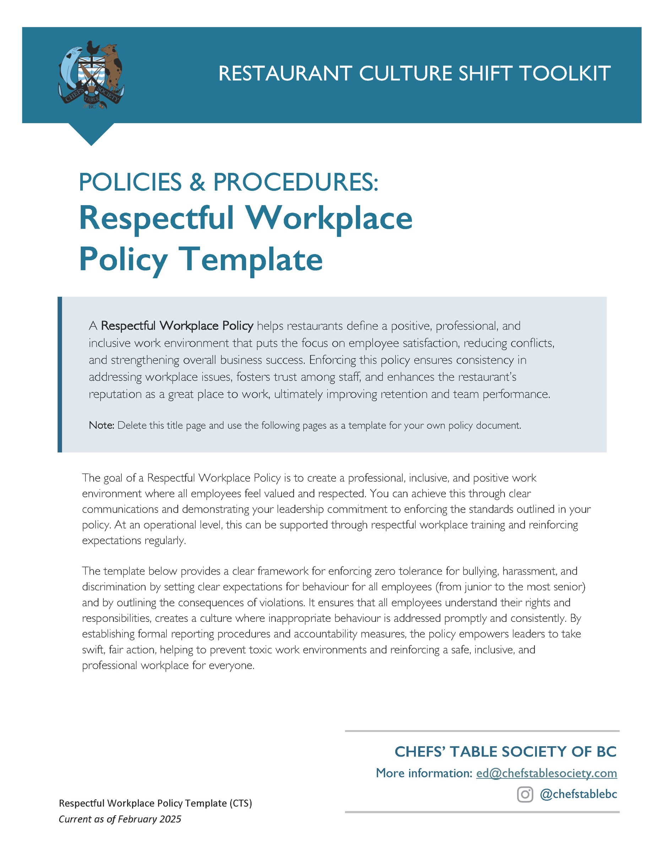

[Restaurant Name]
Respectful Workplace Policy
Created: ________________ Updated: ________________
At [Restaurant's Name], we are committed to fostering a workplace where all employees feel valued, respected, and supported. This policy outlines our commitment to maintaining a professional and inclusive workplace culture based on mutual respect, fairness, and accountability.
Commitment to a Positive Work Environment
We believe that a respectful workplace enhances employee well-being, performance, and job satisfaction. Our goal is to maintain a workplace culture where every individual contributes meaningfully and feels a sense of belonging. We recognize and celebrate positive workplace behaviours that align with our values.
Equal Opportunity and Fair Treatment
[Restaurant's Name] is an equal opportunity employer. We do not discriminate on the basis of race, colour, religion, sex, sexual orientation, gender identity, national origin, age, disability, or any other characteristic protected under British Columbia law. All employment-related decisions, including hiring, promotions, training, and compensation, are based on merit, qualifications, and business needs.
Professionalism and Respect
All employees are expected to treat one another with professionalism and respect at all times. This includes clear and respectful communication, teamwork, and consideration of others. Discrimination, bullying, harassment, or any form of disrespectful behaviour will not be tolerated. This applies to interactions with colleagues, customers, vendors, and the community.
Safe and Inclusive Workplace
We are committed to maintaining a workplace free from harassment, intimidation, and unfair treatment. Employees should feel safe to express concerns, provide feedback, and contribute to the success of the team without fear of retaliation. Leaders are responsible for modeling and enforcing respectful workplace behaviour.
Accessibility and Support
[Restaurant's Name] is dedicated to providing reasonable accommodations for employees with disabilities to ensure equal access to employment opportunities, job performance, and benefits. We actively support employees in identifying and implementing solutions that promote their success.
Fair Compensation and Growth Opportunities
We believe in fair and equitable compensation practices. Regular reviews of pay structures ensure that employees are compensated fairly based on their skills, experience, and performance. We support ongoing training and professional development to help employees grow in their roles.
Conflict Resolution Procedures
We encourage open communication and are committed to resolving workplace conflicts. Employees are encouraged to address concerns informally when possible. If a resolution cannot be reached, issues may be escalated to [supervisor or HR] for mediation and further resolution. Leaders are expected to handle conflicts fairly and proactively.
Zero Tolerance for Retaliation
Employees who report workplace concerns or participate in investigations are protected from retaliation. Retaliation of any kind will not be tolerated and may result in disciplinary action, up to and including termination. Employees should feel safe coming forward without fear of negative consequences.
Confidentiality in Reporting
Employees should feel comfortable reporting concerns and have confidence that every reasonable effort will be made to maintain confidentiality. All reports will be handled with discretion, ensuring that individuals who come forward are protected. Anonymous reporting through [provide the way reports can be made HERE] is available for employees who wish to report concerns privately.
Social Media and Digital Communication
Employees are expected to communicate professionally both in person and online. Any digital communication, including emails, messages, and social media activity related to the workplace, should align with company values and reflect a respectful attitude.
Wellness and Mental Health Support
We recognize the importance of mental well-being in the workplace. Employees are encouraged to seek support through available resources, including [list what supports you offer HERE: e.g. include employee assistance programs, wellness initiatives, and open-door policies] for discussing workplace challenges. Leaders are encouraged to support employees in maintaining a healthy work-life balance.
[OPTION] Community Engagement
As part of our commitment to being a responsible business, we actively support the local community. Our efforts include [list specific initiatives HERE, e.g., partnerships with local organizations, volunteer programs, or charitable donations].
Accountability [OPTION] and Recognition
All employees are responsible for upholding this policy. Concerns regarding violations should be reported to their manager or ______________. We take all reports seriously and will address them in a fair and timely manner. Employees who engage in misconduct may face disciplinary action, up to and including termination. [OPTION] We also recognize and celebrate employees who consistently demonstrate positive workplace behaviours.
This policy is reviewed annually to ensure it remains relevant and effective in fostering a respectful and inclusive workplace.

