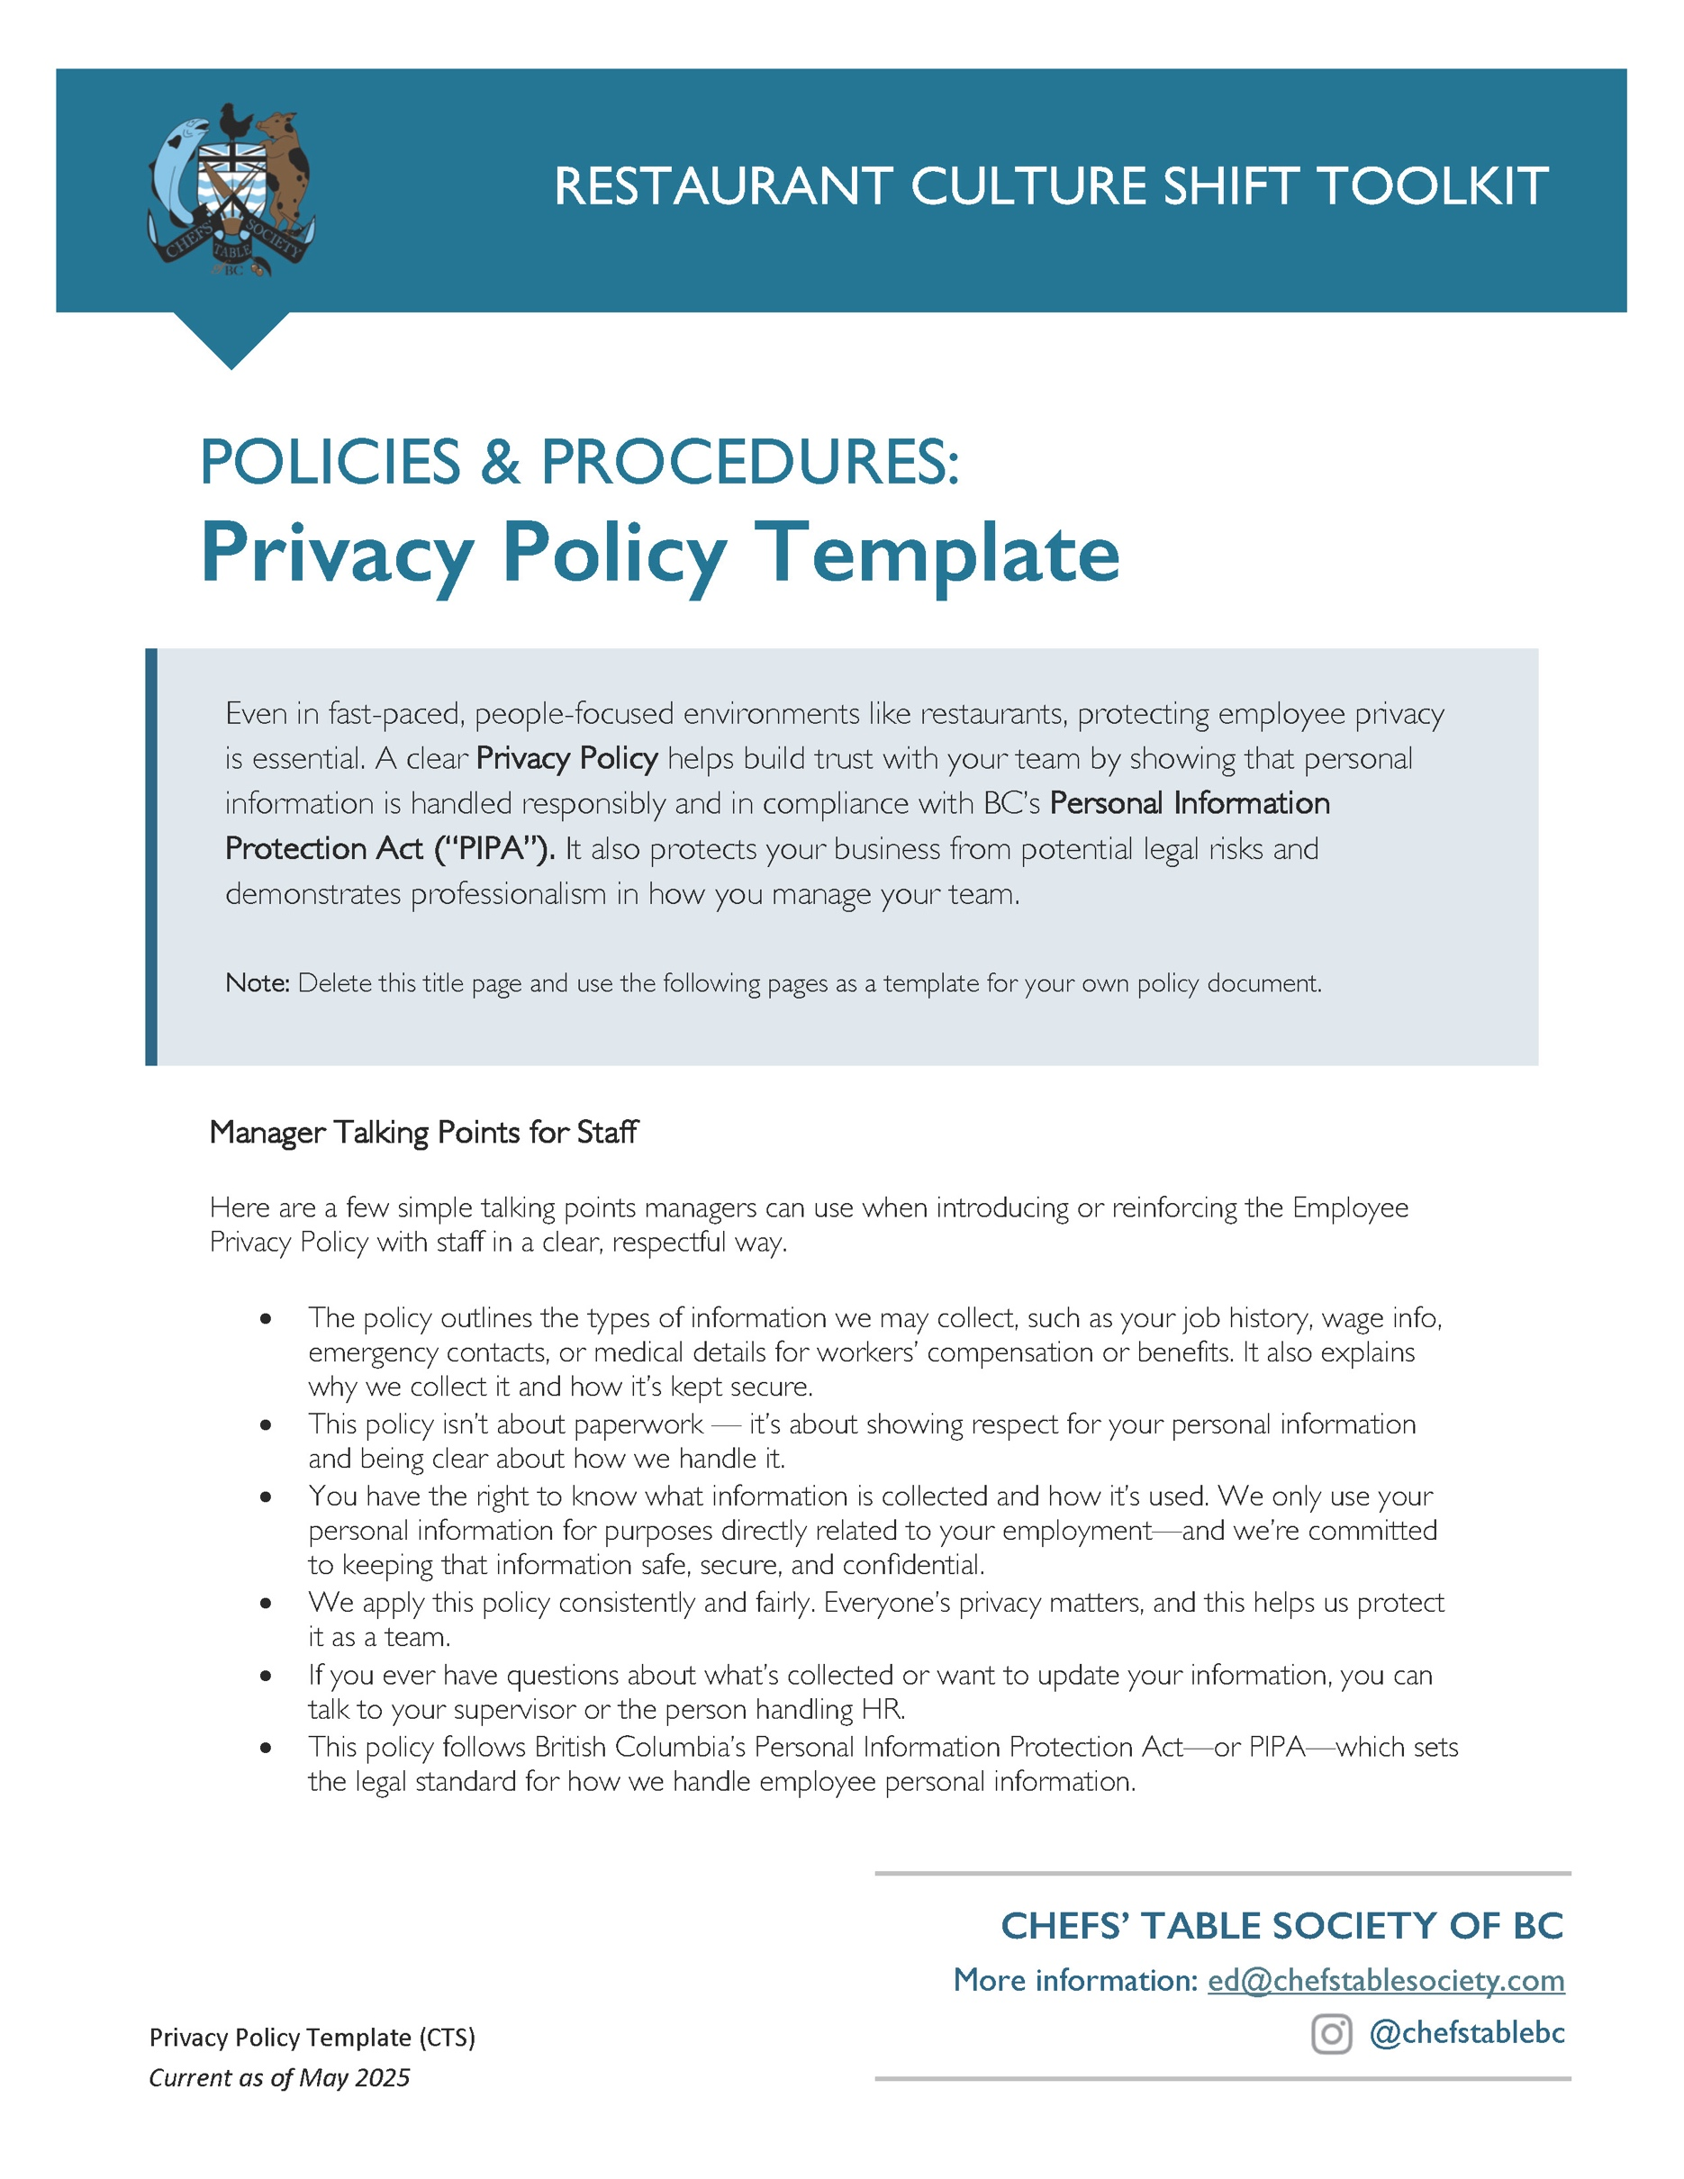

[Restaurant Name]
Employee Privacy Policy
Created: ________________ Updated: ________________
PURPOSE
[Restaurant Name] (the "Company") acknowledges the sensitivity of employee personal information that may be provided to us during the hiring process and throughout employment. This Policy outlines our commitment to protecting the privacy of your personal information in accordance with British Columbia’s Personal Information Protection Act (“PIPA”).
SCOPE
This Policy applies to all employees, including management.
DEFINITION
“Employee personal information” is defined under PIPA as “personal information about an individual that is collected, used or disclosed solely for the purposes reasonably required to establish, manage or terminate an employment relationship between the organization and that individual, but does not include personal information that is not about an individual's employment”.
Examples of the types of information the Company may collect include, but are not limited to: name, residential address, home and cell phone number, SIN, date of hire, tax credit information, banking information, credentials and qualifications, gender, date of birth, family status and dependent information, emergency contacts, wage/salary information, previous employment history, and any job-related information. Medical information may also be collected for workers’ compensation or insurance benefit purposes, or for managing the employment relationship.
PRIVACY CONTACT
[Name, Title] is the current Privacy Contact for the Company.
The Privacy Contact is responsible for overseeing compliance with this Policy and privacy laws generally. If you have a concern or complaint about privacy compliance, please contact the Privacy Contact directly at [Email] or [Phone Number]. You may be asked to put your complaint or request in writing.
The Privacy Contact is also responsible for handling requests to access and/or correct personal information. Such requests must be made in writing, with sufficient detail to identify the personal information requested. The Company will respond to access requests within thirty (30) days, or else written notice of an extension will be provided where additional time is required to fulfill the request. If a request is refused in full or in part, we will notify you in writing, providing the reasons for refusal and the recourse available to you.

CONSENT
The Company will obtain consent to collect, use, or disclose employee personal information, where such consent is required by law. Consent can be implied where the purpose for collecting, using, or disclosing the personal information would be obvious, and the information is voluntarily provided by you for that purpose.
The Company collects, uses, and discloses employee personal information without consent if it is reasonable for the purposes of establishing, managing, or terminating an employment relationship, or where otherwise permitted by law. When required, the Company will notify you that we will be collecting, using, or disclosing your personal information without consent. We will also tell you why we are collecting, using, or disclosing this information.
COLLECTION, USE, AND DISCLOSURE
The Company will only collect, use, and/or disclose employee personal information if doing so is reasonable for the purposes of establishing, managing, or terminating an employment relationship. These purposes include, but is not limited to:
- Identifying you.
- Paying you for work performed.
- Providing benefits to you and your family members, as applicable.
- Providing job feedback and training.
- Communicating with you on work-related matters.
- Fulfilling requests as required and authorized by law.
- Managing the assignment and performance of work.
We limit the collection of personal information to what is strictly necessary for identified purposes and as permitted by law.
We do not use or disclose personal information other than for identified purposes of collection, except with the consent of the individual or as required or permitted by law.
We may disclose personal information to third parties to, for example: report earnings information or provide benefits, or if required by law.
CARE OF PERSONAL INFORMATION
The Company will make best efforts to ensure that the personal information we collect is accurate and complete. Please notify us if any personal information we have for you, such as emergency contact information, changes or requires updating.
The Company is committed to ensuring the security of your personal information in order to protect it from unauthorized access, collection, use, disclosure, copying, modification, disposal, or other similar risks.

If the Company uses your personal information to make a decision that directly affects you, we will keep that information for at least one (1) year after using it so that you have a reasonable opportunity to request access to it.
The Company will destroy or redact documents containing your personal information once that information is no longer needed. When destroying documents containing personal information, we will use appropriate security measures, such as:
- securely shredding documents;
- destroying electronic media containing personal information; and
- permanently deleting electronically stored information.
The Company will review and update our security policies and controls as technology changes to ensure ongoing security of personal information.
EMPLOYEE RESPONSIBILITIES
In some cases, employees may learn personal information about others in the course of their work, whether that be the personal information of other employees or information about customers. We expect our employees to keep this information confidential.
Additional expectations regarding confidentiality may be set out in employment agreements or other Company policies.
ACKNOWLEDGEMENT
I have read and understand the “Privacy Policy” and agree to abide by its contents.

________________________ _______________________ _______________________
Employee Signature Employee Name (print) Date

