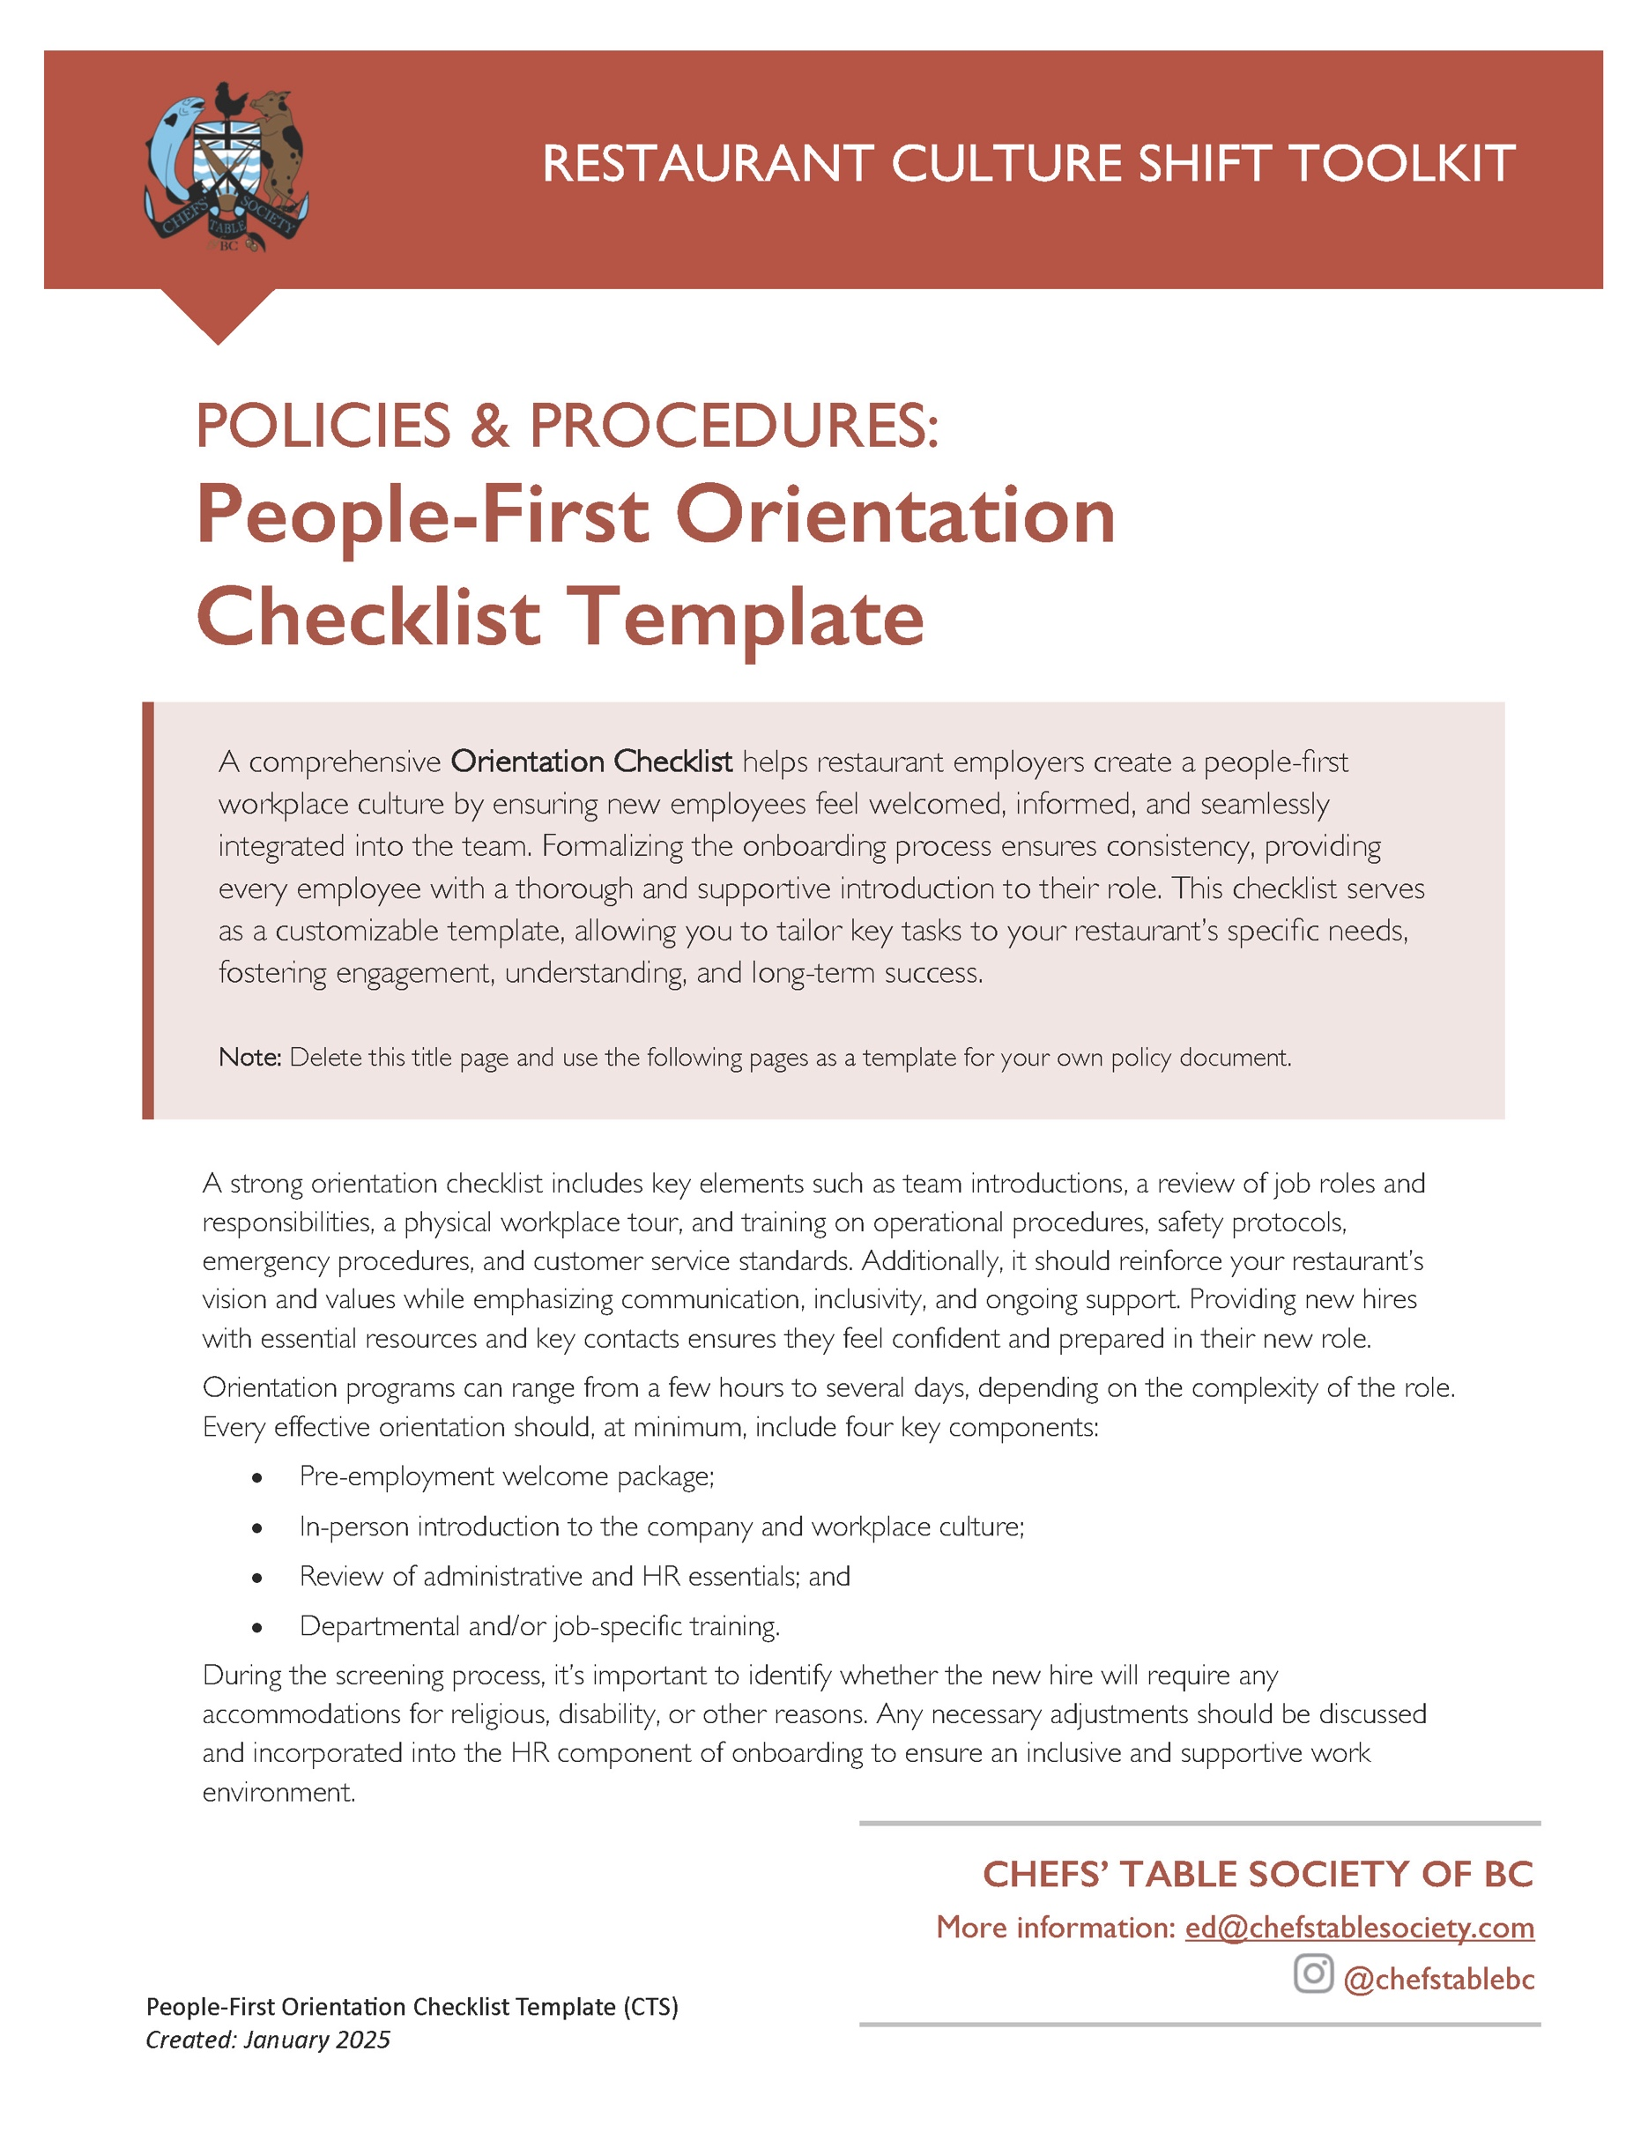

[Restaurant Name]
Orientation Checklist
Created: ________________
Updated: ________________

PRE-EMPLOYMENT PACKAGE
 Send welcome email with start date, time, location, and parking.
 Include the contact details for the person for questions prior to starting.
 Designate a point person for the first day on the job.
 Indicate dress code and request uniform sizes and style preferences (if uniforms are provided).
 Arrange for uniforms, name tags, and any required equipment.
 Provide a schedule for the first day or week.

FIRST DAY

Company Welcome and Introduction

 Greet the new hire and introduce them to the team and management.
 Provide an overview of the restaurant’s history, mission, and values.
 Conduct a tour of the restaurant.
(Incl. dining areas, kitchen, restrooms, areas for staff personal items, parking/bike lockups, emergency exits)

Human Resources Documentation:

 Complete necessary paperwork. (Incl. tax forms, direct deposit, employment agreement)
 Provide and review the employee handbook
(if applicable).
 Complete benefits review and sign up
(if applicable).
 Introduce the new hire to scheduling and shift patterns.
 Ensure completion and recording of any required training or certifications. (Eg. FoodSafe, Serving It Right, SuperHost, WHIMIS)
 Discuss confidentiality, performance reviews & probationary period.

Policies and Procedures:

Explain people policies in detail including:
 Code of conduct
 Diversity, Equity, Inclusion and Belonging OR Respectful Workplace Policy
 Bullying and harassment policy
 Scheduling & illness and injury leave/sick days
 Dress code/clothing standards
 Staff meals and discounts
 Cellphone use at work
 Substance use at work

Role-Specific Training:

 Provide hands on training for key tasks. (E.g. taking orders, serving food, bussing tables, and kitchen prep.)
 Explain the interconnected-ness of the role with other positions.
 Provide an overview of the menu. (Incl. food and drink, ingredients, and how your business handles special dietary requirements)
 POS systems, reservation systems, and other relevant technology training.
 Assign a mentor or buddy for shadowing and on-the-job training.
 Allow the new hire to practice tasks under supervision and provide feedback.
Customer service and communication training:

 Review the elements of your customer service standards.
 Outline pathways of communication for your team(s).
 Role-play common customer interactions and scenarios to build confidence.
 Explain how to handle difficult customers, complaints and special requests.

Health and Safety Training:

 Review health and safety standards for proper food handling, sanitation, hygiene practices
 Review safety procedures, including fire safety and first aid.
 Review emergency procedures including who to call for help.
 Provide an overview of all safety hazards.
(E.g. sticky door, bubble in carpet, slippery floor area, etc.)
 Provide the process for reporting injuries or safety concerns.

FIRST WEEK WRAP UP
After a week, it’s a good time to review how the new worker is integrating into the workplace and to review the onboarding and training to date.
 Meet with the new employee to discuss their experience so far. Review the best practices for the position to make sure the person has all the info they need to do a good job.
 Ask about challenges, concerns, or questions they may have; encouraging them to share observations or ideas for improvement. Discuss any challenging interactions that have happened to ensure the new hire knows how to handle difficult situations with confidence.
 Ensure they understand essential job responsibilities, operational procedures. scheduling procedures, shift expectations, and sick leave policies.
 Confirm they are comfortable with menu items, POS systems, and customer service expectations.
 Reiterate expectations around teamwork, communication and workplace culture.
Reinforce the importance of active participation in team meetings and briefings.
 Encourage ongoing communication with their manager or mentor.
 Provide constructive feedback on their performance: acknowledging successes and areas for improvement.
 Address any gaps in training and provide additional support if needed.
 Answer any lingering questions about policies or workplace conduct.
 Set clear expectations for the next phase of their training or job responsibilities.

Employee Acknowledgment Form 
Have the new employee and their supervisor formally acknowledge that all onboarding steps have been followed, that they have completed and understood the initial phase on training and onboarding. Two template options, basic and detailed, are available in this toolkit.
This will make sure that your company is complying with corporate responsibilities under WorkSafeBC and employee health and safety.

