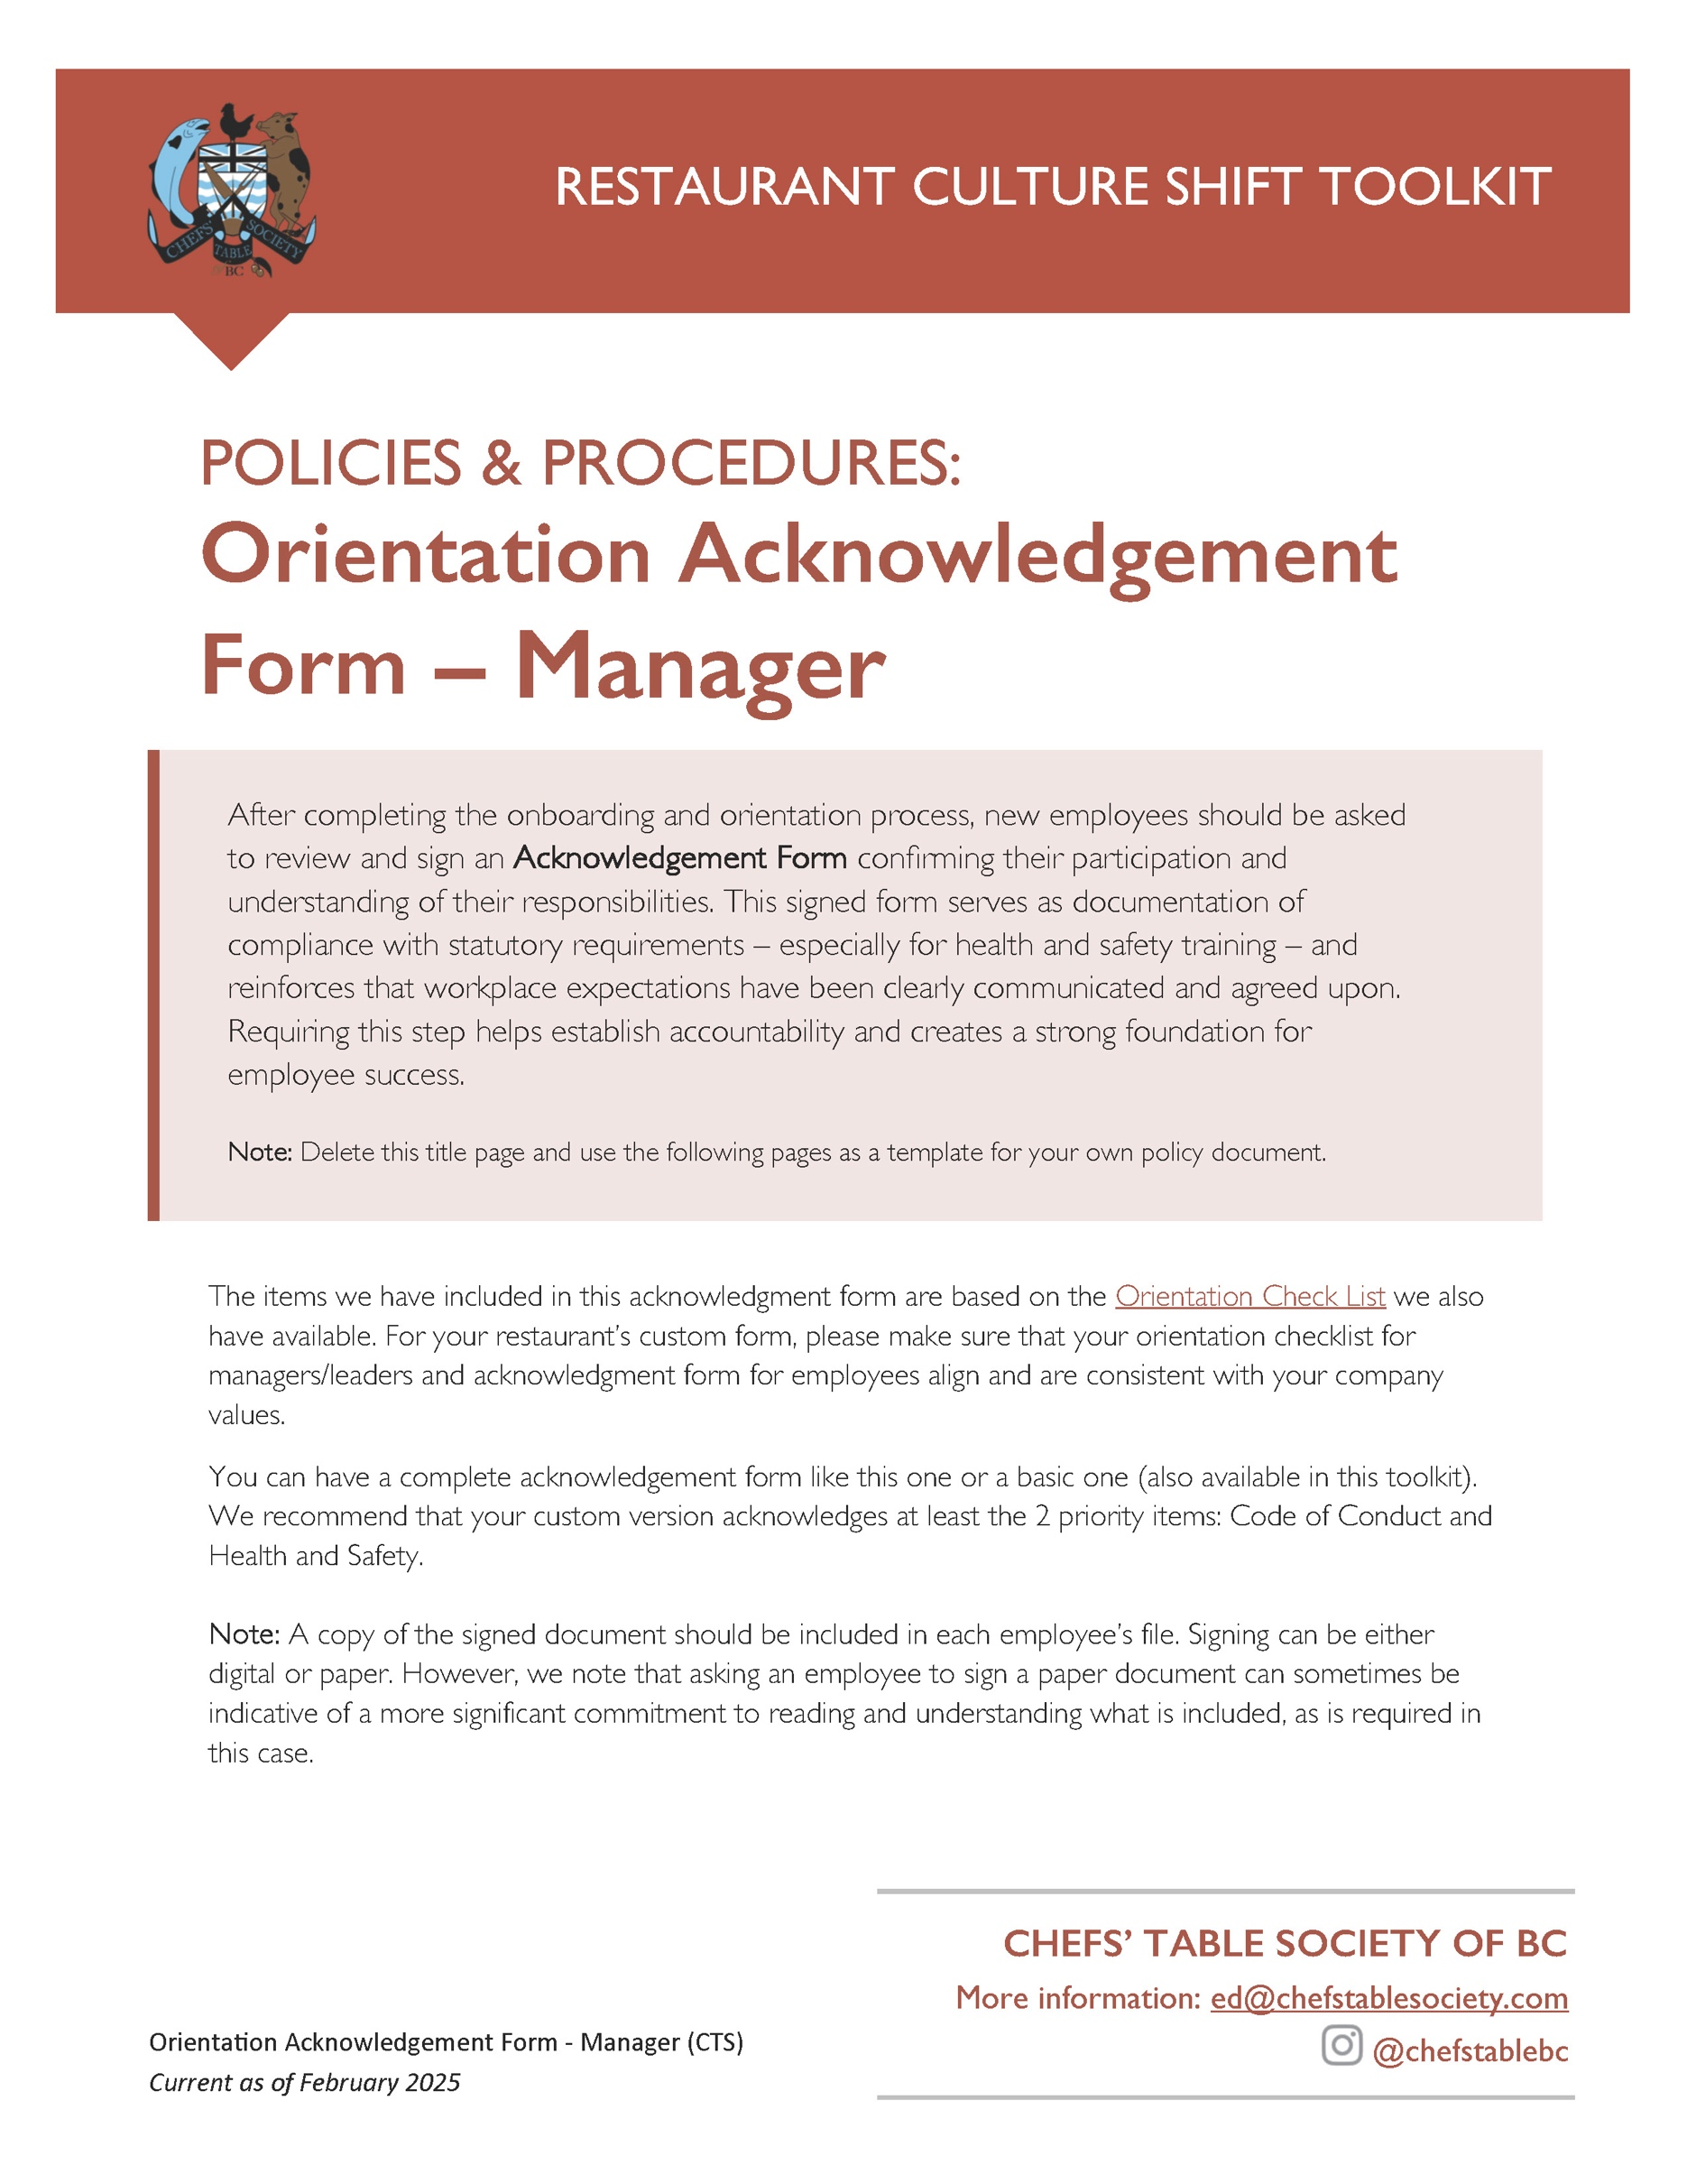

[Restaurant Name]
New Employee Orientation Acknowledgment
for Managers / Leaders

Employee Name: ___________________________
Position: ___________________________
Start Date: ___________________________

I, _________[Full Name]_________, have completed the following steps of my orientation under the supervision of my [Manager/Supervisor] _________[Full Manager/Supervisor Name]_________,

[Option to list the dates of orientation] These orientation steps took place over the dates ___________________________ to ___________________________, [year].

I completed a review of the company basics: Complete
Introduction to team members ☐
Overview of restaurant history, mission, and values ☐
Tour of the facility including any safety hazards ☐

Human Resources:
Completed employment paperwork
Tax forms ☐
Direct deposit ☐
Employment agreement ☐
Received and reviewed a copy of the employee handbook (if applicable) ☐
Completed sign up for employee benefits (if applicable) ☐
Reviewed scheduling process and shift patterns ☐
Discussed probationary period and performance reviews ☐
Filed copies or certificate numbers as required for the position ☐
FoodSafe, Serving It Right, SuperHost, WHIMIS (List those that apply)

I have reviewed and understand the following policies and procedures: (List those that apply)
Code of Conduct ☐
Bullying and Harassment Policy (if separate from Code of Conduct) ☐
Attendance ☐
Dress Code/Clothing Standards ☐
Process for illness and injury leave (paid and unpaid sick days) ☐
Cellphone use ☐
Staff meals or discounts ☐

I have:
Reviewed my job duties and expectations ☐
Understood how my role interacts with other positions ☐
Reviewed the menu and food and beverage offerings ☐
Learned how to use:
POS, reservation system, etc. (List those that apply) ☐
Completed hands on training of key tasks ☐
Met my mentor or buddy and understand they are willing to support me in
my orientation (If you have a mentor program) ☐ Become familiar with [Restaurant Name] customer service standards ☐
Understood the policy for dealing with difficult customers, complaints and
special requests ☐

The health and safety training I received included:
Health and safety standards for: ☐
Food handling, sanitation & hygiene practices (List those that apply)
Emergency procedures including who to call for help ☐
Overview of workplace safety hazards ☐
Safety procedures, including fire safety and first aid ☐
The process for reporting injuries or concerns ☐
Confidentiality:
I agree not to share, copy, or use any confidential information (including but not limited to recipes, cooking methods, supplier contacts, pricing, staff details, training materials and business plans) for personal use or to help anyone else—during or after my employment with the company.

Acknowledgment
I understand the policies, procedures, and expectations above, and I agree to comply with them.

Employee Signature: ___________________________
Date: ___________________________

Manager/Supervisor Signature: ___________________________
Date: ___________________________

