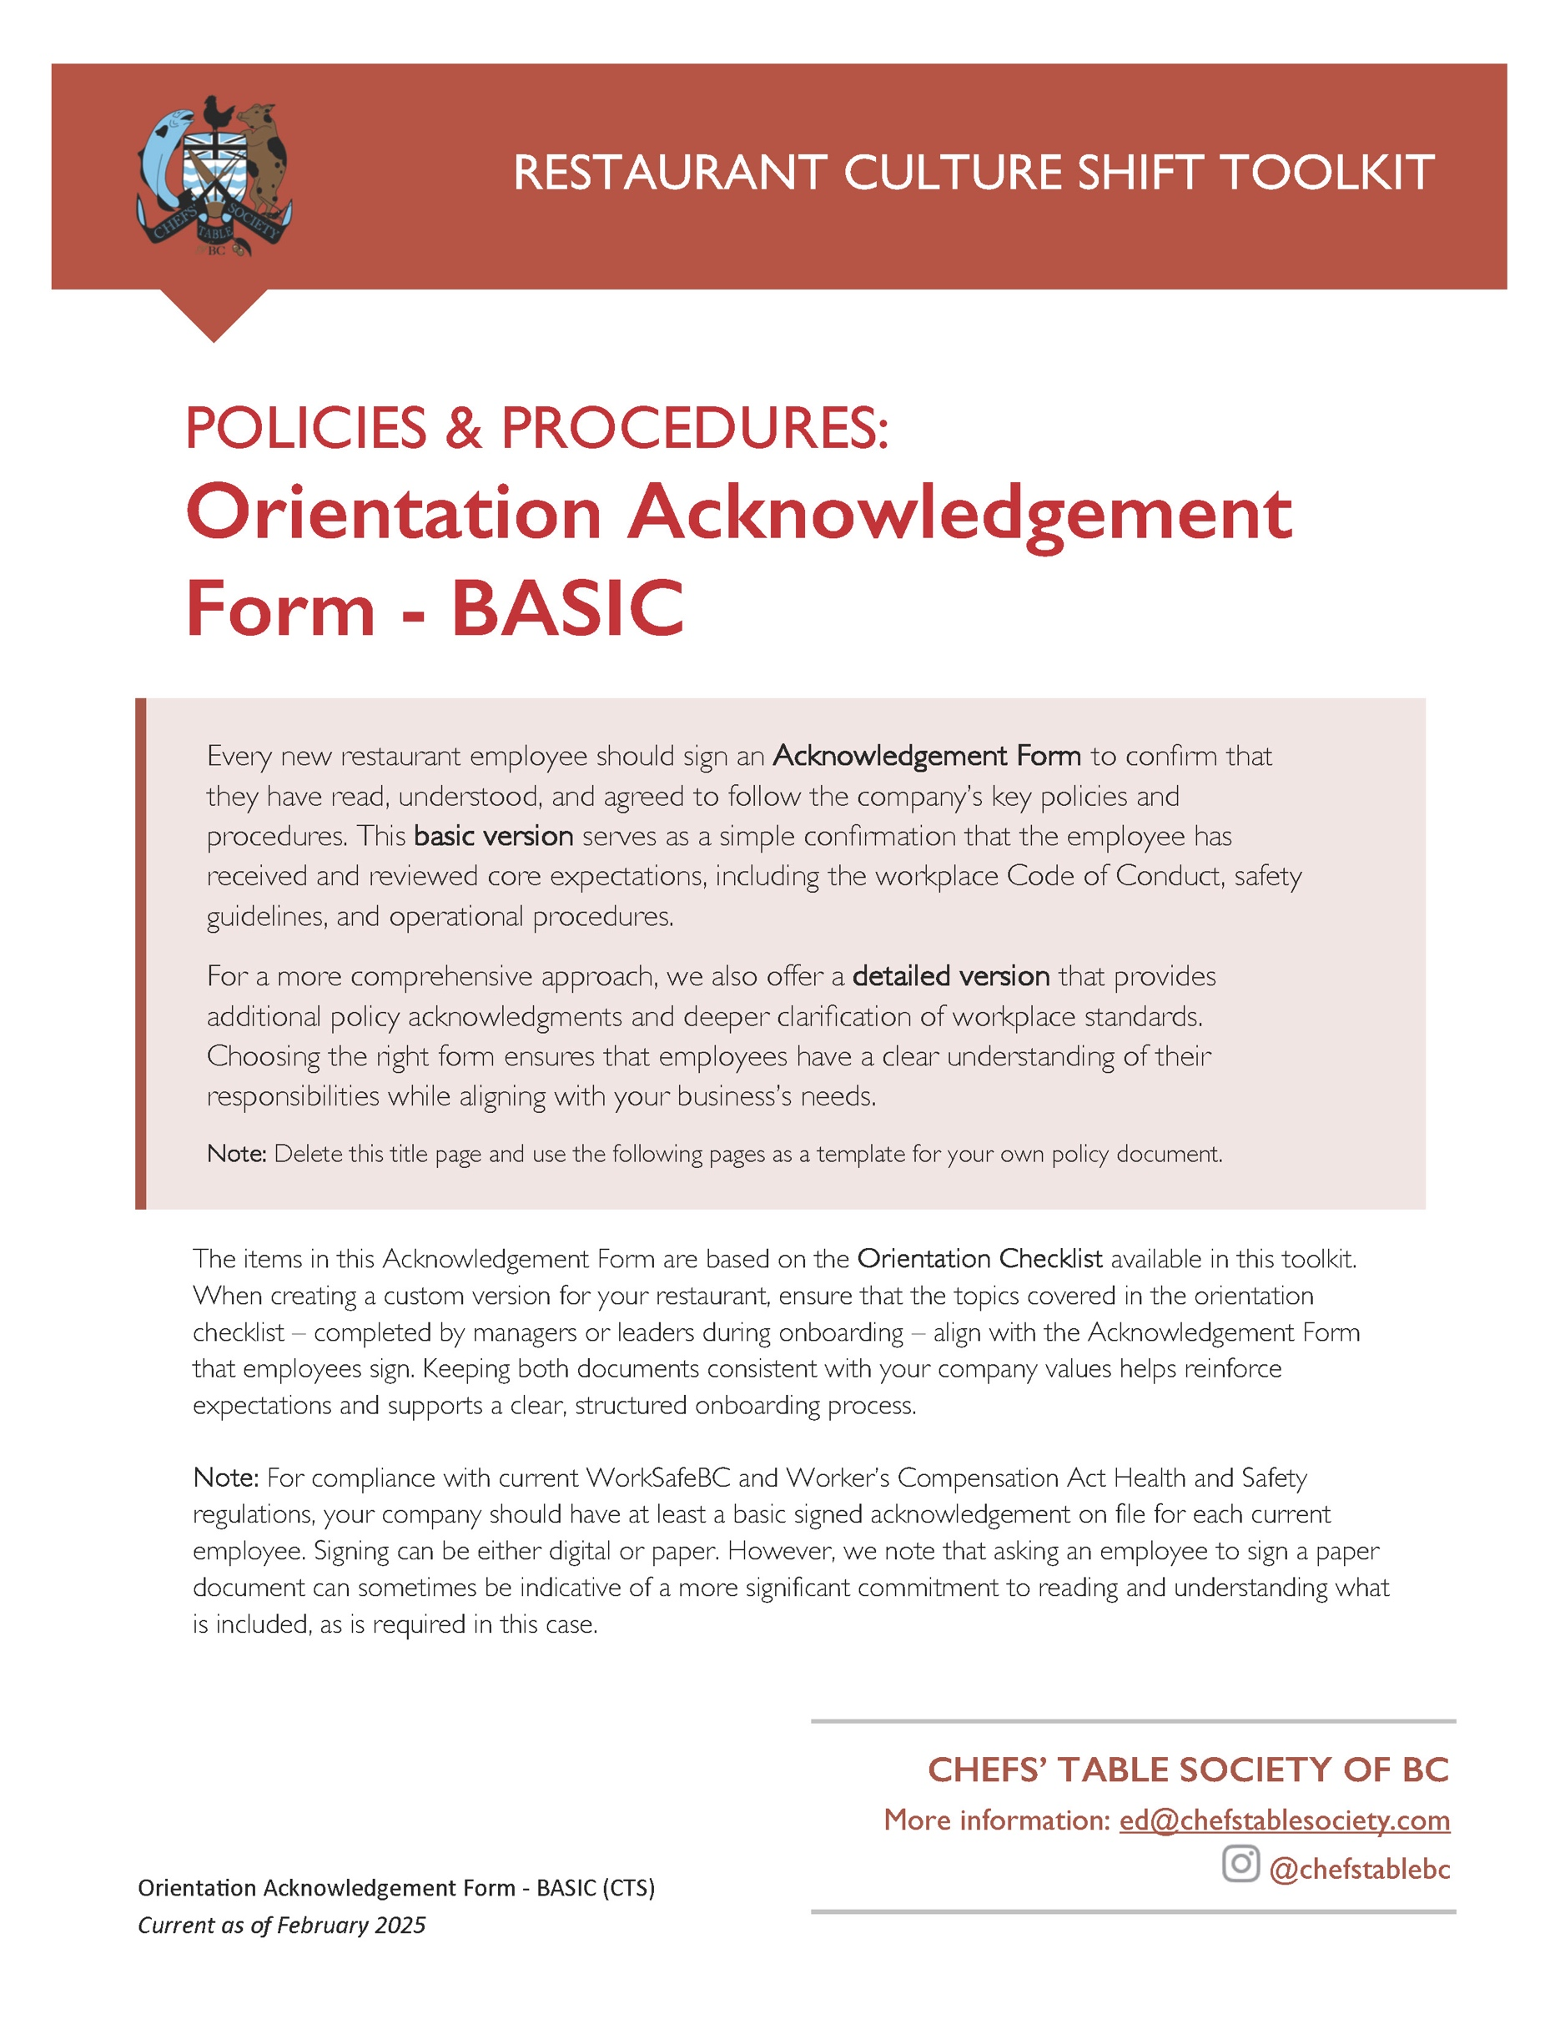

[Restaurant Name]
New Employee Orientation Acknowledgment Form

Employee Information:
Name: ___________________________
Position: ___________________________
Start Date: ___________________________
Supervisor/Manager: ___________________________
I acknowledge that I have received a copy of the [Restaurant Name] Employee Code of Conduct, Health and Safety Guidelines and Company Policies. I understand that it is my responsibility to read and comply with the policies, procedures, and guidelines outlined, including but not limited to:
- Workplace Code of Conduct
- Anti-Bullying, Harassment and Discrimination Policy
- Health and Safety Procedures
- Food Safety and Sanitation Standards [applies to kitchen positions]
- Attendance, dress code and scheduling policies
- Guest Service Expectations
- Process for reporting incidents that fall under the Bullying and Harassment policy
- Process for reporting unsafe or uncertain working conditions
I understand that failure to adhere to workplace policies may result in disciplinary action, up to and including termination of employment.
Confidentiality:
I agree not to share, copy, or use any confidential information (including but not limited to recipes, cooking methods, supplier contacts, pricing, staff details, training materials and business plans) for personal use or to help anyone else—during or after my employment with the company.
Questions: If I have any questions regarding these policies, I will seek clarification from my supervisor or management.

Acknowledgment
I understand the policies, procedures, and expectations above, and I agree to comply with them.

Employee Signature: ___________________________
Date: ___________________________

Manager/Supervisor Signature: ___________________________
Date: ___________________________

