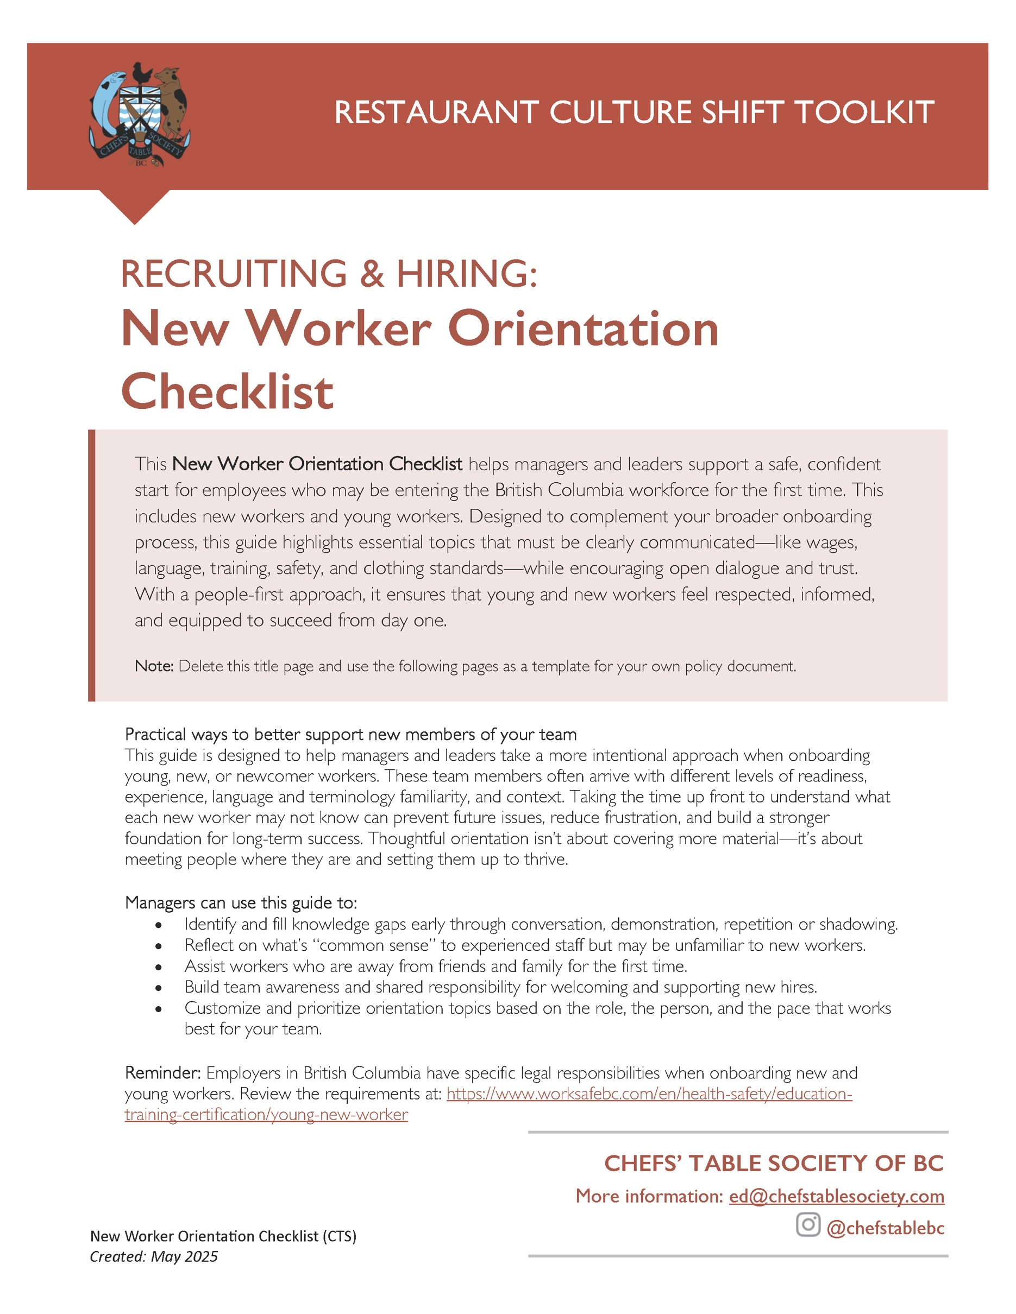

[Restaurant Name]
New & Younger Worker Orientation
Checklist & Guide for Managers/Leaders
Created: ________________
Updated: ________________

Employment Scope
☐ Outline the responsibilities, job duties, expectations and hours.
☐ Include orientation to basic employment rules and rights, including when workers are eligible for overtime, what illness and injury leave is and what the process is.
☐ Walk through the employment paperwork, tax forms and benefits slowly and step-by-step, providing translated materials if/when necessary.
☐ Provide opportunity to ask questions about the terms of employments.
☐ Have a form to sign off that the individual understands the dress codes.

Training and Orientation
☐ Share an orientation plan and training schedule with key milestones.
☐ Set clear expectations for performance, workplace behaviour and communication. Include workplace basics such as time management, professionalism, and teamwork.
☐ Start with hands-on, step-by-step training, ensuring the person fully understand tasks before progressing.
☐ Use simple, clear language and visual aids during training if necessary.
☐ Repeat key lessons as necessary to build confidence and competence, acknowledging that new skills take longer to learn when there is a language gap and account for that in the training timeline.
☐ Incorporate interactive elements like role-playing customer scenarios to build confidence.
☐ Use feedback loops - ask them to repeat or demonstrate tasks to confirm understanding.
☐ Offer translation resources or language support if needed.

YOUR FIRST WEEK WITH [RESTAURANT NAME]
Create a 1-pager for a new hire that tracks orientation goals for them to achieve. This list is given to the person with simple, achievable tasks that help new employees feel productive and organized. This checklist could include tasks like learning the layout of the restaurant, familiarizing themselves with the menu, meeting key team members, observing a shift, and practicing greeting guests.
As they check off each item, they experience a sense of accomplishment and feel more comfortable in their role. It also allows employers to ensure that all essential steps are covered, while helping the new employee feel empowered and in control of their first day.

NEW EMPLOYEE WELCOME PROJECT
Assign each new worker a small, manageable task or project they can complete within their first week. Completing the project gives the person an immediate sense of accomplishment and helps them understand their role’s impact. For employers, it’s an opportunity to observe the new hire’s strengths and provide early, positive reinforcement.

Language and Terminology
☐ For new workers of all kinds, use visual aids, pictograms, and images for clear communication.
☐ Provide orientation to words or acronyms that are specific to your workplace or a position. (e.g., This can be introducing the concepts of front of house and back of house or more specifically teaching the English words for spatula or reservation or explaining colloquialisms like “the machine” for the payment terminal.)
☐ For new and newcomer workers, provide materials in multiple languages, including training manuals, safety guides, and employee handbooks. Free services like Google Translate can assist with this.
☐ Connect employees to free or subsidized language classes focused on workplace communication. There are many organizations across the province that offer free Language Instruction for Newcomers to Canada (LINC) training which focuses on practice English. If such a class exists in your community, make sure the language learner has the right time off to participate.

Wages
☐ Provide a summary of the wages the person will make and when they will be paid (ex. every two weeks on a Friday) and what taxes will be taken off their check.
☐ Explain how tips work and/or introduce them to the staff person responsible for the tip program to explain it to them.
☐ Confirm that the person has the banking set up to accept the pay.
☐ Ask whether the person understands the difference between accruing vacation time and receiving vacation pay on regular pay – and allow them to pick which works for them.
☐ Provide opportunity to ask questions about pay.

TALK ABOUT FINANCES & FINANCIAL LITERACY
As an employer you can support financial literacy for new workers by:
☐ Providing guidance on setting up a bank account and/or direct deposit.
☐ Providing an annual session on navigating annual tax filings.
☐ Partnering with local financial experts or institutions to provide value added information on budgeting, banking, and managing taxes. An expert or bank works that works in a location that is walkable from your business is the best option.

Clothing standards/dress codes/uniforms
Note: In BC, employers do not have to pay for an employee to meet a dress code, for example business casual clothing or a white shirt, dark pants, dark dress shoes. If you require staff to wear a uniform or special clothing, employers must provide the uniform or special clothing to employees at no cost. Employers cannot charge a deposit for uniforms or special clothing.
Employees must pay to clean and maintain these items or agree to reimburse employees for it. Special clothing is chosen by the employer, purchased from a specific store, a specific brand or style or easily identified with the employer (e.g. clothing with a company logo or unique company colours). If you have young or new workers, you may want to provide the above a starter clothing allowance even for a dress code to make sure the person can buy clothing of the calibre you prefer.

☐ Provide a document that outlines clear dress code expectations.
☐ Include the requirements for shoes, grooming and jewellery if you have them.
☐ If you have clothing expectations based on position, be clear about what those are. (eg. Hair nets or hats for cooks or non-slip shoes for people in the kitchen.)
☐ Ensure the individual understands the dress codes and signs off on the Orientation Acknowledgement.
☐ Provide information on a clothing or shoe allowance and how it works, if you have one.
Note: if you have many workers that are new to Canada, providing an annual clothing allowance is essential to ensuring clothing standards.
☐ Let all new employees know to speak to their supervisor/manager if they have challenges with the dress code.
If there is a challenge, ask the new employee whether they require an accommodation and make an agreement about what the accommodation will be. (e.g., An employee doesn’t feel culturally comfortable wearing to short sleeves. As an employer, you should confirm what kind of long sleeve shirt works for your company or confirm that the worker wear layers and what that looks like.)

Workplace Culture and Values
☐ Provide an overview of workplace etiquette and acceptable behavior, ensuring sensitivity to cultural differences.
☐ Make a clear connection between your business values and your workplace culture. This helps to align employee values and expectations and workplace values and expectations.
☐ Provide an overview of your Anti-Bullying and Harassment policy and explain how concerns within the workplace will be addressed.

Confidence and Connections
☐ Schedule one-on-one check-ins to discuss progress, provide constructive feedback, address concerns and celebrate progress. Making sure check-ins are scheduled rather than unscheduled assists in building confidence and connection.
☐ Recognize achievements and milestones, such as mastering a new skill, completing training, or reaching a work anniversary. Public acknowledgment builds confidence and reinforces a sense of belonging.
☐ Provide clear, actionable steps for improvement when necessary.
☐ Offer tuition assistance or free training certifications that are necessary for the position like FoodSafe, Serving It Right or SuperHost.
☐ If a first-time employee shows interest in career progression, set a personal growth plan that provides a plan and targets for advancement.
☐ Maintain an open-door policy for questions and concerns.

Supports
☐ Introduce new and newcomer workers to community programs that offer settlement assistance, housing support, childcare, and local supports in a range of languages. These are equally valuable for new to your community and new to the country workers.
☐ Share information about free programs like Mind the Bar (mindthebar.com) and People Working Well (peopleworkingwellbc.ca) that provide support in the mental health space.

PEOPLE WORKING AWAY FROM HOME
New workers and new to Canada workers may both be working away from friends and family for the first time in their lives. Support first-time workers living away from home by:
☐ Fostering a welcoming culture, offering resources like housing guidance or local area orientation.
☐ Acknowledging the challenges of living away from loved ones in touch bases with these employees to show care and concern.
☐ Offering team check-ins, shared meals, or even small celebrations during the year for employees that do not have family to share holidays with.

Health and Safety
Training and orienting young and new workers is a regulatory requirement under WorkSafeBC and is part of your restaurant’s overall health and safety program. WorkSafeBC specifically requires that young and new workers need special attention because they may be at more risk of injury than their more experienced counterparts.

Note: Occupational Health and Safety Regulation define a "young worker" as any worker under age 25. A "new worker" can be any age and includes those who are new to the workplace or location or facing new hazards. WorkSafeBC has specific resources dedicated to young and new worker safety that are in place to protect workers from inadequate training, orientation, and supervision.
https://www.worksafebc.com/en/resources/health-safety/books-guides/support-for-employers-training-and-orientation-for-young-and-new-workers?lang=en

If you need help in this area: go2HR offers a 90-minutes online Safety Basics – Health and Safety Orientation Course https://train.go2hr.ca/products/8499-safety-basics

Mentors, Buddies and/or Peer Support Groups
For new and young workers, buddies can help navigate workplace norms and provide emotional support. For newcomer workers, a buddy from a similar background or language skills can provide mentorship and guidance with the benefit of a shared experience. They can also support an orientation that explains workplace culture, expectations, and common practices in Canada.
☐ Pair new employees with a buddy or introduce them to a peer support group in your workplace.

SHADOW & SHARE
New workers shadow experienced employees during their first days and then share their reflections or ideas in a follow-up meeting. This approach builds confidence by giving new hires firsthand insight into their role while making them feel valued when their observations are heard. It benefits employers by fostering a culture of collaboration and often uncovering fresh perspectives that can improve workflows or workplace morale.

Conduct interactive training when onboarding 2 or more workers at once
☐ Instead of a traditional sit-down orientation, use interactive training modules or a "scavenger hunt" style training where new employees are tasked with finding key areas of the restaurant (kitchen, storage, supplies) or learning important aspects (where the fire extinguisher is, how to clock in/out) in a fun way. This makes learning more engaging and memorable.
☐ Host a short, informal team gathering where new employees are introduced to everyone, and an icebreaker activity is used to help them feel comfortable. It could be something simple, like sharing a favorite food or hobby. This helps the new worker build relationships right away.

Employee Acknowledgment Form
Have the new employee and their supervisor formally acknowledge that all onboarding steps have been followed, that they have completed and understood the initial phase on training and onboarding. Two template options, basic and detailed, are available in this toolkit.
This will make sure that your company is complying with corporate responsibilities under WorkSafeBC and employee health and safety.

