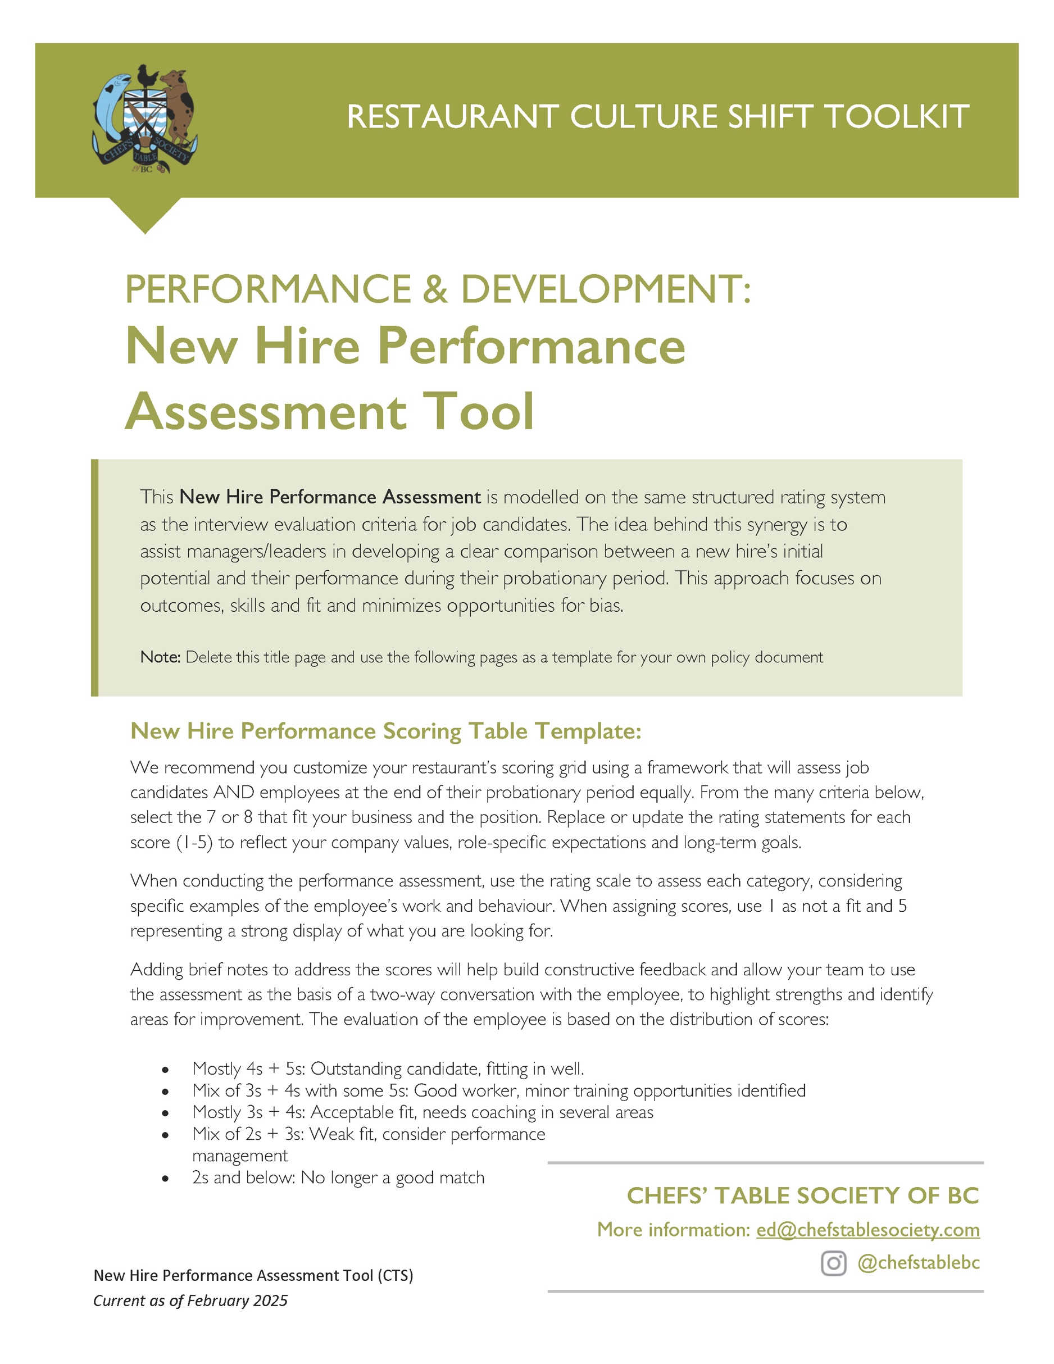
EMPLOYEE NAME |  |  |  | START DATE
POSITION |  |  |  | REVIEW DATE
SUPERVISOR |  |  |  | SCORE
CATEGORY | CRITERIA | 1 - POOR | 2 - FAIR | 3 - GOOD | 4 – VERY GOOD | 5 - EXCELLENT | SCORE
 |  | To score the candidate, check the statements for each rating and find alignment.
Cultural Fit  All positions | Aligns with restaurant values, attitude, and is able to be a team player | Does not align. Can-do attitude is lacking. | Some misalignment, not confident in a teamwork setting. | Generally fits in. Appears open-minded. | Strong alignment, has a can-do attitude. | Cultural fit. Shows good enthusiasm. | __/5
Cultural Fit  All positions | COMMENTS:
Teamwork & Collaboration  All positions | Works well with coworkers, supports the team, ability to collaborate | Seems to prefer working alone.  Feels resistant to new ideas and/or to feedback. | Shows willingness to work with others.  Hesitant to communicate. | Works well with others. Shows flexibility. Follows instructions. Ability to adjust when needed. | Highly adaptable. Proactive team player. Helps others without being asked | Thrives in teamwork. Leads by example.  Contributes to strong team culture. | __/5
Teamwork & Collaboration  All positions | COMMENTS: | .
Work Ethic & Reliability  All positions | Punctuality, responsibility, willingness to go the extra mile | Appears unreliable or unmotivated, frequently late, limited effort | Shows some responsibility but appears inconsistent, needs reminders | Reliable, meets expectations, follows through | Shows initiative, takes responsibility, always on time, dependable | Highly dependable, eager to contribute, tales initiative | __/5
Work Ethic & Reliability  All positions | COMMENTS:
Passion, Enthusiasm  & Attitude  All positions | Enthusiasm for the position and their role, eagerness to learn | Doesn’t demonstrate any passion/interest. Lacks energy. | Shows interest but lacks enthusiasm. Neutral attitude. | Displays interest and a willingness to improve/learn. Asks good questions. | Passionate about their craft.  Eager to grow. Comes to work prepared. | Highly motivated. Committed to personal excellence. | __/5
Passion, Enthusiasm  & Attitude  All positions | COMMENTS:
Handling Pressure  All positions | Ability to stay calm and work efficiently under stress | Keeping up with the pace of the job is difficult.  Shows little problem-solving ability. | Lacks confidence but shows good instincts and is starting to apply techniques to manage stressful situations. | Inconsistent at handling pressure but has good instincts. Would benefit from support/training. | Appears to work efficiently under pressure. Helps de-escalate stressful situations within the team. | Thrives in fast-paced environment. Stays composed. | __/5
Handling Pressure  All positions | COMMENTS:
Adaptability & Problem-Solving  All positions | Handles stress, adjusts to changing situations | Appears easily flustered. Not showcasing consistent problem-solving skills.  Needs guidance. | Shows adaptability. Hesitant but willing to try problem solving ideas. | Can adjust and problem-solves with help.  Shows willingness to seek help/advice. | Adaptable, thinks quickly under pressure. Handles issues effectively. | Thrives in challenges.  Finds solutions independently. Calm. | __/5
Adaptability & Problem-Solving  All positions | COMMENTS:

Communication Skills  All positions | Clarity, professionalism, and ability to engage with guests | Poor communicator.  Very quiet/unsure.  Struggles to interact effectively. | Occasionally unclear. Hesitant or lacking confidence. Showing improvement. | Communicates well. Handles most interactions professionally. Needs some polish. | Confident and professional. Engages with guests and team effectively. | Engaging. Clear communicator. Builds rapport easily. Enhances the guest experience and team morale. | __/5
Communication Skills  All positions | COMMENTS:
Customer Service  FOH positions + Managers/Leaders | Friendliness, attentiveness, handling guests’ needs | Struggles when engaging with customers or teammates. Lacks warmth. Often inattentive. Frequent complaints. | Sometimes forgets guests’ needs. Could be more engaging. Needs support with confidence. | Good customer service. Friendly and consistent service. A few complaints. | Warm, attentive and makes guests feel welcome. Proactive attitude. | Strong service mindset. Consistently exceeds guest expectations. | __/5
Customer Service  FOH positions + Managers/Leaders | COMMENTS:
Culinary Skills & Experience  Chefs or cooks | Knife skills, cooking techniques, food knowledge | Only basic skills but beginning to learn. Requires a lot of practice. | Basic skills. Absorbing and applying company standards. | Good technical skills. Follows instructions/  Recipes. | Strong skills. Efficiently executes the menu and makes good suggestions. | Highly skilled. Executes dishes flawlessly, Shows leadership. | __/5
Culinary Skills & Experience  Chefs or cooks | COMMENTS:
Speed & Efficiency  All positions | Ability to multitask, work in a fast-paced environment | Works very slowly. Easily overwhelmed. Forgets tasks. | Struggles at times. Makes mistakes. Improving with experience. | Manages tasks well. Works at an appropriate pace. Some room for improvement. | Fast and organized. Anticipates needs. Rarely makes mistakes. | Highly efficient. Stays ahead. Handles high volume with ease. Improves service flow. | __/5
Speed & Efficiency  All positions | COMMENTS:
Menu Knowledge & Upselling  FOH positions + Managers/Leaders | Knows the menu, is engaged, makes suggestions, upselling) | Limited menu knowledge. Struggles with recommendations. | Learning the menu but hesitant to upsell. | Understands the menu. Makes occasional suggestions. | Shows good menu knowledge. Confidently recommends pairings. Good with guest questions. | Expert knowledge. Confidently sells or speaks to the culinary program. | __/5
Menu Knowledge & Upselling  FOH positions + Managers/Leaders | COMMENTS:
Cleanliness & Organization  Chefs and Cooks | Follows food safety, maintains a clean station | Disorganized. Shows poor hygiene practices. | Needs reminders to stay clean/organized. | Keeps station tidy. Follows health codes. | Very organized. Maintains cleanliness. | Impeccable hygiene.  Highly organized. Sets standard. | __/5
Cleanliness & Organization  Chefs and Cooks | COMMENTS:

