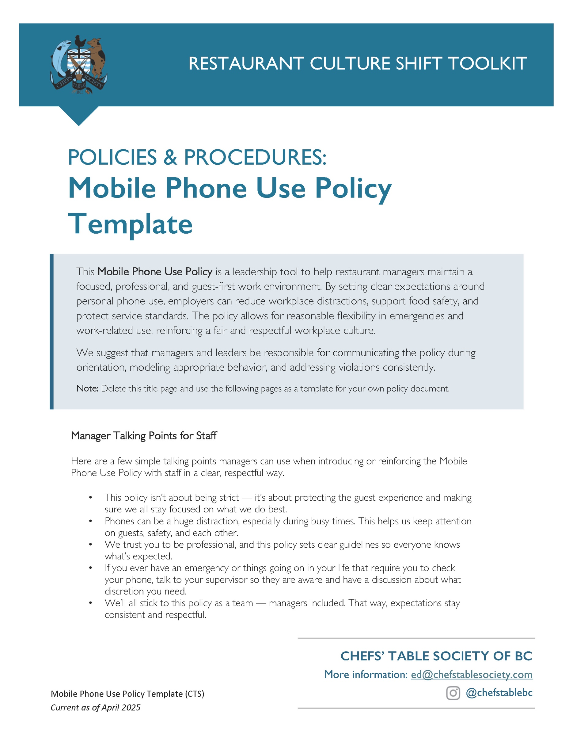

[Restaurant Name]
Employee Mobile Phone Use Policy
Created: ________________ Updated: ________________
[Restaurant Name] recognizes that mobile phones are a common part of everyday life. However, to ensure excellent customer service, maintain a professional work environment, and uphold food safety and operational efficiency, this Policy regarding mobile phone use by employees during work hours is in effect.

Purpose: This Mobile Phone Use Policy aims to minimize distractions, promote teamwork, and provide the best possible experience for our customers. The Policy outlines the acceptable and unacceptable use of mobile phones by all restaurant employees while on duty.

Expectations:
- Personal mobile phone use is not permitted on the restaurant floor or in customer-facing areas. This is to maintain a professional image and ensure your full attention is on your duties and our guests.
- Keep your personal phone stored away (e.g., in a locker, break room, or your bag) and on silent or vibrate. If you must keep your phone on your person, it must be fully out of sight.
- Use of personal mobile phones is permitted during scheduled break times and before or after your shift, provided that you are obviously off duty or otherwise not within the customers’ line of sight.
- Taking photos or videos within the restaurant without explicit management authorization is not permitted.
- In specific situations, and with the explicit approval of a manager, mobile phones may be used for essential work-related communication (e.g., contacting a supplier, coordinating with other staff members outside the immediate work area).
- In the event of a personal or family emergency, employees may use their mobile phones to make or receive essential calls or messages. Employees should inform their manager as soon as possible about such situations.

Management Responsibilities:
- Managers are responsible for communicating and enforcing this Mobile Phone Use Policy consistently.
- Managers have the discretion to address specific situations and make exceptions in extenuating circumstances.
- Managers will lead by example and adhere to this Mobile Phone Use Policy.

Consequences of Policy Violation: Violation of this Mobile Phone Use Policy may result in disciplinary action, up to and including verbal warnings, written warnings, suspension, or termination of employment, depending on the severity and frequency of the violation.

Review and Updates: This Mobile Phone Use Policy will be reviewed periodically and may be updated as needed to reflect changes in technology, business needs, or legal requirements. Employees will be notified of any updates.

Acknowledgement: By signing below, I acknowledge that I have read, understood, and agree to comply with the [Restaurant Name] Mobile Phone Use Policy.

________________________ _______________________ ________________________
Signature Name (print) Date

