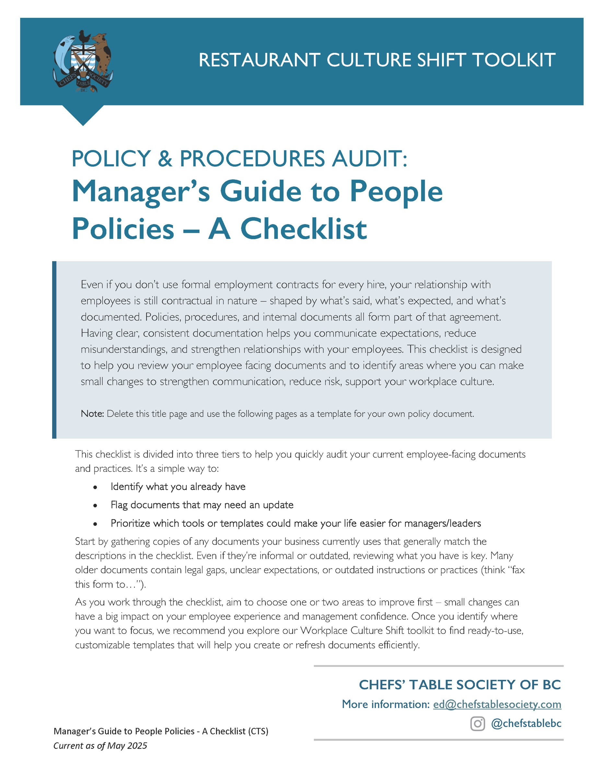

HR/People Policy Document Checklist
[Restaurant Name]
TIER 1: Essential Tools (Start Here)
These are the minimum must-haves to protect your business, set expectations, and support legal compliance.
HAVE | NEED | Document | Available
 |  | Employment Agreements and/or Employment Contacts (even a basic version) | YES
 |  | Job Descriptions for each position | Speak to go2HR
 |  | Onboarding / Orientation Checklist  REQUIRED BY WorkSafeBC to include Health and Safety Training | YES
 |  | Orientation Acknowledgement form (new employees sign to acknowledge that they completed an orientation and onboarding process) | YES – 2 versions
 |  | Code of Conduct / Workplace Behaviour Policy | YES
 |  | Scheduling, Hours of Work and Overtime Policies | YES - Combined policy
 |  | Illness and Injury leave and/or Absenteeism Policy  The Employment Standards Act mandates 5 “regular” days Illness and Injury leave per employee per calendar year after 90 days continuous employment. | YES - Combined policy
 |  | Bullying/Harassment/Discrimination Prevention Policies  REQUIRED BY WorkSafeBC | YES
 |  | Health and Safety Policy Statement  REQUIRED BY WorkSafeBC | YES
Incident Reporting & Unsafe Work Refusal Process
REQUIRED BY WorkSafeBC
 |  | Tip Out Policy and Distribution Method
 |  | Food Safety and Serving It Right Log

TIER 2: Recommended Tools (Build Stability)
These tools help create consistency, reduce conflict, and improve communication and retention.
HAVE | NEED | Document | Available
 |  | Staff or Employee Handbook | Speak to your go2HR Regional Human Resources Advisor
 |  | Employee Training Manual(s) | Speak to your go2HR Regional Human Resources Advisor
 |  | Application form | Speak to your go2HR Regional Human Resources Advisor
 |  | Respectful Workplace Policy OR  Diversity, Equity and Inclusions Policy | Both available
 |  | Forms associated with reference checks | Reference Check form template go2HR online Toolkit
 |  | Pre-employment welcome email template
 |  | Employee Complaint/Concern Procedure OR Anonymous feedback process OR Whistler-blower policy
 |  | Uniform & Appearance Guidelines | Speak to your go2HR Regional Human Resources Advisor
 |  | Vacation and Time Off Policy / Vacation request form | Speak to your go2HR Regional Human Resources Advisor
 |  | Averaging Agreement Template | YES
 |  | Compensation, bonus and/or incentive plan document(s)
 |  | Benefit plan documents(s) or Benefits summary | YES
 |  | Health and Safety rules or procedures | Speak to your go2HR Regional Human Resources Advisor
 |  | Performance Review or Annual/Periodic Assessment Form(s) | Speak to your go2HR Regional Human Resources Advisor
 |  | Disciplinary form(s) OR Standard disciplinary letters | Speak to your go2HR Regional Human Resources Advisor
 |  | Employee Personal Details Form and/or Emergency Contact Form
 |  | Template or standard termination letters
 |  | Incident Reporting Forms (Safety or injury or first aid or combo) | WorkSafeBC  Report of Injury Form  How to report an injury
 |  | Incident Reporting Log (Safety or injury or first aid or combo)

TIER 3: Enhanced Tools (Support & Strengthen Culture)
HAVE | NEED | Document | Available
 |  | Setting Expectations for New Workers 1-pager | YES
 |  | Prospective Employee Rating Template | YES
 |  | Probationary Employee Rating Template | YES
 |  | Annual Performance Review Template | go2HR Toolkit Performance Evaluation Form template
 |  | Employee Personal Growth Plan | YES
 |  | Manager Self-Assessment Form | YES
 |  | Mobile Phone Policy | v
 |  | Training & Development Tracker
 |  | Exit Interview Checklist
 |  | Exit Interview Template | go2HR Toolkit  Exit Interview Template
 |  | Social Media Policy | YES
 |  | Task Checklists (opening/closing duties, cleaning schedules)
 |  | Employee Satisfaction or Employee Engagement Survey
Note: You may have other documents that do not fit neatly in the categories listed above. However, these are the primary ones we have identified.
Why are we suggesting you connect with go2HR?
go2HR supports strong workforces and safe workplaces in BC’s Tourism & Hospitality Industry.
They offer 1:1 Human Resources and Health & Safety advisory services, various resources and a number of online training options to sector employers.
Restaurant and eatery employers can reach out directly by phone and email.
More info about the advisory services can be found here: www.go2hr.ca

