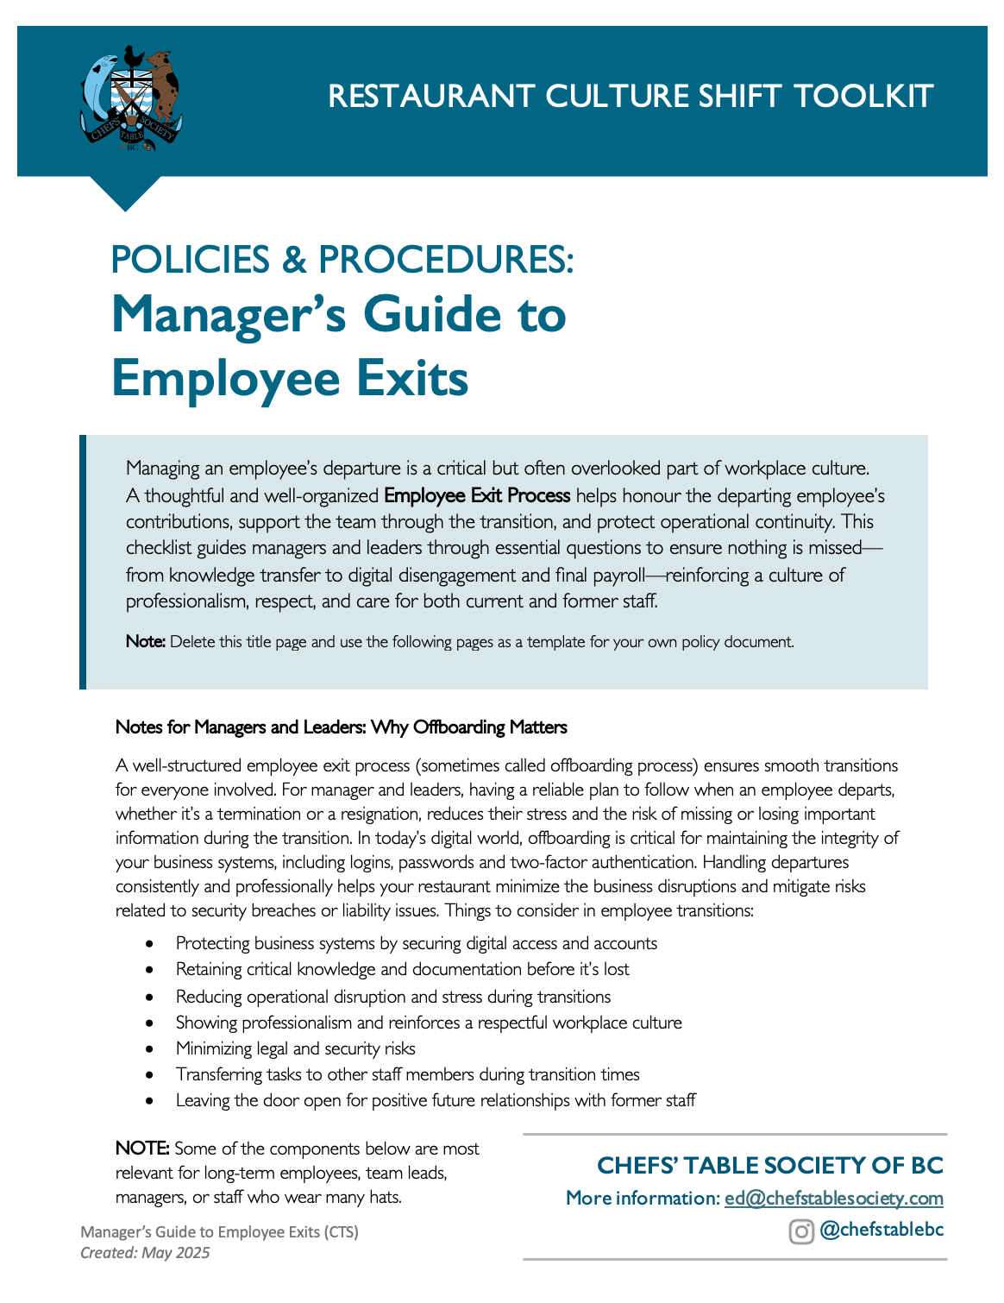

Employee Exit from [Restaurant Name]

Departing Employee: _____________________

Position: |  | Last Day:
Is the position being reposted? |  | Does the job description need updating?

RESPONSIBILITIES
What regular tasks and responsibilities does this person have that will need to be reassigned without delay?

What are the tasks and responsibilities that can wait till the replacement is hired?

Are there deadlines, events, or high-demand tasks that are in progress that require immediate transition planning? Yes / No
If yes, provide details:

What are the infrequent responsibilities (weekly, monthly, annually) related to this role? What is the timing for each task?
RESPONSIBILITY | WHEN IS THIS DONE
Note 1: It’s easier to miss less frequent tasks and it’s more likely that infrequent tasks would be missing in job descriptions. At a manager level, this could include annual renewals of a subscription or licensing or being the point person for a large annual holiday party that brings in a lot of revenue. For a chef, this could be the deep cleaning of range hoods, exhaust fans or grease traps.
Are there any tasks that this person has assumed responsibility for that are outside of their traditional job description? Yes / No
If yes, which ones:

KNOWLEDGE TRANSFER
Is this employee the manager or gatekeeper for any policy or procedures? Yes / No
If yes, which ones:

Note 2: In the front of house, this could include training and orientation protocols, scheduling preferences or insights into regular customers. In the back of house, this could be recipes, plating standards, or unique prep notes for chefs/kitchen staff.
Do you have all the documentation for these policies or procedures? Yes / No
Which policy and procedures documents and information need to be handed over?

Note 3: Where possible get support from (allow time for) the departing employee to gather role-specific documentation to ensure that the departing employee leaves behind comprehensive instructions for their replacement (e.g., recipes for chefs, POS processes for managers).

Does this employee manage vendor and supplier relationships (e.g., for food, beverages, or cleaning supplies)? Yes / No
If yes, which ones:
VENDOR/SUPPLIER | CONTACT NAME/NUMBER

Note 4: Consider asking the employee to develop a job FAQ: a "quick reference" question and answer guide for team members taking over responsibilities.
DIGITAL PROFILE
In this section, primary means they are the primary account holder or have the master account access. Personal means they have an individual log in and/or password. General means that they use a general log in and/or password: examples include a general, info or manager account that multiple people use.
If the employee is a basic user with only a personal login, deactivate their access.
If the employee has access to an info@, manager override/account or other general account log in, change the password and record the new one.
If the employee is a primary/secondary account holder:
    - Secure their login and passwords.
    - Record/update the email/phone being used for 2-factor authentication or authentication app.
    - Conduct the steps necessary transition the account to another point person.
    - Only revoke access to the accounts once the transition is complete.

Note 5: Check for any unusual activity on company systems during the transition.
Does this employee have access to: | Primary | Personal | General | N/A
Social Media Accounts
Website
Subscriptions
Supplier Ordering Platform
For Managers / Leaders: | Primary | Personal | General | N/A
POS
Banking
Bill Payments
Business Licensing
Liquor Licensing
Insurance
Online Ordering/Shopify
Online Reservation
Delivery Apps
Company Calendar
 | Signing Authority |  | N/A
Payroll
Cheque Signing/Authentication
Does the employee have involvement or access to any physical systems? | Primary | Personal | General | N/A
Keys/Access Cards
Security System
POS System
Reservation System
Tip Pool Administration

Company Emails:
Best practice for company emails, particularly for leaders/managers/group coordinators, is to be deactivated through a staged process to ensure that no annual events or billings or two-factor authentications are missed in the transition. Particularly if someone books groups or parties, you want to make sure the account is kept open until the last event they booked is finished.
Employee Login
Employee Password
Has the email employee access been removed?
What is the new password?
Does the email need to be forwarded?
If yes, to what person/email?
Has an auto-reply or forwarding Out-of--Office message been set up?
What is the timeline for closing the email?
Suggest: 3-6 months regular employee, 12 months for senior leaders.
Have the employee’s work AND personal emails been removed from mailing lists and directories?

Scheduling App, Slack & What’s App Access:
If you use scheduling apps, Slack or What’s App, it’s essential to remove people from the group chats to limit the opportunity to use these platforms for grievances etc.
Have the employee’s work AND personal phones been removed from group chats or other App access?

What company equipment does this person have? (laptops, phones, ID badges, uniforms).
Note 6: Returning uniforms can seem like overkill but you want to ensure that the person doesn’t represent your company unintentionally.
ITEM | RETURNED

LEGAL AND HR COMPLIANCE
- Calculate final payments, including salary, bonuses, or unused vacation/vacation pay and confirm them to the employee by email at the earliest convenience.
- Pay final wages within 6 days of the last day worked when the employee ends employment (resigns), and paid within 48 hours if the employer ends employment (termination).
https://www2.gov.bc.ca/gov/content/employment-business/employment-standards-advice/employment-standards/termination/quit-fired
- Create Record of Employment (ROE) – can be submitted to Service Canada electronically or provided as paper document.
- Provide information about transitioning benefits or pensions (if applicable).
- Make sure the employee has cleared any outstanding employee tabs or loans.
- Provide a final record of employment.
- Get a forwarding address and/or updated email for the T4 for the year end.

TEAM NOTIFICATION
Notify team members, stakeholders, vendors, external partners and suppliers of the pending departure and the transition plan (if necessary) and introduce the person assuming the responsibilities (even if it’s temporary). Best practices include:

Being authentic with the message of transition.
Speaking to specific or individual successes or contributions over saying impersonal things like “We wish them the best of luck in their future endeavours”. Platitudes have a negative impact on the employee leaving AND the ones staying with you.
If the departing employee managed vendor relationships, creating a professional email that introduces the new point of contact. (e.g., "You can now reach out to [New Contact] for assistance.")

Sample Email
The idea with this simple email is to reinforce the positive workplace culture while managing the transition. The email speaks to the individual who is leaving and the plan in place to minimize the impact on the other team members.
Hi Team,
I wanted to inform you that [Employee Name] will be leaving [Restaurant Name] as of [Last Working Day]. We thank [Employee Name] for [specific achievements or roles, e.g., "leading our weekend brunch service" or “being a loyal and dedicated employee these last 10 years].
To ensure a smooth transition:
- [Task/Responsibility A] will now be handled by [New Responsible Person].
- [Task/Responsibility B] will be covered by [New Responsible Person].

Please join me in thanking [Employee Name] for their contributions to our company and in wishing them success in their next position.
Thank you for your support during this transition.
[Manager’s Name]

EXIT INTERVIEW – SAMPLE FRAMEWORK
Schedule a time one-on-one to thank the individual and to connect with the employee about their experience and gather feedback for improvement. It’s beneficial for all positions BUT specifically for transitioning managers/leaders and long-term staff.
For entry level positions, you may choose to have an online survey to gather feedback instead.
At this meeting, you should coordinate knowledge transfer (pending projects, upcoming deadlines), access (passwords, logins) and security and review the summary of HR/payroll issues for timing and payments.

Note 7: Host the exit interview with enough time to follow up on any tasks arising from the meeting.

Sample Meeting Framework
Introduction
- Thank the employee for their time and contributions.
- Explain the purpose of the exit interview: to gather feedback for improving the workplace.
Questions
- What were the most positive aspects of your role and working at [Restaurant Name]?
- Were there any challenges or frustrations in your role?
- How would you describe the team dynamics and communication?
- Do you feel you had the tools and support needed to succeed in your position?
- Do you have any suggestions for improving our processes, policies, or workplace culture?
- Is there anything else you’d like to share about your experience here?
Review of Expectations
- Summarize the transition plan and deadlines.
- Provide a summary of the final pay, ROE and when it will arrive.
- Review what knowledge transfer expectations.
- Discuss transition for access and security issues.
- Review what to expect on the last day and return of company property.
Closing
- Reiterate your appreciation for their feedback and contributions.
- Offer to provide a reference if applicable.
- Provide details about their final paycheck and benefits.

FINAL EMAIL TO EMPLOYEE
Subject: Final Steps for Your Departure from [Restaurant Name]
Hi [Employee Name],
As your last day with us approaches, I wanted to outline the final steps for your departure:
- Please return all company property, including [specific items: keys/access card, uniforms, tablet, cell phone], by [date].
- Your final paycheck, including [details of any vacation pay or tips], will be processed on [date].
- Your benefits will end [x date] if you wish to assume the benefits personally, please ask us about that before your last day.
- Your access to company systems will be deactivated as of [date].
- We ask that you complete the following pending tasks [list] and transfer the following information [list] by [date].

Thank you for your contributions to [Restaurant Name]. We wish you all the best in your [travels/education/next position]. Please let us know if you have any questions.
Best regards,
[Manager’s Name]
[Restaurant Name]

