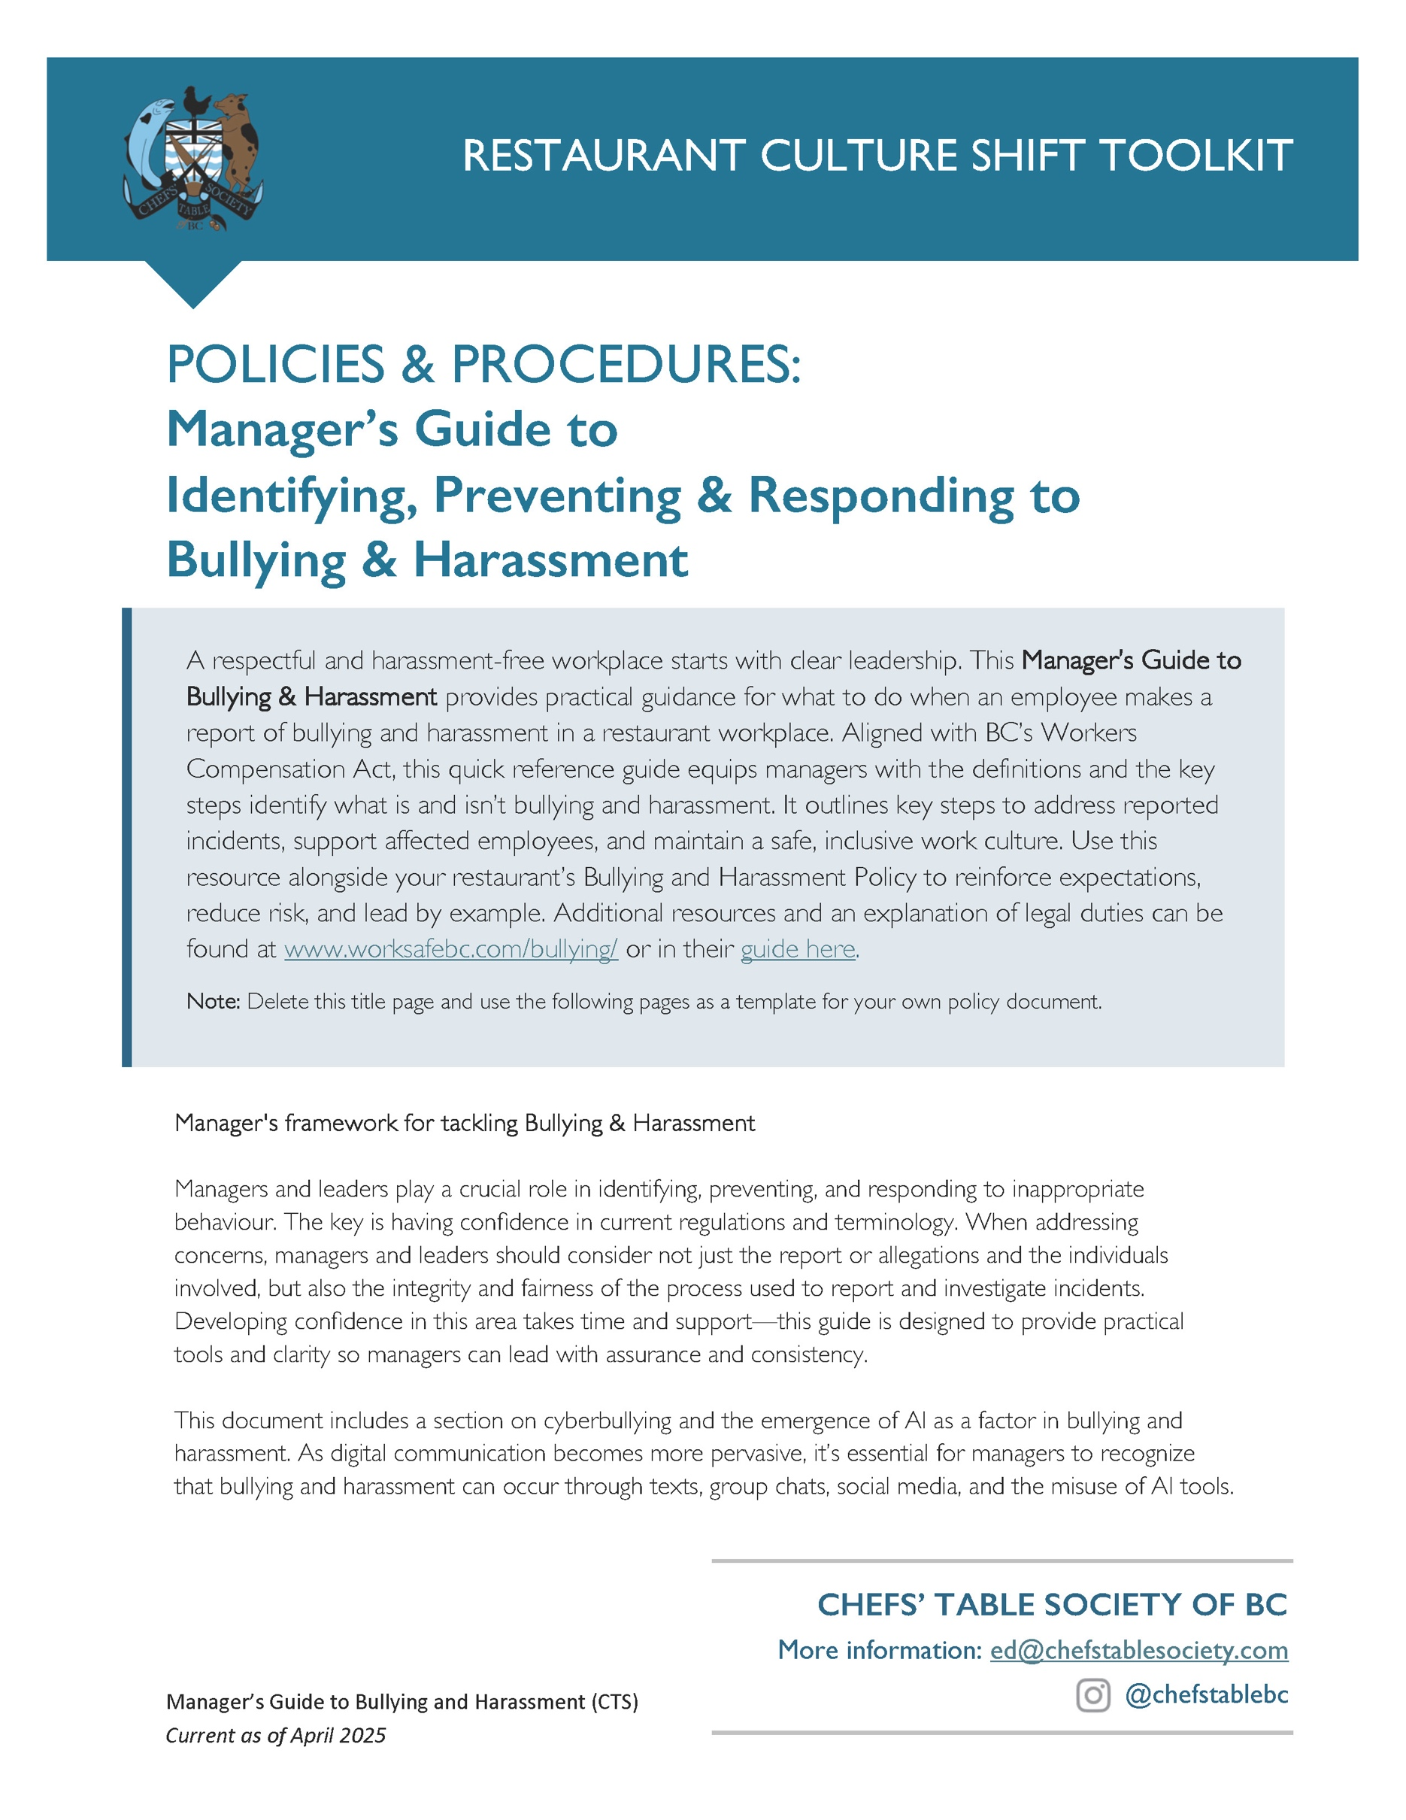
MANAGER’S GUIDE to
Identifying, Preventing & Responding to Bullying & Harassment
What is Bullying & Harassment?  Any inappropriate conduct or comment by a person towards a worker that the person knew or reasonably ought to have known would cause that worker to be humiliated or intimidated. This includes:  - verbal aggression or insults  - calling someone derogatory names  - harmful hazing or initiation practices  - vandalizing personal belongings  - spreading malicious rumours  - unwelcome sexual suggestions, requests  - unwelcome touching or physical contact  - cyberbullying and online harassment.  Bullying & harassment is usually, but not always, part of a pattern or repeated actions. | Important Exceptions  The terms ‘bullying’ and ‘harassment’ do not include reasonable actions relating to the management and direction of workers, including instructions or expectations, communicated professionally, concerning matters such as:  - Job duties and work to be performed  - Workloads and deadlines  - Layoffs, transfers, promotions, and reorganizations  - Work instruction, supervision, or feedback  - Work evaluation  - Performance management  - Discipline, suspensions, or terminations
Management Responsibilities Managers and Supervisors must, in all circumstances:
- Always lead by example, with integrity, professionalism, respect and courtesy.
- Take all reported concerns seriously.
Listen without judgment, and treat every report—verbal or written—with respect, discretion, and urgency.
- Remain engaged to identify, intervene and prevent bullying and harassment.
- Recognize That Harassment Can Be Subtle or Digital.
Pay attention to exclusion, passive-aggressive behaviour, repeated microaggressions, or misuse of authority — and don’t overlook digital channels. Cyberbullying (via text, email, group chats, or social media) can damage trust and team morale just as much as in-person behaviour.
- Focus on Impact, Not Intent.
What matters is how behaviour affects the recipient, not whether it was “meant as a joke.” Don’t dismiss harm based on intentions.
- Document and Act Promptly.
Take detailed notes, maintain confidentiality, and initiate the appropriate follow-up or investigation process outlined in your workplace policy.
- Create a Culture of Respect.
Model respectful conduct. This means managers must never engage in conduct that could be perceived as bullying or harassment. Make it clear that your workplace doesn't tolerate bullying or harassment — in any format, from any source (including customers or vendors).
- Support All Parties Fairly.
Be impartial. Offer support to anyone impacted and ensure those accused have the opportunity to respond appropriately and respectfully.

Responding to Formal Bullying & Harassment Allegations
- Review WorkSafeBC’s Bullying & Harassment Guidance on https://www.worksafebc.com/bullying and gain familiarity with terms & procedures.
- Demonstrate that all complaints/allegations are taken seriously and will be investigated.
- Insist that bullying/harassment allegations be articulated clearly in writing, including details of the specific words/actions.
- Use opportunities to educate, emphasizing the following practical messages:
  - When possible, we must advise ‘bullies’ that we do not appreciate the conduct and ask that it stop.
  - We must appreciate that the words ‘bullying’ and ‘harassment’ are serious words, to be used seriously and applied vigorously when the occasion warrants their use.
  - We must not trivialize, cheapen or devalue their importance by using these terms as loose labels
to describe petty acts or foolish words, where there is no intent to harm and such harm, if any, is fleeting.
  - All interpersonal disputes and unprofessional behaviour will be addressed and corrected, even if it does not amount to ‘bullying’ or ‘harassment’.
- Refer employee to your company’s applicable Bullying & Harassment Prevention Policy, including reporting and investigation procedures.
- Assure the employee of a timely investigation; provide updates on investigation progress and conclusion; follow-through and complete the investigation.
- Report to senior management – seek further advice, even for matters that might seem trivial.
Cyberbullying and the Digital Workplace
Bullying and harassment can happen in person, in writing, or through digital platforms—including text messages, email, social media, messaging apps (e.g. WhatsApp, Slack), or workplace systems. Cyberbullying may include:
- Spreading harmful or false information online
- Repeated negative comments or targeted exclusion in group chats
- Harassing messages or inappropriate memes/gifs/images
- Public shaming or ridicule via digital channels
- Impersonating someone or using fake accounts to harm or embarrass others
Digital misconduct is workplace misconduct when it affects the well-being or safety of staff—even if it happens outside work hours or off-site.

Artificial Intelligence (AI) and Emerging Technology Misuse
With the rise of generative AI and digital tools, new forms of inappropriate behaviour are emerging. AI misuse in a bullying or harassing context might include:
- Creating or sharing AI-generated content (e.g. deepfakes, altered images, or fake text) that humiliates, threatens, or targets an employee
- Using AI tools to mimic, mock, or impersonate co-workers maliciously
- Generating content (like messages or images) meant to intimidate, embarrass, or spread misinformation about a colleague
All employees and managers should treat digital and AI-related misconduct with the same seriousness as face-to-face harassment. Technology does not excuse or hide abusive behaviour—and all staff must be held accountable for how tools are used.

