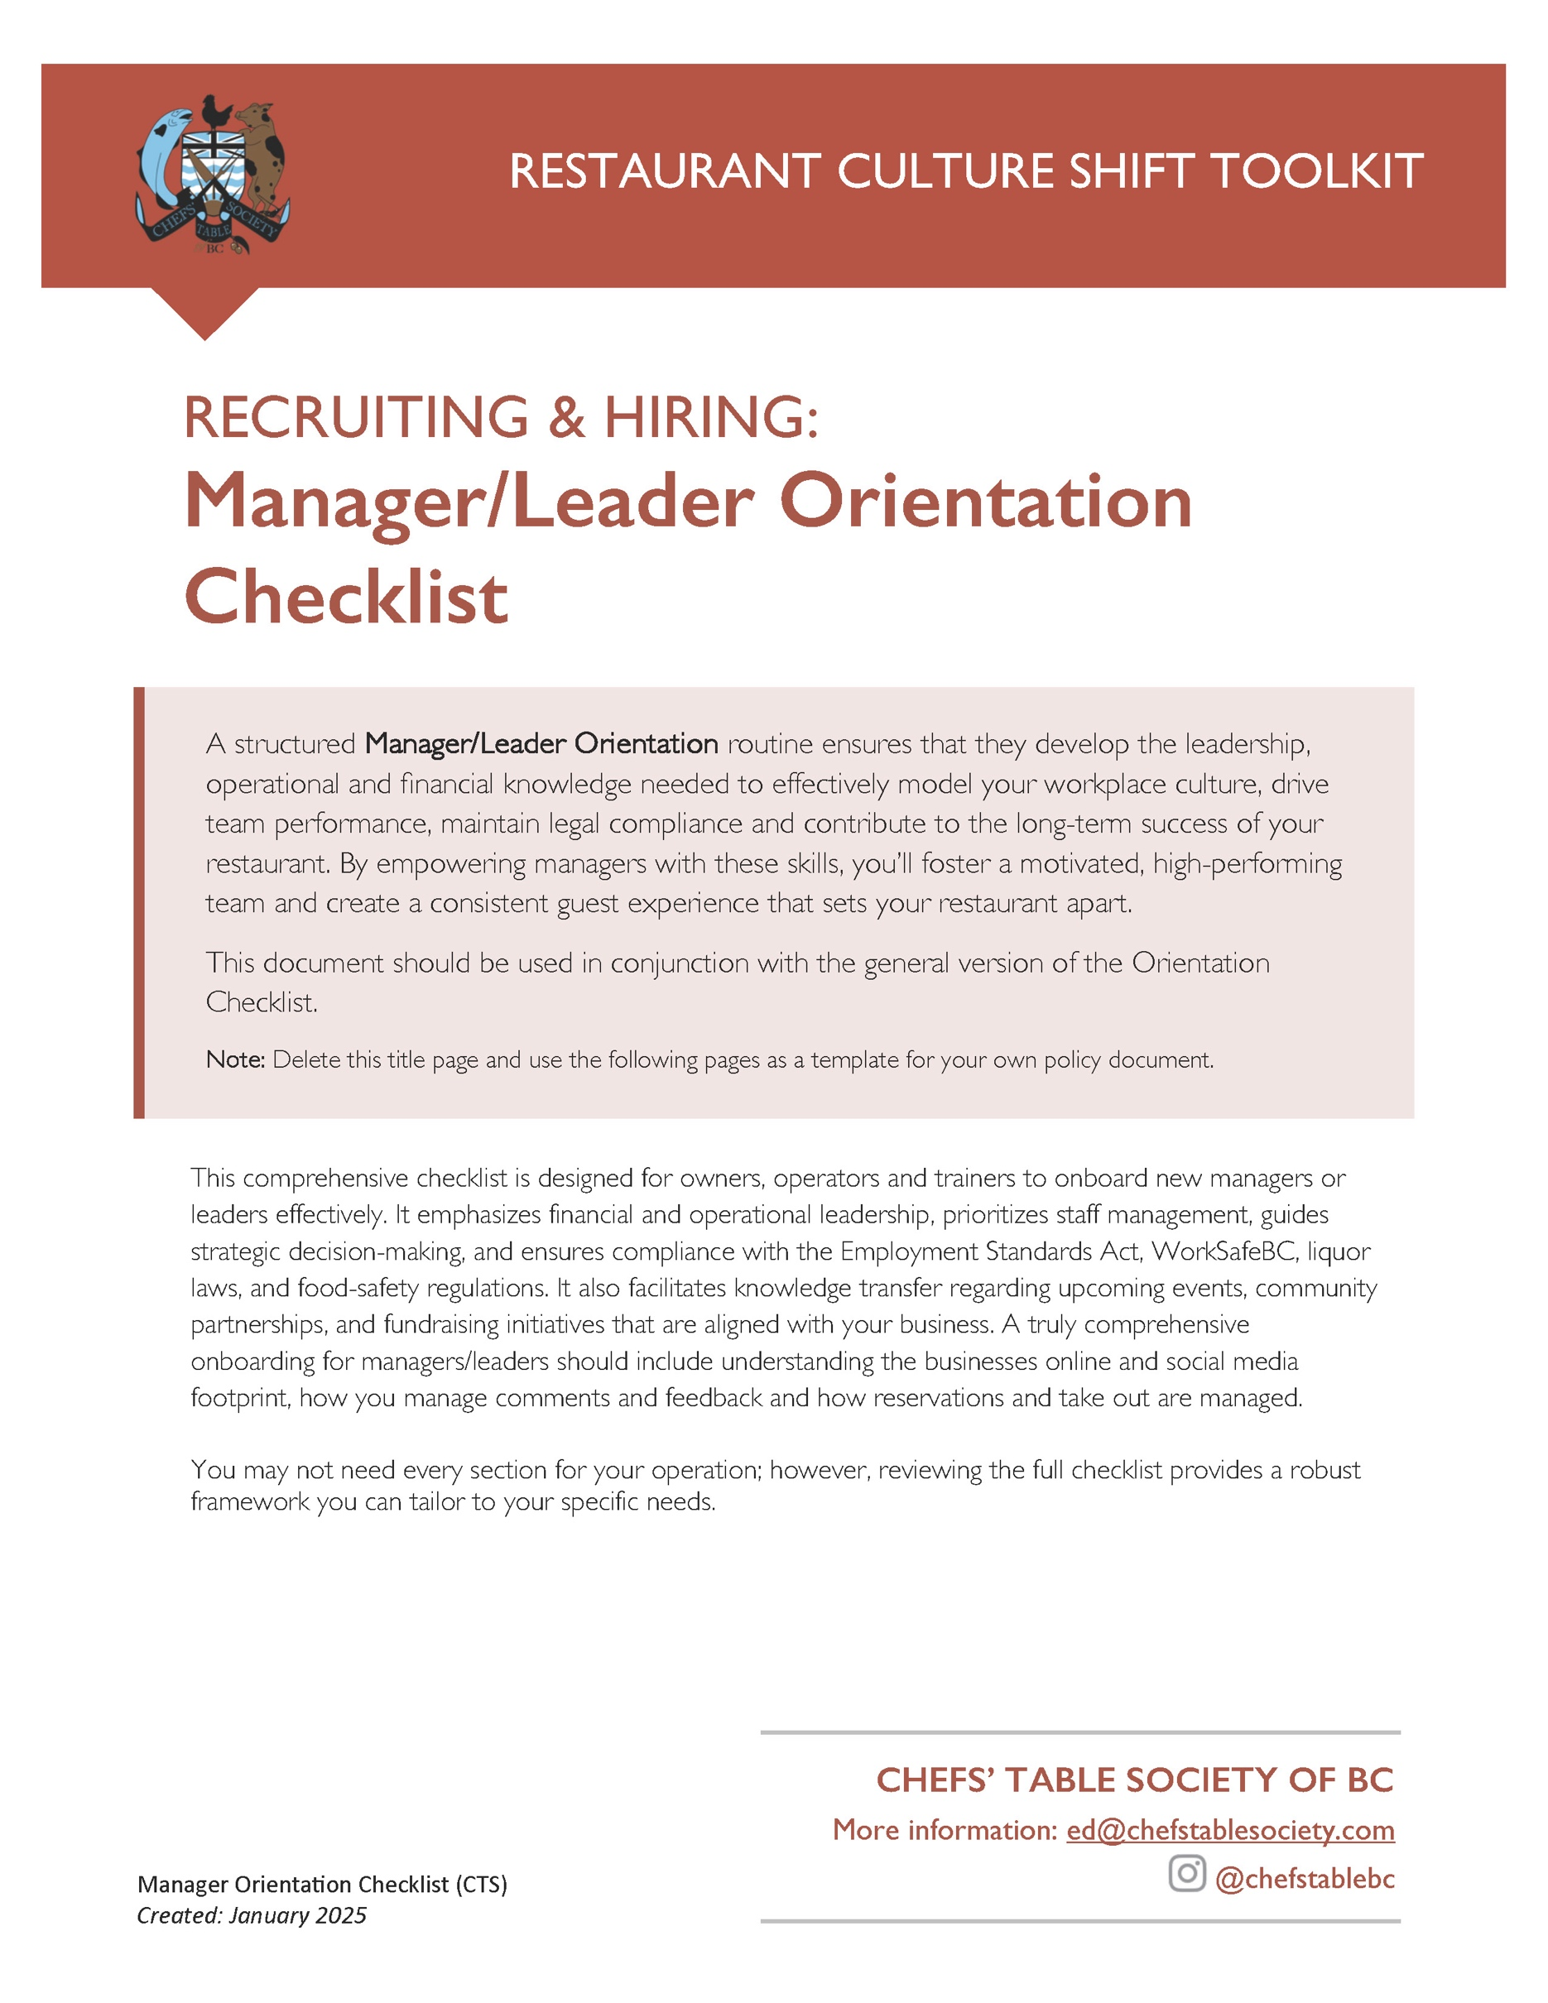

[Restaurant Name]
Manager/Leader Orientation Checklist
Created: ________________
Updated: ________________

PRE-ORIENTATION PREPARATION
- Set up the new manager's workspace with necessary tools, technology, and access credentials before their first day.
- Consider sending a welcome email that includes the employee handbook, organizational chart, and a personalized welcome note, especially if they will be managing folks from day 1.
FIRST WEEK

Integrate the manager/leader into the workplace culture

- Introduce the restaurant’s mission, vision, and core values. Provide real-life examples of how these values are brought to life in leadership and decision-making.
- Share the leadership structure, reporting lines, and communication expectations. Ensure the manager understands their position within the chain of command: who they report to and who reports to them.
- Train the new leader on the style of people motivation that is reflective of your restaurant culture.
- Demonstrate your restaurant culture around leading pre-shift meetings, engaging staff, and setting the tone for service.
- Teach your team communication protocols for meetings, check-ins and reporting.
- Present the process for staff to provide feedback and the process for managers to action or respond to the feedback. Include conflict resolution and disciplinary process and the role this manager/leader will take in handling workplace issues.
- Include training on cultural competency and bias awareness to strengthen team dynamics and enhance guest interactions.
- Assign a mentor or buddy from the existing leadership team to provide guidance and support during the initial transition period.
- Share stories of how your company recognizes and celebrates successes and innovations by team members and invite the new manager to contribute their own ideas and passion for recognition.
- Explain how your company is putting an emphasis on mental health and well-being for your team members and what strategies or resources are available for dealing with anxiety, stress and burnout in your workplace. Under this theme also address the importance of stress management and mental well-being for managers/leaders themselves, given the demanding nature of the role.
- Provide an overview of the restaurant's history, including key milestones and achievements, to give context to its current position and future goals.
- Highlight any sustainability initiatives, such as waste reduction programs or energy-saving practices, and the manager's role in these efforts. Sustainability is a core value for many young workers and needs to be front of mind for training new hires who will work under this person.

Train on business operations & financial oversight:

- Review the company wide sales goals, key performance indicators (KPIs), and financial targets. Explain how this position contributes to these goals and which specifically fall under the responsibility of this manager/leader.
- Train the new manager/leader on your budget, financial reports and cost control procedures including daily and weekly reporting, inventory tracking, sales reports, and profit margins.
- Showcase company best practices on how to manage labour costs, create efficient schedules and adjust based on business needs.
- Show how to read and analyze Profit & Loss (P&L) statements to make informed business decisions.
- Train on POS, scheduling software, inventory management. Indicate how to use the systems to track costs, pull numbers and to develop relevant reporting.
- Share cash handling, banking procedures and deposit policies [if applicable].
- Review company policies for theft prevention.
- Introduce the manager to key contacts in the finance and accounting departments for ongoing support and clarification.

Technology and Systems Training:
- Provide an overview of all relevant IT systems, including email, internal communication platforms, POS systems, scheduling software or any other specialized software used by your restaurant.​
- Educate on data protection protocols and the importance of maintaining customer and company confidentiality.
- Communicate your password and 2-factor authentication processes vis-à-vis use of personal devices, phones and emails for work.
- Ensure the new manager understands the company website, the company Google listing and any ordering or reservations platforms and their role in managing any and all of these.

Integrate kitchen and culinary managers/leaders (only):

- Deep dive into the menu, the sourcing and related supplier relationships.
- Highlight your restaurant’s sustainability initiatives, such as local sourcing, waste reduction, and eco-friendly practices, and involve the manager in improving these efforts.
- Introduce food safety plans, emergency procedures in the kitchen, and WorkSafeBC regulations.
- Walk through inventory management, waste logs and First In, First Out practices to reduce food waste, and portion control to minimize cost of goods sold (COGS).
- Provide a thorough understanding of BC Food Safety regulations, including HACCP procedures, sanitation protocols, and health inspection preparation.
- Arrange for the manager to spend time shadowing each kitchen station to understand workflows and team dynamics.​

Review compliance with legal & safety regulations:

- Go over payroll and scheduling including how and when wages are paid, how tip pool is administered by staff, illness & injury days and shift swapping policies.
- Review BC Employment Standards Act regulations for scheduling, overtime, breaks, statutory holidays, time between shifts, averaging agreements (if you are using them) and termination.
- Educate on BC-specific liquor laws, Serving It Right responsibilities, and procedures for handling intoxicated guests.
- Review WorkSafeBC safety protocols, including injury reporting and staff safety training requirements.
- Go into detail about your company policies preventing bullying and harassment and discrimination in your workplace and the process for reviewing and mitigating issues that are reported. WorkSafeBC Bullying and Harassment regulations provide clear standards around training and implementing effective policies in this space.
- Provide guidance on ethical decision-making and handling situations that may pose conflicts of interest.
- Conduct a mock health and safety inspection to reinforce compliance expectations.
- Provide step by step instruction for inspection readiness including health inspections, liquor audits, and labour compliance checks.
- Ensure the manager completes any mandatory compliance training sessions or certifications required by provincial or federal law.​

Review company people management & HR practices:

- Guide the manager through the hiring process, including recruitment strategies, interviewing techniques, and onboarding procedures.
- Provide orientation to front-of-house (FOH) and back-of-house (BOH) training expectations and cross-training opportunities.
- Review company guest service expectations from both FOH and BOH perspectives.
- Teach how your company provides constructive feedback, conducts stay interviews or one-on-one coaching sessions, documents employee performance and sets improvement plans.
- Explain the performance review process, including timelines, criteria, and how feedback is delivered and documented.
- Coach on workplace culture strategies, team engagement initiatives, and retention best practices.
- Role-play conflict resolution scenarios and disciplinary conversations to build confidence in handling staff issues.
- Provide access to leadership development resources and mentorship opportunities.
- Emphasize how managers should uphold and enhance the guest experience, especially during peak times or challenging situations.
    - Use role play situations to observe and discuss guest interactions to identify areas for enhancing customer satisfaction.
    - Demonstrate techniques for managing difficult guests or complaints and turning negative experiences into positive outcomes.
- Train on best practices for reservations, waitlists, large party coordination, VIP guest service and no shows.

Go into detail about your customer experience expectations:

- Detail your brand standards and expectations for customer interactions to ensure consistency in guest experiences.​
- Introduce systems that are in place for collecting and responding to customer feedback and how frequently feedback channels (eg. Facebook, Instagram, Yelp, Tripadvisor) need to be reviewed and responded to.
- Discuss how take-out, delivery and third-party delivery are managed and what the service expectations are with regards to these service methods.
Train on restaurant specific operational procedures:

- Review key responsibilities and performance expectations for the position. Explain daily leadership responsibilities, including shift management, team motivation, and guest experience oversight.
- Demonstrate your company process for effective communication between FOH and BOH teams and how this new hire engages with this process. Include managing ticket flow, timing coordination, and BOH communication.
- Explain maintenance procedures that fall into their domain, including how to report equipment failures who to call for repairs and schedule preventative maintenance.
- Run through real-life disruptions that could influence this manager/leader and their team (e.g., short staffing, guest complaints) and problem-solving strategies.
- Introduce all vendors and suppliers that this new hire will work with as well as the process for ordering schedules, managing orders, invoices, and deliveries from these partners as well as invoice reconciliation.
- Talk about your local impact by introducing the manager to local vendors, community partners, and any ongoing local initiatives.
- Provide access to key training materials for positions that report to this role.
- [When applicable] Train the new hire on managing the restaurant's online presence, including responding to reviews and engaging with customers on social media.

Prepare for emergencies & crisis management:

- Implement scenario-based training for handling unexpected situations like health crises or supply chain disruptions to test problem-solving skills and adaptability.
- Review emergency protocols, including fire evacuation plans (include clear steps for leading staff and guests out safely) and medical response procedures.
- Train on power outage and equipment failure response, including contacting vendors or service technicians.
- Demonstrate proper handling of intoxicated guests to ensure legal compliance and guest safety.
- Ensure the manager knows the location of first aid kits, emergency exits, and incident reporting procedures.

Leadership integration:

- Assign shadowing shifts with senior leadership to observe decision-making and operations.
- Pair the new manager with a seasoned leader for mentorship and regular check-ins.
- Inspire creative thinking by challenging the manager to propose one new guest experience initiative within their first 90 days.
- Encourage the manager to lead a pre-shift meeting and manage a service independently as a final evaluation.
- Set clear 30/60/90-day performance goals. Provide an opportunity to solicit and include staff feedback in these reviews.
- Conduct regular leadership check-ins, either weekly or biweekly, with ownership or GM to ensure the new leader/manager has an opportunity to ask questions and address issues as they arise.

Review your Community and Marketing engagement strategy:
- Talk about any preferred partnerships in the community. Restaurants are always asked for donations: if you have preferred partners (eg. Food program, kids charity or pet charity) make sure the manager knows so that they only consider requests that fit with your brand.
- Discuss any formal partnerships, fundraisers or programs with local organizations and talk to the manager/leader about how they or their department are involved.​
- Provide an overview of current marketing efforts and the manager's role in promoting events or specials.​
FIRST WEEK WRAP UP

As with all new employees, after a week, it’s a good time to review how the new worker is integrating into the workplace and to review the onboarding and training to date.
- Meet with the new manager/leader to discuss their experience so far.
- Review the best practices for the position to make sure the person has all the info they need to do a good job.
- Ask about challenges, concerns, or questions they may have; encouraging them to share observations or ideas for improvement.
- Discuss any challenging interactions that have happened to ensure the new hire knows how to handle difficult situations with confidence.
- Ensure they understand essential job responsibilities, operational procedures. scheduling procedures, shift expectations, and sick leave policies.
- Confirm they are comfortable with menu items, POS systems, and customer service expectations.
- Reiterate expectations around teamwork, communication and workplace culture.
- Address any gaps in training and provide additional support if needed.
- Answer any lingering questions about policies or workplace conduct.
- Discuss any concerns they have around leading others and conveying/enforcing company policies to their direct reports.
- Set clear expectations for the next phase of their training or job responsibilities.

Employee Acknowledgment Form 

Have the new employee and their supervisor formally acknowledge that all onboarding steps have been followed, that they have completed and understood the initial phase on training and onboarding. Two template options, basic and detailed, are available in this toolkit.

This will make sure that your company is complying with corporate responsibilities under WorkSafeBC and employee health and safety.

