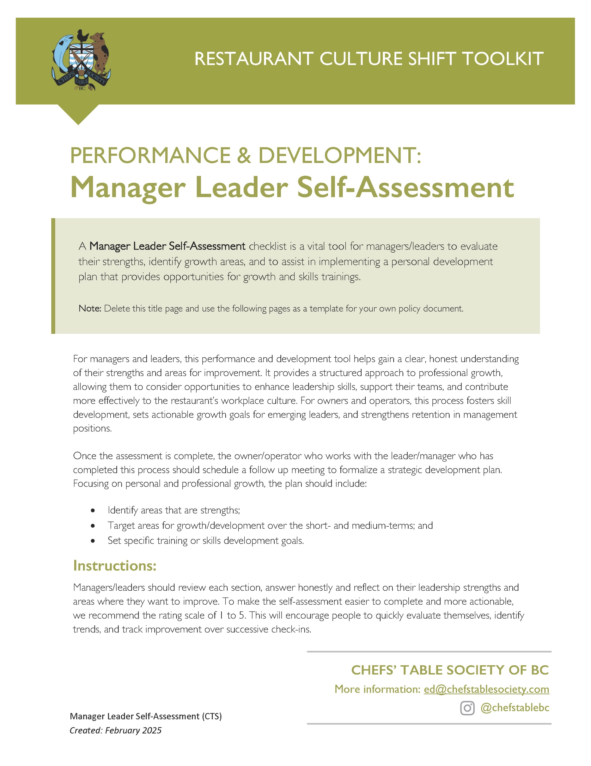

[Restaurant Name]
Manager Leader Self-Assessment &
Skills Development Checklist

Manager/Leader Name: _________________________
Review Completed: _________________________

The Rating Scale
For each question, rate yourself on the scale of 1 to 5 and add one or two key takeaways to guide your personal and professional development plan:
I identify this as a strength and I am confident to share my skill/knowledge with others. | 5
I am confident but I could use some formal skills development and/or training to help me excel. | 4
I understand this work but need more confidence to be consistent. | 3
I struggle in this area and would benefit from training and/or support. | 2
This is a clear gap area for me and I want to skill-up. | 1

Manager Leader Self-Assessment:

Leadership & Team Management
Do I effectively communicate expectations, goals, and feedback to those that report to me? | 1 | 2 | 3 | 4 | 5
Am I handling conflict situations with fairness and professionalism? | 1 | 2 | 3 | 4 | 5
Am I active in coaching and developing my team members to improve skills and performance? | 1 | 2 | 3 | 4 | 5
Am I leading by example in professionalism, attitude, and work ethic? | 1 | 2 | 3 | 4 | 5
Am I building +/or supporting a positive workplace culture that fosters teamwork and retention? | 1 | 2 | 3 | 4 | 5
MY CURRENT  LEADERSHIP DEVELOPMENT  GOALS ARE: | THE SKILLS TRAINING +/or  CERTIFICATIONS I WANT TO PURSUE TO SUPPORT THESE GOALS ARE:

Business & Financial Acumen
Am I confident with the restaurant’s financial goals and my role/my team’s contribution to the financial success? | 1 | 2 | 3 | 4 | 5
Am I able to review and understand [financial reports, POS reports or P&L statements] to make data-driven decisions? | 1 | 2 | 3 | 4 | 5
Am I effective negotiating and managing the vendor relationships under my purview? | 1 | 2 | 3 | 4 | 5
Am I able to effectively manage labour costs and scheduling using the POS/shift scheduling software? | 1 | 2 | 3 | 4 | 5
Do I have confidence using tools to monitor sales performance, guest counts, and revenue trends? | 1 | 2 | 3 | 4 | 5
Do I have training and tools to manage inventory, food costs, and waste reduction effectively? | 1 | 2 | 3 | 4 | 5
MY CURRENT  BUSINESS & FINANCIAL  GOALS ARE: | THE SKILLS TRAINING +/or CERTIFICATIONS I WANT TO PURSUE TO SUPPORT THESE GOALS ARE:

Restaurant Operations & Compliance
Am I using my experience and the tools provided to ensure smooth day-to-day service operations? | 1 | 2 | 3 | 4 | 5
Do I have the knowledge of BC Food Safety regulations and health and safety regulations to lead in this area? | 1 | 2 | 3 | 4 | 5
Do I feel confident enforcing current liquor laws, including Serving It Right policies and ensuring the FOH team offer responsible alcohol service? | 1 | 2 | 3 | 4 | 5
Do I have the tools and protocols to be proactive in managing maintenance, repairs and emergency protocols? | 1 | 2 | 3 | 4 | 5
Do I have a strong handle on emergency action plans for power outages, injuries or security incidents? | 1 | 2 | 3 | 4 | 5
MY CURRENT  RESTAURANT OPERATIONS  GOALS ARE: | THE SKILLS TRAINING +/or  CERTIFICATIONS I WANT TO PURSUE  TO SUPPORT THESE GOALS ARE:

Guest Experience & Service Standards
Am I confident handling guest complaints and supporting staff in turning negative experiences into positive ones? | 1 | 2 | 3 | 4 | 5
Is the regular training I am offering Front of House and Back of House ensuring the delivery of exceptional hospitality? | 1 | 2 | 3 | 4 | 5
Am I proactive in identifying ways to enhance the guest experience and support team members in enhancing the guest experience? | 1 | 2 | 3 | 4 | 5
Am I confident managing reservations, VIP experience and large party coordination? | 1 | 2 | 3 | 4 | 5
Do I have the tools and techniques to use POS systems data to analyze guest feedback? | 1 | 2 | 3 | 4 | 5
MY CURRENT  RESTAURANT OPERATIONS  SKILLS GOALS ARE: | THE SKILLS TRAINING +/or  CERTIFICATIONS I WANT TO PURSUE  TO SUPPORT THESE GOALS ARE:

Growth & Development
Am I confident asking for +/or receiving feedback from my team, peers and leadership? | 1 | 2 | 3 | 4 | 5
Do I feel confident speaking to my reports about their role/contribution and helping to support their growth with the company in one-on-one conversations? | 1 | 2 | 3 | 4 | 5
Do I have the skills/confidence to deal with the personal challenges that my reports are currently facing, including mental health challenges? | 1 | 2 | 3 | 4 | 5
Am I adaptable and confident in the face of challenges and high-pressure situations? | 1 | 2 | 3 | 4 | 5
Am I dedicating the time to manage my reports for success? | 1 | 2 | 3 | 4 | 5
Am I able to take the time to manage my key responsibilities? | 1 | 2 | 3 | 4 | 5
Am I managing my personal stress and self-care so I can lead with authenticity? | 1 | 2 | 3 | 4 | 5
MY CURRENT  PERSONAL GROWTH & PROFESSIONAL DEVELOPMENT GOALS ARE: | THE SKILLS TRAINING +/or  CERTIFICATIONS I WANT TO PURSUE  TO SUPPORT THESE GOALS ARE:

[Restaurant Name]
Manager Leader Next Steps
Professional Development Action Plan
Based on the discussion facilitated by the process above, you can use this grid to formalize the Manager/Leader’s Professional Development Action Plan and summarize how the plan can be achieved, what success looks like and what rewards are benchmarked to those successes.
Employee Name: ____________________________
Manager/Leader: ____________________________
Date of Plan: ____________________________
PERSONAL & PROFESSIONAL GROWTH STATEMENT:
AREAS OF STRENGTH TO FURTHER DEVELOP:
1 LEADERSHIP & TEAM MANAGEMENT GOAL incl DESCRIPTION:
TIME FRAME FOR ACHIEVEMENT | SUPPORTER FOR THIS GOAL | RECOGNITION IF THE GOAL IS ACHIEVED
- BUSINESS & FINANCIAL MANAGEMENT GOAL incl DESCRIPTION:
TIME FRAME FOR ACHIEVEMENT | SUPPORTER FOR THIS GOAL | RECOGNITION IF THE GOAL IS ACHIEVED
3 RESTAURANT OPERATIONS & COMPLIANCE GOAL incl DESCRIPTION:
TIME FRAME FOR ACHIEVEMENT | SUPPORTER FOR THIS GOAL | RECOGNITION IF THE GOAL IS ACHIEVED
4 GUEST EXPERIENCE & SERVICE STANDARDS GOAL incl DESCRIPTION:
TIME FRAME FOR ACHIEVEMENT | SUPPORTER FOR THIS GOAL | RECOGNITION IF THE GOAL IS ACHIEVED
5 GROWTH & DEVELOPMENT GOAL incl DESCRIPTION:
TIME FRAME FOR ACHIEVEMENT | SUPPORTER FOR THIS GOAL | RECOGNITION IF THE GOAL IS ACHIEVED
TRAINING(S), COURSE(S) or CERTIFICATION(S) GOALS:
TRAINING DESCRIPTION | SUPPORTER FOR THIS GOAL | RECOGNITION IF THE GOAL IS ACHIEVED
NEXT 3 MEETING DATES:
NEXT STEPS:

