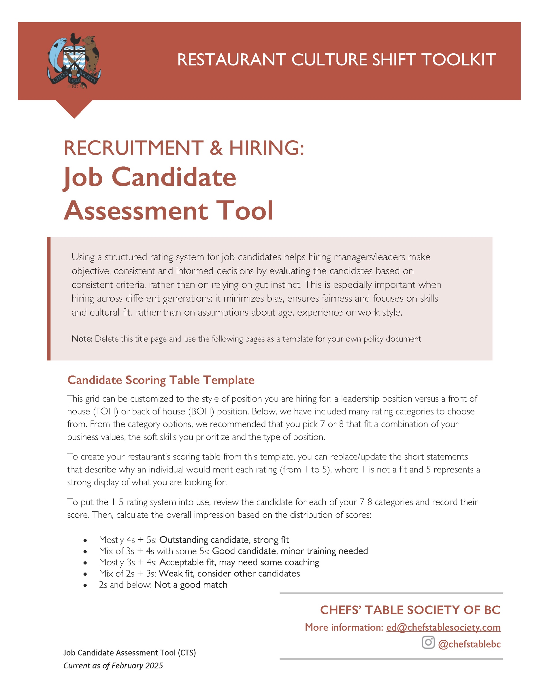

CANDIDATE NAME |  |  |  | CONTACT INFO
APPLYING FOR |  |  |  | DATE
INTERVIEWER 1 |  |  |  | INTERVIEWER 2
 |  |  |  | SCORE
CATEGORY | CRITERIA | 1 - POOR | 2 - FAIR | 3 - GOOD | 4 – VERY GOOD | 5 - EXCELLENT | SCORE
 |  | To score the candidate, check the statements for each rating and find alignment.
Cultural Fit  All positions | Aligns with restaurant values, attitude, and is able to be a team player | Does not align. Can-do attitude seems lacking. | Some mis-alignment, not confident in a teamwork setting. | Generally fits, appears open-minded. | Strong alignment. Has a can-do attitude. | Cultural fit, shows good enthusiasm. | __/5
Cultural Fit  All positions | COMMENTS:
Teamwork & Collaboration  All positions | Works well with coworkers, supports the team | Seems to prefer working alone. Feels resistant to new ideas. Struggles with communication. | Shows willingness to work with others but appears hesitant to communicate. | Shows flexibility and the ability to adjust when needed. Seems to enjoy teamwork. | Highly adaptable, shows good examples of being a team player. Proactive communicator. | Thrives in teamwork. Proactive problem solver that prides themselves on leading by example. | __/5
Teamwork & Collaboration  All positions | COMMENTS:
Work Ethic & Reliability  All positions | Punctuality, responsibility, willingness to go the extra mile | Appears unreliable or unmotivated. | Shows some responsibility but appears inconsistent. | Shows good examples of their reliability. | Shows initiative, good examples of taking responsibility. | Highly dependable, eager to contribute. | __/5
Work Ethic & Reliability  All positions | COMMENTS:

Passion, Enthusiasm & Attitude  All positions | Shows genuine interest in the role. Has passion for culinary or great service. | No passion, just looking for a job. Lacks energy. | Shows interest but lacks enthusiasm. Neutral attitude. | Displays interest and a willingness to improve. Asks good questions. | Passionate about their craft. Eager to grow, came prepared. | Highly motivated, committed to personal excellence. | __/5
Passion, Enthusiasm & Attitude  All positions | COMMENTS:
Handling Pressure  All positions | Ability to stay calm and work efficiently under stress | Not able to showcase examples of when they have handled stress or show problem solving. | Lacks confidence but expressed good instincts for how they might manage stressful situations. | Provided solid examples of how they would handle challenging situations. | Appears to work efficiently under pressure with experience navigating stress. | Thrives in fast-paced environment. Able to showcase how they stay composed. | __/5
Handling Pressure  All positions | COMMENTS:
Adaptability & Problem-Solving  All positions | Handles stress, adjusts to changing situations | Appears easily flustered, not able to convey how they would respond to scenarios. | Shows adaptability. Hesitant but willing to suggest problem solving ideas. | Can adjust and problem-solves with help. Shows willingness to seek help/advice. | Adaptable, thinks quickly under pressure. | Thrives in challenges. Finds solutions independently. Appears calm under pressure. | __/5
Adaptability & Problem-Solving  All positions | COMMENTS:
Communication Skills  All positions | Clarity, professionalism, and ability to engage with guests | Poor communicator.  Unclear responses. | Basic communication skills. Is hesitant or lacks confidence. | Communicates well, needs some polish. | Clear, confident and professional. Engages well. | Engaging, clear communicator.  Builds rapport easily. | __/5
Communication Skills  All positions | COMMENTS:
Customer Service  FOH positions + Managers/Leaders | Friendliness, attentiveness, handling guests’ needs | Struggles to communicate. Didn’t break out of their shell. | Communicates effectively but lacks confidence and warmth. | Good customer service. Needs some development. | Warm, attentive, willingness to make guests feel welcome. Proactive attitude. | Strong service mindset. Friendly demeanor. | __/5
Customer Service  FOH positions + Managers/Leaders | COMMENTS:
Culinary Skills & Experience  Chefs or cooks | Knife skills, cooking techniques, food knowledge | Only basic skills, little experience. | Limited training but not a lot of experience.  Shows interest. | Shows technical skills and willingness to follow recipes/learn. | Strong skills. Ability to convey efficiency and creativity. | Highly skilled, able to execute complicated dishes. | __/5
Culinary Skills & Experience  Chefs or cooks | COMMENTS:
Speed & Efficiency  All positions | Ability to multitask, work in a fast-paced environment | Appears easily overwhelmed.  Hhasn’t been in fast paced environment before. | Relates to the pace of work but has no experience.  Needs support. | Seems able to convey how they would handle the fast pace. | Shows evidence of being fast and organized. | Appears efficient and has good examples of handling high volume with ease. Able to anticipate. | __/5
Speed & Efficiency  All positions | COMMENTS:
Menu Knowledge & Upselling  All positions | Shows investment by studying the menu before the interview, has ideas about the menu (creative or selling) | No knowledge of the menu. | Basic understanding. Struggled with sharing an item they wanted to try. | Understands the menu. Suggested some ideas (creative or selling) occasionally. | Shows good menu knowledge. Willing to make thoughtful recommendations. | Expert knowledge, confidently sells or speaks to the culinary program. | __/5
Menu Knowledge & Upselling  All positions | COMMENTS:
Cleanliness & Organization  Chefs and Cooks | Follows food safety, maintains a clean station | Disorganized, poor hygiene practices. | Needs reminders to stay clean and/or organized. | Keeps station tidy, follows health codes. | Very organized.  Maintains cleanliness. | Impeccable hygiene, highly organized, sets standard. | __/5
Cleanliness & Organization  Chefs and Cooks | COMMENTS:

