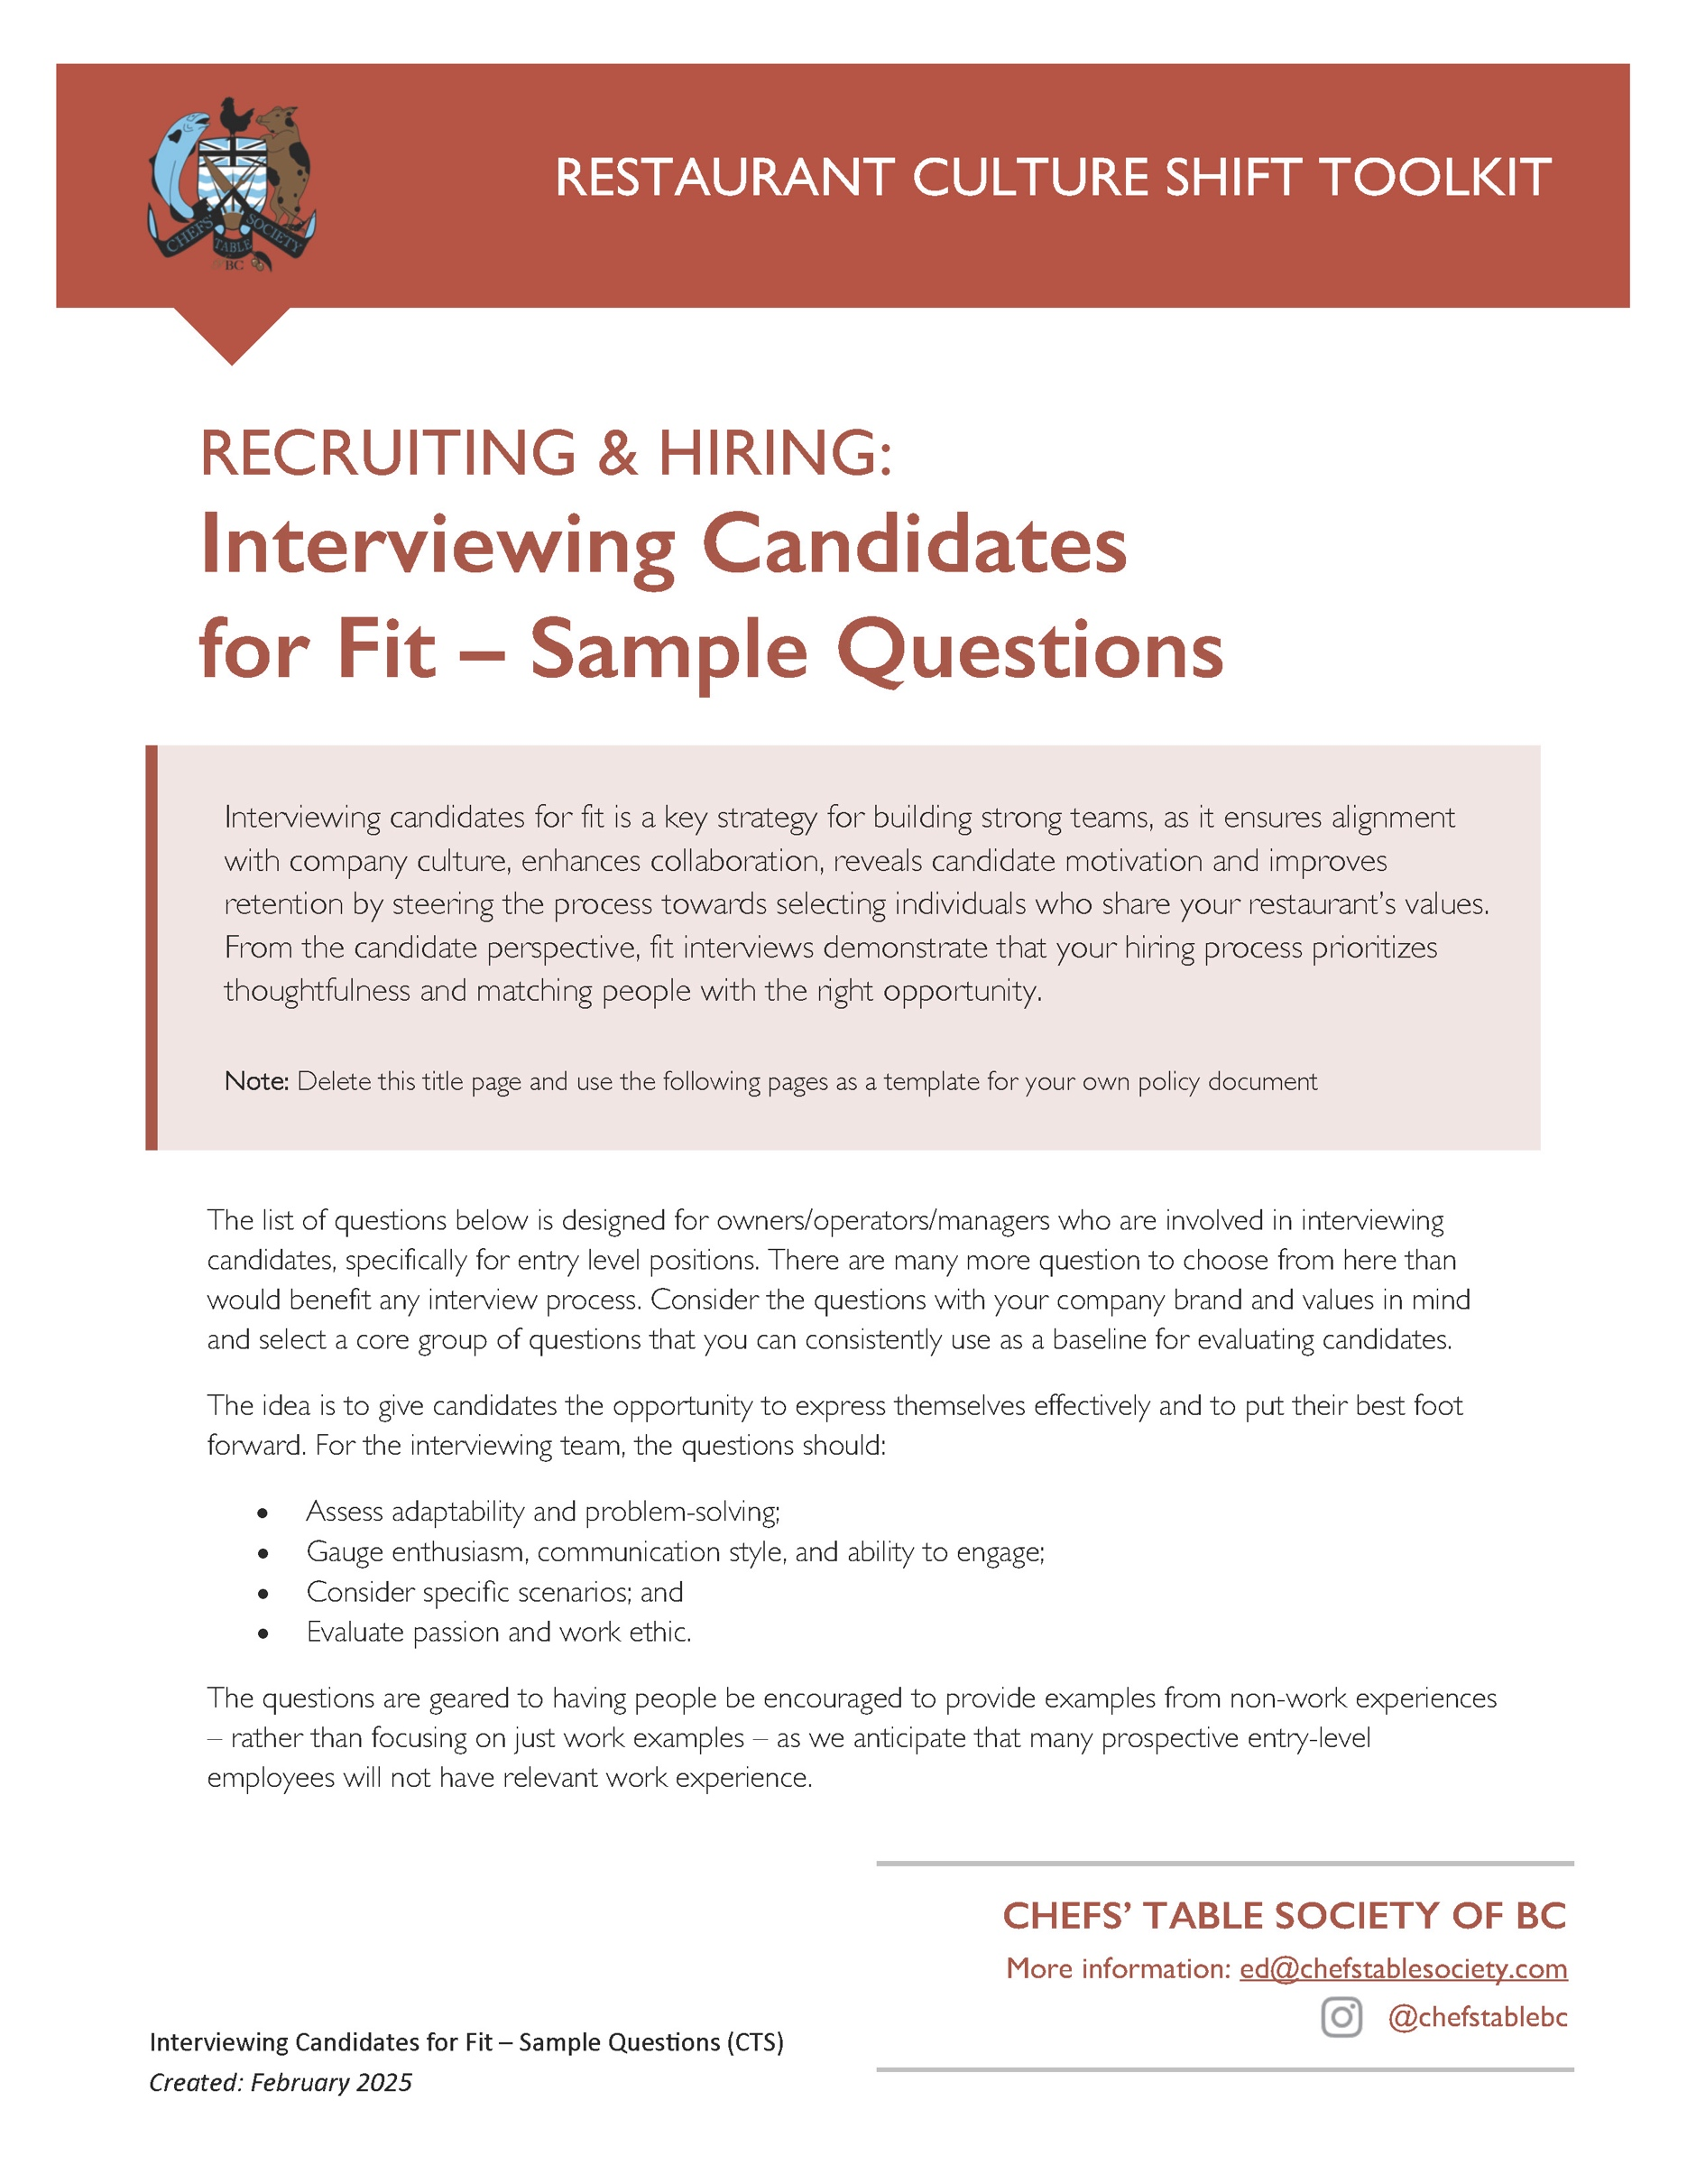
Interviewing Candidates for Fit

Beyond asking the right questions, how a person presents themselves can help assess the fit with your team. We recommend making room for questions that get you to see more of the person and what they value. When judging how a person presents themselves, it’s essential to consider factors like whether the prospective employee may have limited or no clothing that would be previously considered “interview outfits”, that they might have limited experience being interviewed or have language barriers. In addition, consider making room for the idea that not all candidates are able to share their experiences and showcase their personal successes effectively without some coaching on the part of the person conducting the interview. While this may reflect a lack of confidence, it does not directly impact their ability to be a great employee.

- Body Language and Presence: Candidates who actively listen and ask clarifying questions are more likely to engage well with customers and team members. Don’t judge this too quickly, some people need time to feel comfortable. Ask easy questions first and then add one that can help a candidate demonstrate their confidence.
- Presentation: If someone comes to your interview dressed how they would fit in with your business clothing standards, it’s a good sign they are paying attention to non-verbal cues. For positions in the front of house, attention to details is a great sign they will integrate into the team and be customer focused. For less professional presentations, consider whether the chosen outfit reflects a personal style that may not fit with your business or whether the interviewee simply does not own clothing selections that would match the company style. The later can easily be solved if your company has a clothing allowance or provides uniforms.
- Self-Reflection: Candidates who can describe past challenges (of any sort) and reflect on how they grew from those experiences will have more self-awareness and confidence than counterparts who can’t answer those questions. They are more likely to hit the ground running in a dynamic restaurant environment. That said, be sure to prompt someone who is tentative to help them give examples of other non-work scenarios that showcase their teamwork, leadership or learning, as being comfortable in interviews is a learned skill that many new workers have not yet developed.

Library of Potential Questions

The mix of questions you choose should be selected to help you assess how well the candidate will align with your restaurant culture, if they have your must-have soft skills, how they will respond to day-to-day stresses and how they will integrate with the members of the team they will be working with.

Motivation:
- What excites you about the opportunity to work in a fast-paced environment like this?
- What inspired you to pursue a role in the restaurant industry?
- Why are you interested in working at our restaurant specifically?
- What are your long-term career goals, and how does this position fit into them?
- What do you hope to learn or gain by working here?
- How do you keep yourself motivated when dealing with repetitive tasks or long shifts?

Cultural Fit:
- What type of environment helps you do your best work? Why do you think you thrive in that kind of environment?
- Our team values [specific cultural values, e.g., collaboration, innovation, guest-first mindset]. How do these align with your own values?
- Are you comfortable working evenings, weekends, and holidays, which are often our busiest times? How do you keep your energy up to work these kinds of shifts?
- Tell me about a time when you had to adapt to a new group or workplace culture. What challenges did you face, and how did you overcome them?
- What values are most important to you? How do you ensure your actions align with those values?

Confidence:
- What do you do to stay positive and focused, especially when work gets demanding?
- What’s one skill or quality you bring that would make you a great addition to our team?
- What excites you most about working with our team, and how do you see yourself contributing to our success?

Communications Skills:
- Can you tell me a situation where you had to explain a complex situation or give instructions? What did you do to make sure the person you were speaking to understood?
- What role do you think communication plays in ensuring a great team dynamic?
- What is one thing you would do to help ensure clear communication with your colleagues at work?

Problem Solving:
Consider asking a question or two that will help you understand how a prospective employee thinks and how they problem solve. You can do this by proposing a scenario that is likely to happen in the day-to-day of the job they are applying for and then asking for how the person would navigate the situation. By identifying the situation, they aren’t required to have had the experience. The answer doesn’t even have to be right – it’s more about seeing if they can think on their feet and how confident they are to rely on themselves to problem solve.
- Can you describe a situation where something went wrong and the steps you took to address the issue?
- If you were working on the floor, and a guest ordered a special and it turns out when you place the order that the kitchen has run out. How would you handle this situation with the guest?
- If you have a conflict or misunderstanding with a friend, family member or coworker, what strategies do you use to help resolve it? Can you provide an example of when you’ve navigated a conflict situation like this?
- Can you give an example of when you’ve been under pressure and how you’ve handled it?
- How do you typically handle busy or high-pressure situations? Can you share an example?
- If a coworker calls in sick, and the team is short-staffed, how would you handle it?

Logic & Reasoning:
- If you have a guest that comes in and is being disruptive to people around them by talking loudly on the phone, how would you handle that situation?
- A guest places an order with a lot of customizations, and you are struggling to understand which are allergies and which are food preferences so you can explain it to the kitchen. How would you make sure you get the information from the guest and translate it back to the cooks to make sure there is no cross contamination?
- All of a sudden, the kitchen is incredibly busy and you and fellow cooks are having a hard time keeping up with orders. How would you address the situation with the servers so they can manage the guest experience?

Empathy:
- Imagine a guest is unhappy with their service or who insists on sending back their meal. How would you handle the situation?
- If you were to encounter a difficult customer, [examples would be many allergies, short temper, not wanting to wait] how would you help to make their experience at our restaurant better?
- Can you tell me about a time when you noticed a guest or co-worker or friend was upset or stressed? What did you do to help the situation, and what was the outcome?
- Describe a time when you went out of your way to help someone, whether it was a guest, coworker, or someone outside of work. What motivated you to take that action?
- You notice a teammate is struggling to keep up during a busy shift. What would you do?

Leadership Potential:
- In a situation where you have been the team leader [examples would be a school project, a sports team experience or a leadership in a workplace] what strategies did you try to encourage/motivate your team to be successful? How did it work out?
- Can you give an example of how you contributed to a positive team dynamic in a past school, volunteer or work setting?
- When you feel that someone you are working with on a project or a common task has done a great job and made an extra effort to contribute to a success, what would be your favourite way to show them you recognize their effort?
- What do you believe is the key to creating a great experience for both coworkers and guests?
- In your opinion, what makes a restaurant team successful, and how do you see yourself fitting into such a team?
- Who was your favourite manager/leader/teacher and why did you connect with their leadership style?
- What is an example of a situation with a leader where you didn’t respect a decision or how they handled a situation and why?
- If your team is short-staffed on a busy night, how would you ensure that guests still have a great experience?

Location:
Location is super important to discuss in terms of fit. If someone has to drive a long way, take transit, or walk late at night, it’s important to understand so you can consider the health and safety of the person if they join your team.
- We find people who live closer to our restaurant adapt better to our [long hours/shift work]. Do you live close to our business? How would you get into work?
- If they have a long commute: That sounds like a long commute to work. What makes you want to make that significant commitment to working with us?

Seasonal Worker Questions:
These questions help assess a candidate’s enthusiasm, adaptability, problem-solving skills, and fit for the unique challenges of a seasonal role. Given that many seasonal communities in BC have real challenges with housing and each town has a distinct personality, the two top questions that we recommend always be asked are (1) whether the person has a place to live and (2) what their non-work interests are. These will help you determine whether the candidate will be able adaptable to the community and make the most of their experience.
- Why are you interested in working in a [NAME] community this season?
- What do you hope to gain from working in this community during the [winter/summer/ski] season?
- You’ll be joining our operation in our busiest season. What would you do if you didn’t know the answer to a guest’s question or request?
- Tell me about a time when you had to learn something quickly on the job. How did you handle it?
- How would you approach working with a team made up of people from different backgrounds and with varying levels of experience?
- What do you know about our community?
- Have you checked out the housing situation in [region]? OR Have you secured housing for the [winter/summer] season?
- How do you plan to balance work with enjoying the lifestyle opportunities our [resort/community/town] offers?
- What do you like doing in your downtime?

