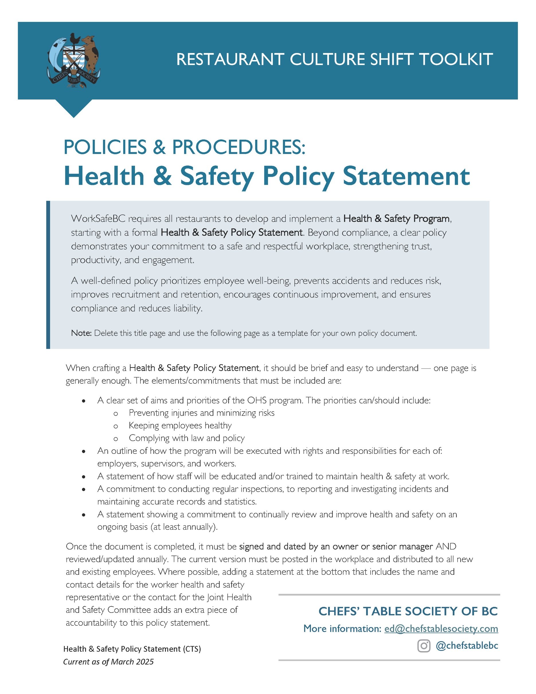

[Restaurant Name]
Health & Safety Policy Statement

[Restaurant Name] strives to provide a healthy and safe environment for our workers, supervisors, managers, and guests. To achieve this, [Restaurant Name] has established a Health and Safety Program and is committed to maintaining and improving it as necessary. Workplace health and safety is a shared responsibility and therefore, we will collectively work together to see the success of this program.

We believe that all incidents are preventable, so our goal is ZERO incidents. Active participation at all levels will ensure that our goal can be achieved.
[Restaurant Name] is dedicated to providing proper and relevant employee training, job-specific safe work practices, personal protective equipment, operation and maintenance procedures, and safety guidelines that focus awareness on reducing the risk of incidents in all activities.
[Restaurant Name] contractors, and all working individuals, are responsible for complying with all health and safety standards and regulations, including the Workers Compensation Act and the OHS Regulation governed through WorkSafeBC.
[Restaurant Name] is committed to safe and sustainable practices in all aspects of our operations and therefore will review and update our safety program on a yearly basis to adapt to industry changes, trends and requirements.
OPTIONAL:
The Worker Health and Safety Representative at this location of [Restaurant Name] is ______________. They can be reached at [phone or email] _________________.
Acknowledgment
President/CEO Name |  | Signature |  | Date

For more information, contact our onsite Health and Safety Representative(s):
Employee Name |  | Email |  | Phone
Employee Name |  | Email |  | Phone

