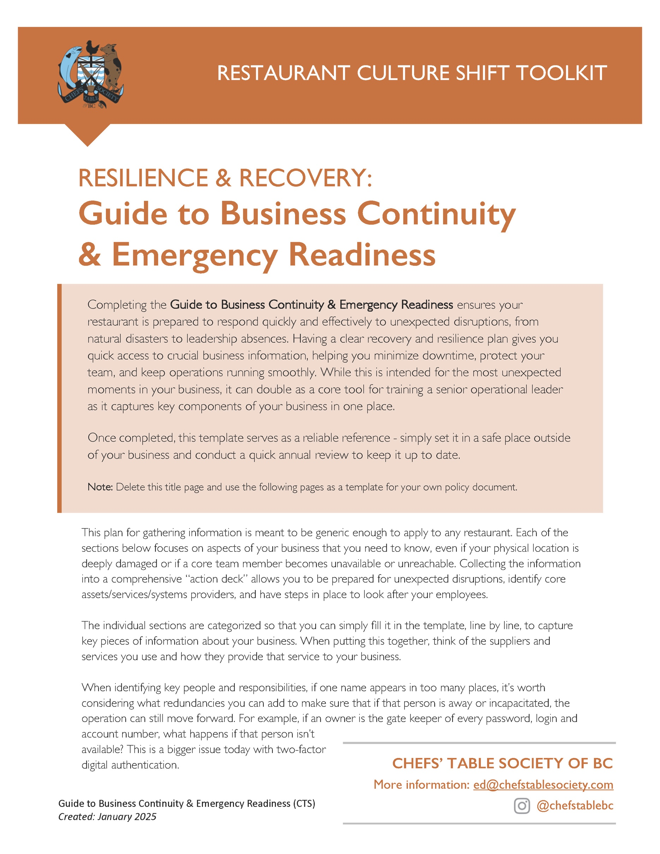

[Restaurant Name]
Business Continuity & Emergency Readiness Plan

Created: _________________
Updated: _________________

Restaurants are regularly experiencing business disruptions that 5 years ago no one would have imagined: region wide forest fires and catastrophic atmospheric rivers/flooding, cyber-crime incidents and data breaches. When these incidents happen, business owners have many responsibilities. Getting the physical business location assessed and insurance triggered are often the first priority, but the reality is that figuring out the impacts on employees is an even bigger stress and responsibility. In an instant, your whole team can go from having a job to having no concrete sense of when and where the next pay cheque is coming from.

1. BUSINESS BASICS

Registered address
City
Business Phone Primary
BC business number
Key Holder 1 |  | Phone #
Key Holder 2 |  | Phone #
Key Holder 3 |  | Phone #
Key Holder 4 |  | Phone #
* Include a copy of your business license and registration in your virtual folder and your print copy, if possible.

BUILDING CONTACT
if different than business contact
Leasing Company
Phone Number
Email
* Include a copy of your lease or leases in your virtual folder and your print copy, if possible.

SECURITY COMPANY
Company Contact
Phone Number
Email
Who is registered on the account?

INSURANCE COMPANY
Insurance Policy #
Company Contact
Phone Number
Email
Claims hotline phone #
Who is registered on the account?
* Include copies of your current policy in your print copy and virtual folder.

UTILITY COMPANIES
BC Hydro Account #
BC Hydro Emergency | 1.888.769.3766 (Report an outage or electrical emergency)
Main BC Hydro shut off location
Who is registered on the Hydro account?
FortisBC Account #
FortisBC Emergency | 1.800.663.9911 (Emergencies and outages. 24 hours)
Main FortisBC shut off location
Who is registered on the Fortis account?
Water Account #
(if applicable)
Main water shut off location

HEALTH & SAFETY
H&S Lead (Internal) | Name:
 | Number:
WorkSafeBC
Claims Assistance | 1.888.967.5377
Worksite Emergency | 1.888.621.7233
Crisis Support | 1.800.624.2928
Critical Incident Support | 1.888.922.3700
go2HR
Health & Safety | safety@go2hr.ca
Human Resources | hr@go2hr.ca
Mental Health | mentalhealth@go2hr.ca

2. EMERGENCY CONTACTS – STAFF

TITLE | NAME | PHONE # | Call Out Priority  1st / 2nd / 3rd etc
Owner
Health & Safety Lead
General Manager
Front of House Mgr
Executive/Head Chef
Operations Manager
Facility Manager

3. EMERGENCY CONTACTS – SUPPLIERS

 | COMPANY | CONTACT | PHONE #
Main Food Supplier(s)
Beverage Suppliers(s)
Janitorial/Cleaners
IT Company
Internet Company | Shaw/Rogers |  | 1.877.742.9249
 | Telus |  | 1.800.361.3311
Benefits Company
Employee Assistance Plan
Lawyer/Legal Services

4. FINANCIAL INFORMATION

BANKING INSTITUTION
Branch Location
Bank Contact
Contact Phone
How do you contact the bank?
Who has signing authority?
ACCOUNTING/TAX FIRM
Accountant Name
Email
Phone Number
Who has signing authority?

5. CORE SYSTEMS PROVIDERS

Shift Scheduling Company
Company Contact
Contact Phone / Email
How do you contact this company?
Who has the login access?
Who has signing authority?
POS Company
Company Contact
Contact Phone / Email
How do you contact this company?
Who has the login access?
Who has signing authority?
Payroll Company
Payroll day/frequency
Company Contact
Contact Phone / Email
How do you contact this company?
Who has the login access?
Who has signing authority?

6. COMPANIES WITH WHO YOU HAVE RECURRING ORDERS
These are companies that send an order (weekly, bi-weekly, monthly) without confirming the order.

COMPANY | What do they provide? | How often do orders arrive? | Contact

7. COMPANIES WITH WHOM YOU HAVE EQUIPMENT LEASES
These are companies that you have an ongoing leases for equipment. We suggest listing these as the financial obligations continue regardless of business disruptions and the costs factor in your continuity planning.

EQUIPMENT | Company | Contact | Is there a service agreement?
 |  |  | Y / N
 |  |  | Y / N
 |  |  | Y / N
 |  |  | Y / N

