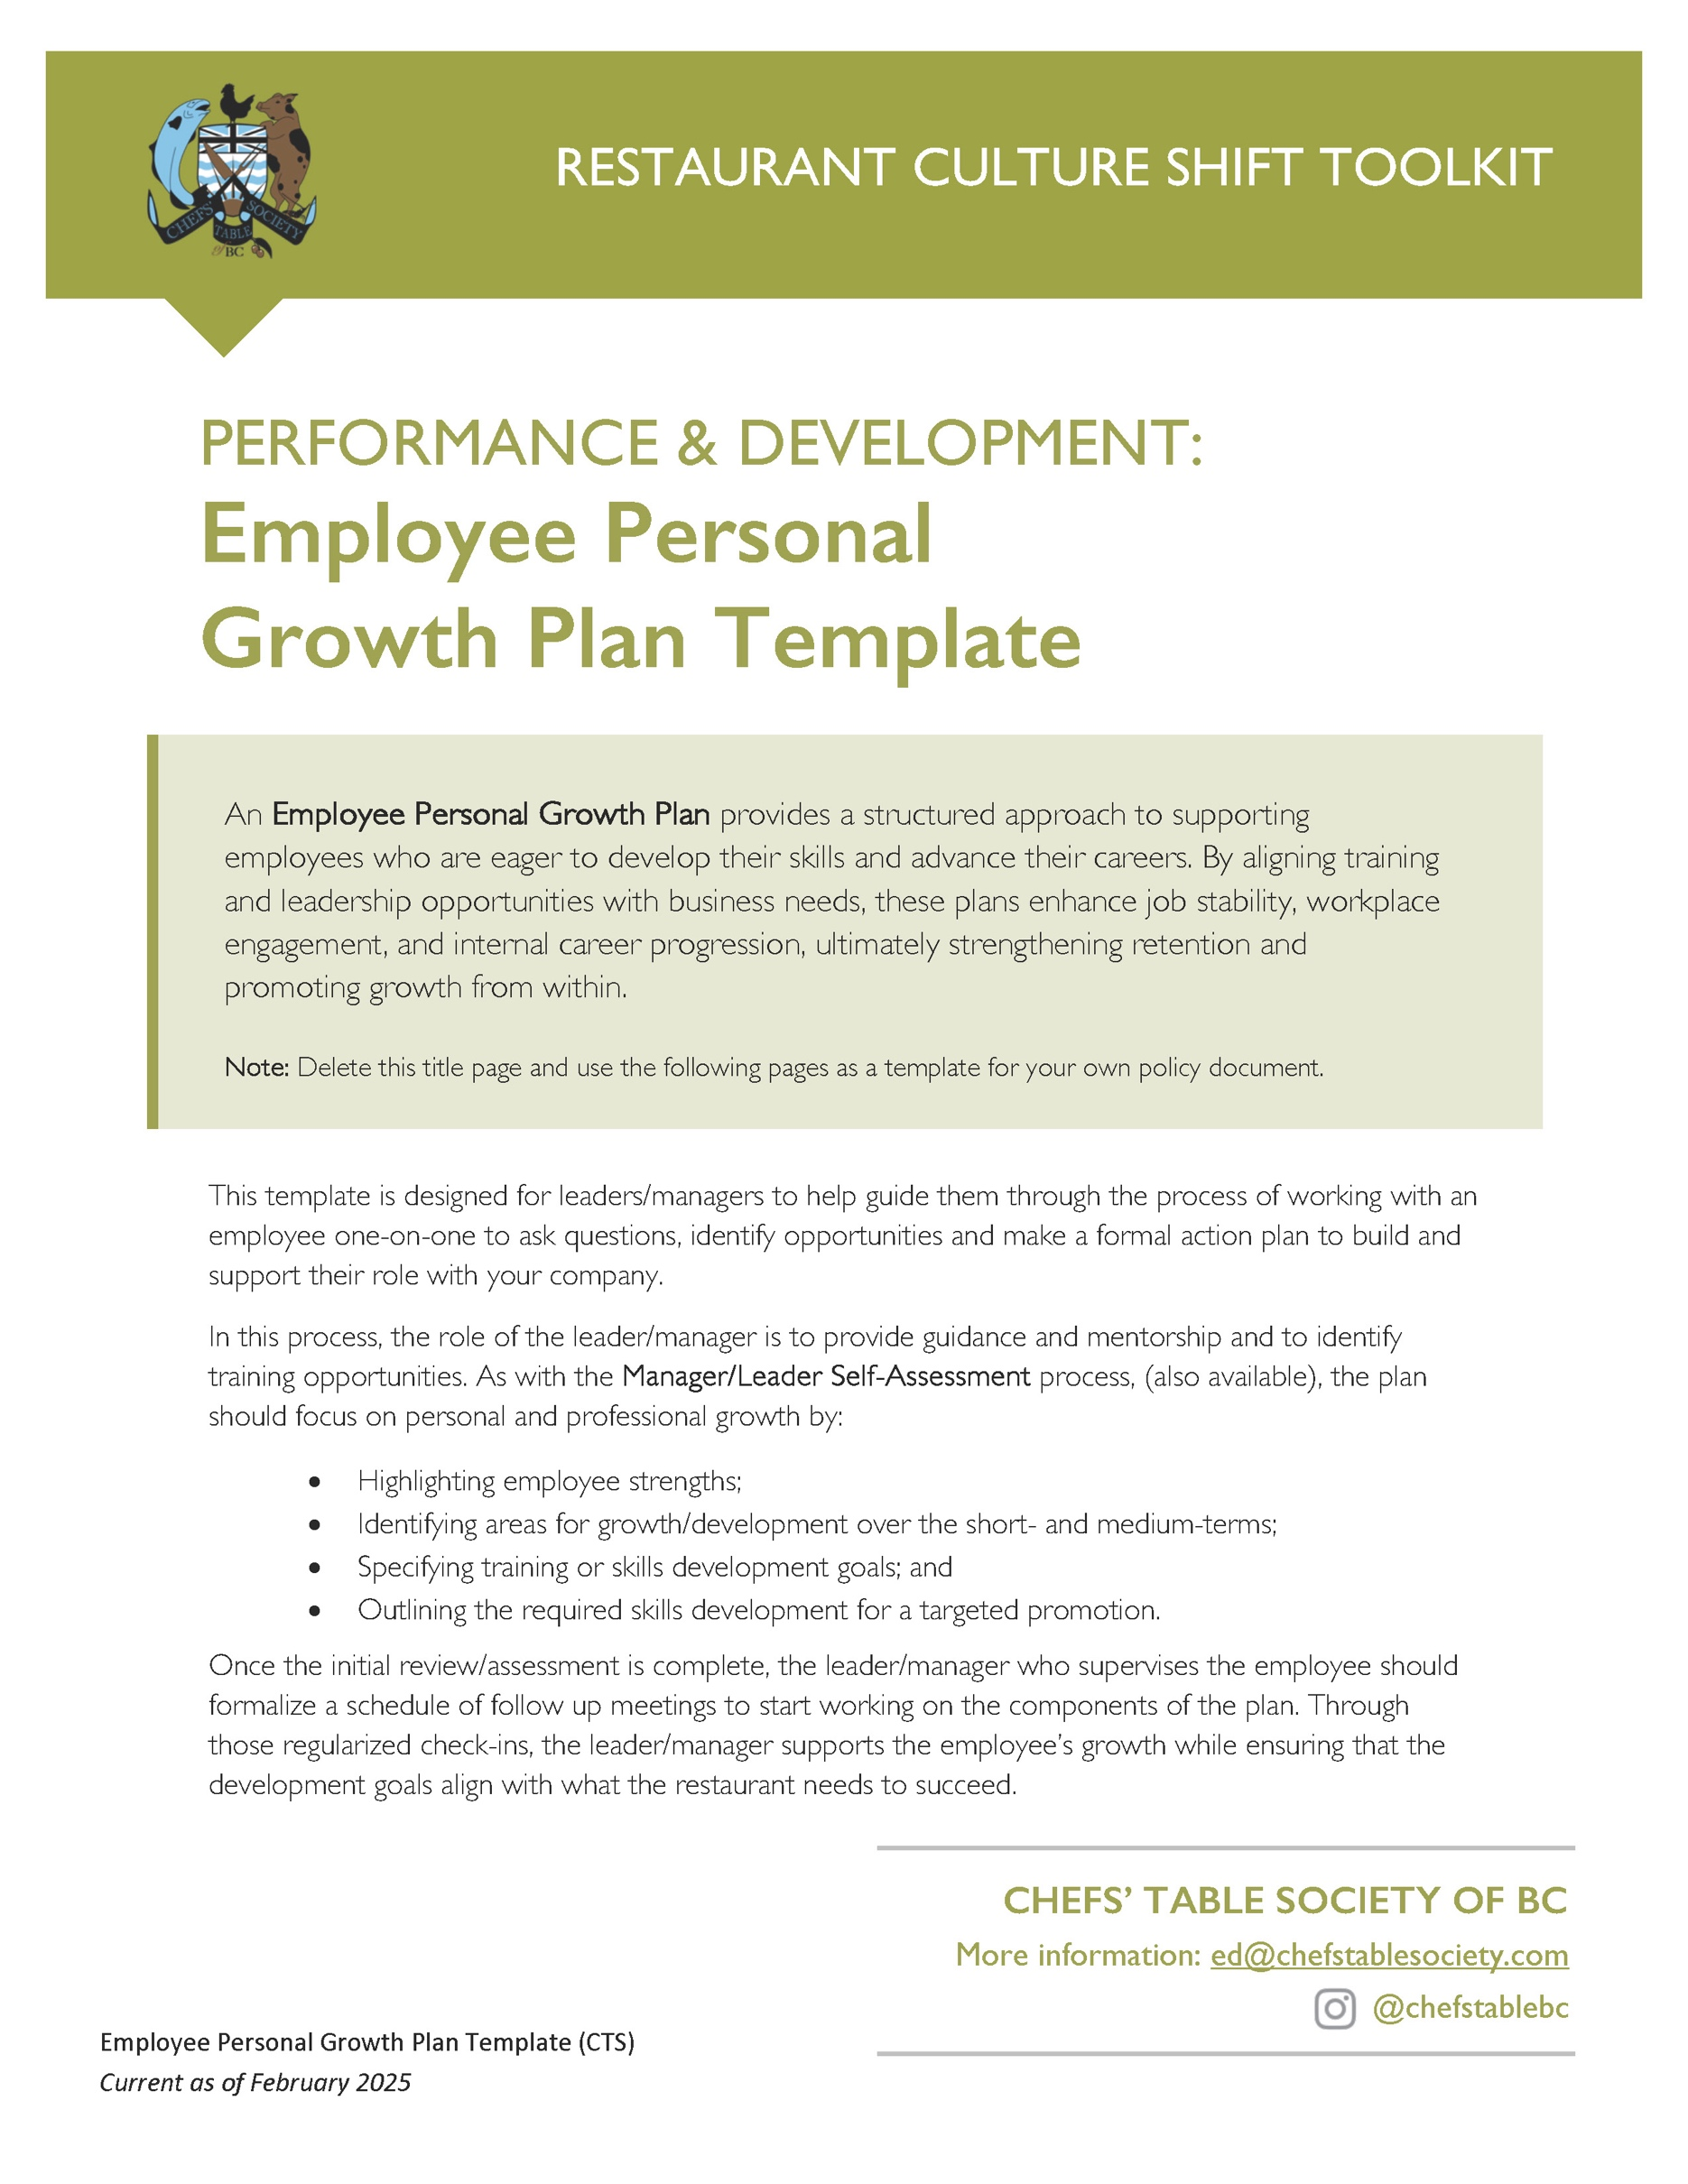

[Restaurant Name]
Employee Personal Growth Plan
Discussion Guide

Employee Name: ____________________________
Current Position: ____________________________
Target Position: ____________________________ [if promotion is the goal]
Manager/Leader: ____________________________
Date of Discussion: ____________________________

Identify Career Goals
What is the ideal role you want to grow into in this company?
OR
What is your stretch job goal?
What is your timeline for advancing in your career here?
OR
When would you like to see yourself getting a promotion or an increase?
How can we help you grow in your role with our company?
Where do you see yourself in one year?

Conduct a Skills Assessment
What do you enjoy most about your current role?
What skills do you use in your job that you are proud of?
Can you share a story of positive feedback have your received from guests or colleagues?
What do you consider your strengths as they apply to your job here?
What areas do you want to focus on improving?
OR
Are there any challenges or areas where you’d like more training or support?
What skills are you interested in developing to help you take the next step in your career?
Are there any cross-training or leadership trainings you want to pursue?

Discuss Learning Objectives
Based on the nature of the learning goals being set, the learning objectives can be suggested by the employee or their leader/manager. The learning objectives can be achieved through mentorship, cross-training, in house training or job shadowing, soft and hard skill development or certification and courses {eg customer service, SuperHost, conflict resolution, mental health leadership).
You can use one or more of these grids depending on the individual growth plan.
ADVANCEMENT GOAL
STEPS TO ACHIEVING THE GOAL
Short-Term (30-90 days)

Mid-Term (90-180 days)
Long-Term (6-12 months)
Professional Resources (eg. can be a colleague, mentor or a link to online training)

Set targets for Leadership & Soft Skills Development
Based on the specific leadership goal(s), the strategies for achieving the goal can be suggested by the employee or their leader/manager. In-house leadership development ideas include: mentoring new employees, coaching peers, preparing a presenting a mini-training session, leading pre-shift meetings, shadowing a manager, taking on a coordination role for a group or VIP customer, taking on a leadership role within the Employee Health and Safety Committee or the Tip Pool.
You can use one or more of these grids.
LEADERSHIP GOAL

STEPS TO ACHIEVING THE GOAL
Short-Term (30-90 days)
eg. Successfully lead a pre-shift meeting.
Mid-Term (90-180 days)
eg. Make a presentation to leaders on how to increase guest satisfaction.
Long-Term (6-12 months)
eg. Take a leadership course online or through a local continuing education program.
Professional Resources (eg. can be a colleague, mentor or a link to online training)

Support & Check-Ins
Formalizing a timeline for checking in to review and revise the goals and objectives is a necessary part of the process that allows both employee and employer to adjust the development plan according to successes or needs for improvement. Making sure that both the manager/leader and the employee have clear expectations about when the follow ups are happening and what is involved will ensure that both parties are invested in the process.
Schedule of regular check ins: | Weekly / Bi-Weekly / Monthly
Who will be conducting/attending the check in?
What is the process for confirming the next meeting?

Planned Recognition or Incentives for Achieving Milestones
In discussing with the employee, discuss and formalize planned recognition (or incentives) for achieving the objectives in the plan. This can include small rewards (gift cards), a training allowance, wage boost or increase, title change, bonus, additional responsibilities or promotion.
STATED GOAL or MILESTONE | RECOGNITION OR REWARD WHEN GOAL or MILESTONE IS ACHIEVED
Advancement Goal 1:
____________________
Advancement Goal 2:
____________________
Leadership Goal 1:
____________________

Employee Personal Growth
Development Plan Template
Based on the discussion facilitated by the process above, you can use this grid to formalize the Employee’s Growth Plan and summarize how the plan can be achieved, what success looks like and what rewards are benchmarked to those successes.
Employee Name: ____________________________
Manager/Leader: ____________________________
Date of Plan: ____________________________

PERSONAL & PROFESSIONAL GROWTH STATEMENT:
AREAS OF STRENGTH TO FURTHER DEVELOP:
ADVANCEMENT GOAL incl DESCRIPTION:
TIME FRAME FOR ACHIEVEMENT | SUPPORTER FOR THIS GOAL | RECOGNITION IF THE GOAL IS ACHIEVED
LEADERSHIP GOAL incl DESCRIPTION:
TIME FRAME FOR ACHIEVEMENT | SUPPORTER FOR THIS GOAL | RECOGNITION IF THE GOAL IS ACHIEVED
TRAINING or CERTIFICATION REQUIRED:
TRAINING DESCRIPTION | SUPPORTER FOR THIS GOAL | RECOGNITION IF THE GOAL IS ACHIEVED
NEXT 3 MEETING DATES:

