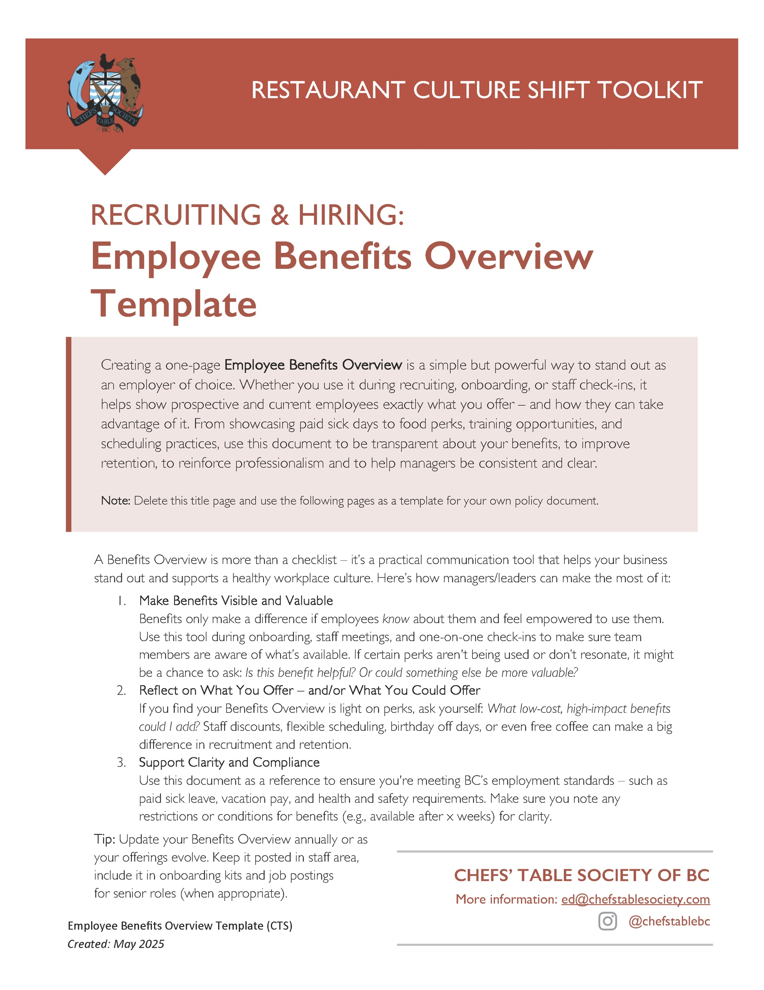
SAMPLE 1-PAGER ON YOUR COMPANY BENEFITS
FOR PROSPECTIVE OR RECENTLY HIRED EMPLOYEES

Two potential titles:

Employee Benefits Overview
[Restaurant Name]
or
Your Benefits & Perks at [Restaurant Name]
We’re glad you’re here! Whether you’re just starting or exploring a role with us, here’s what we offer to support you at work and beyond. NOTE: Customize your document with the items below that are relevant for your business.

Health & Wellness
What we offer  NOTE: Use this column for the benefit | What this means to you?  NOTE: Put a description in this column
BC’s Illness and Injury Leave | BC’s legally required leave is 5 “regular days” paid sick leave and 3 “regular days” unpaid sick leave
Paid Sick Days | Include this if you offer days beyond legal minimum
Paid Mental Health Days | Include this if you have a mental health leave policy or actively include mental health leave in your sick leave
Mental Health Support / EAP | If you don’t have a program, consider the free program offered by https://mindthebar.com/
Medical & Dental Coverage | Make sure you list when the coverage starts (e.g., after [X] months).
Health Spending Account (HSA) | Some businesses offer HSA instead of Medical & Dental Coverage. You set an annual limit and ask staff to provide receipts for reimbursement for vision, dental, prescriptions, etc. up to the annual maximum.
Vision (Glasses/Eye Exam) Benefits | Make sure you list when the coverage starts (e.g., after [X] months).
Footwear & Uniforms | Include here if you provide or subsidized or reimburse uniform or footwear expenses and the dollar amount.

Food & On-Shift Perks
What we offer | What this means to you?
1 free [or ___% off] meal per shift | Describe if it’s a staff meal or choice of menu item or items per shift.
Drink perks on shift | Describe what they get (e.g., free coffees, sodas, or smoothies, etc.)
Staff discounts on food and beverages | List the ___% off food and drink staff get when off-work
Family/friend dining discounts | List the ___% off food and drink for friends or family when they dine-in with a staff person
Take-home meals or “staff pantry” for leftovers | Can staff take food home at the end of the night? Is there a pantry they can take items from for home use?

Time Off & Scheduling
What we offer | What this means to you?
Guaranteed scheduling notice | Promote your scheduling notice: best practice is 10-14 days in advance; note the day (e.g., every other Thursday)
Earn paid vacation days | Do you offer vacation pay or accrue vacation days?
Paid Bonus Day | Can you offer a bonus day off per year at the discretion of the staff person? Could be birthday, anniversary, kid or partner birthday, or a mental health day. Provide info on what notice is required if you offer this perk.

Financial Perks
What we offer | What this means to you?
Competitive hourly wage or salary
Tip sharing across roles | Talk about your tip sharing rules or how you pay out tips
Profit-sharing or bonus system | Do you have profit sharing or bonuses?
Referral bonuses | Do you offer a $$ bonus for the employee who recommends a successful hire who stays with the company 90 days?
Tuition or training reimbursement | Do you offer training dollars after 1 or more years with your company?
Transit or parking or gas allowance | Do you offer free parking or transit passes or gas cards to help people get to work?
Growth & Development
What we offer | What this means to you?
Paid training shifts
Structured onboarding
Mentorship program
Promotion-from-within policy
Cross-training in other departments | Talk about what cross-training looks like for the specific role
Access to industry events or tastings | Can staff attend wine tastings or beer tasting or trade event as a company representative?
Culture & Community
What we offer | What this means to you?
Staff appreciation events | List specific annual events: Staff Summer Barbecue or Holiday Party. Don’t over promise.
Recognition and rewards programs | Do you have an Employee of the Month program? Or top sales program?
Opportunities to participate in menu development | Can back of house suggest menu items?
Volunteer opportunities or paid volunteer hours | If folks choose to volunteer, can they get 1 day off per year to volunteer and get paid?
Support for staff-run fundraisers or causes | If folks are passionate about a cause, can they ask about hosting fundraisers at the restaurant? Do staff influence where your company makes donations?

Lifestyle Perks
What we offer | What this means to you?
Discounts at partner businesses | List any of the partner discounts you have at gyms, salons, tourist activities, etc.
Access to community festivals or events | List any local events your staff get free passes to.
Vegan, Vegetarian, Gluten-Free | If your business has a strong program to support food preferences, worth listing as it may attract certain workers.
Have questions or ideas about what you see here? Talk to your manager or email [Contact Name] at [Contact Email]. We’re always working to make this a great place to work.

