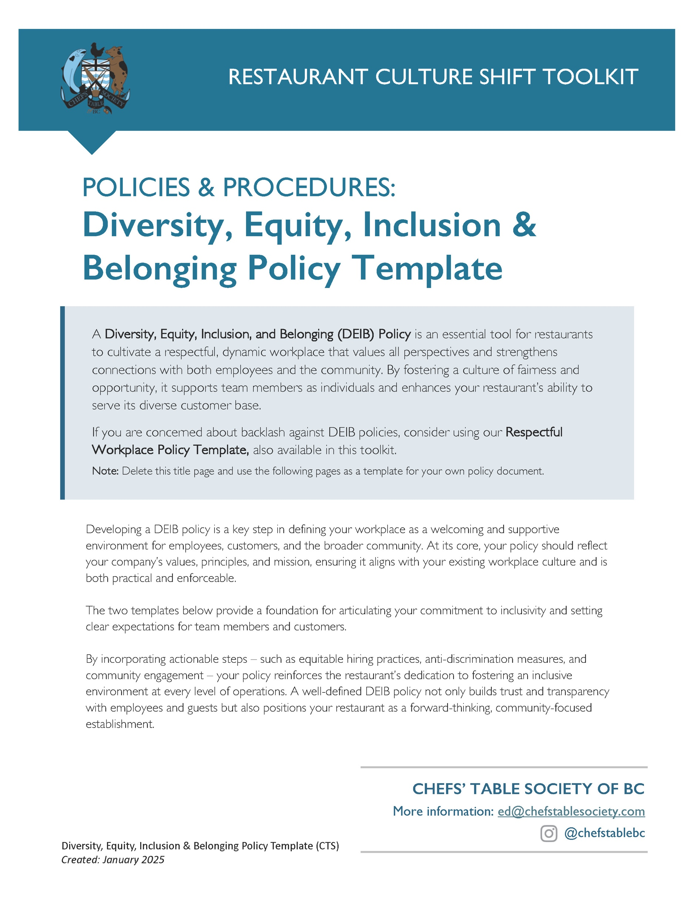
OPTION 1:
[Restaurant Name]
Diversity, Equity, Inclusion & Belonging (DEIB) Policy
Created: ________________
Updated: ________________
Purpose:
This policy outlines [Restaurant Name’s] commitment to ensuring that all employees, customers, contractors and supplies are treated with dignity, respect, and fairness. We value the diverse backgrounds, experiences, and perspectives of our team members and believe that fostering a welcoming and inclusive environment benefits both our employees and the community we serve.
Scope:
This policy applies to how we engage with all employees, customers, contractors and suppliers associated with [Restaurant Name]. It encompasses recruitment, hiring, training, employee engagement, promotion, and customer service.

Commitment to Diversity:
Our goal is for our team to reflect the diversity of the community we serve. We recognize that diversity includes but is not limited to race, ethnicity, gender identity, sexual orientation, age, religion, disability, family status, and socio-economic background. We showcase these commitments through:

• Hiring Practices: We aim to recruit and retain a workforce that reflects our diverse community. We use structured interview processes and standardized evaluation criteria to ensure fair and unbiased hiring decisions.
• Celebrating Diversity: We actively celebrate diverse holidays, cultural events, and observances that reflect our team’s and community’s diversity.
• [OPTION] Supplier Diversity: We prioritize partnerships with locally owned businesses and those owned by underrepresented groups. We assess supplier diversity efforts in procurement decisions.

Commitment to Equity:
We are committed to ensuring that all individuals have equal access to opportunities and resources in the workplace. We provide all our team members with the resources and support they need to succeed through

• Fair Compensation: Our wage structure is designed to provide fair and competitive compensation. We regularly review our wage practices to address any disparities.
• Career Advancement: Employees have access to mentorship, leadership training, and skills development programs to support career progression.
Commitment to Inclusion:
At [Restaurant Name], we foster a workplace culture where everyone feels valued and respected. Our approach is to create a workplace culture where everyone can freely express themselves and be their authentic selves without fear of discrimination or harassment.
We encourage the use of inclusive language in all communications and interactions. Employees are encouraged to use gender-neutral and culturally respectful language in all workplace communications.
Commitment to Belonging:
We believe everyone should feel like they belong at work, through feeling heard and knowing that their perspectives are valued. Belonging in our workplace is about more than just acceptance – it is about actively engaging with our diverse workforce and ensuring that everyone’s contributions are considered and, when possible, celebrated.
We reinforce these 4 commitments through: [List HERE all the ways your restaurant is following through on these commitments, ideas are below.]
• Training: All team members will participate in [annual/yearly/onboarding] training on diversity, equity, inclusion, and cultural sensitivity. Our training is updated [regularly/annually] to reflect evolving best practices and emerging workplace challenges."
• [If you don’t have an Anti-Bullying and Harassment policy, you should commit to those principals here.] Zero Tolerance for Bullying and Harassment: We are committed to a workplace free from bullying and harassment, discrimination, and retaliation. Any reports of discrimination or harassment will be investigated promptly and thoroughly. Employees can report concerns confidentially through [HR contact or anonymous reporting system]. Reports will be addressed promptly and fairly.
• Nurturing Feedback and Engagement: We regularly seek feedback from our team through surveys, suggestion boxes, and open forums. This feedback helps us make informed decisions to create a better workplace for everyone.
• Encouraging Team Building and Community Engagement: We host regular team-building activities and encourage participation in community events to strengthen bonds within our team and the community.
• Accessible Workplace: We ensure that our work environment is accessible to all, including those with disabilities. This includes making reasonable accommodations to support employees’ needs.

Policy Accountability and Enforcement:
All employees are responsible for helping [Restaurant Name] owners and leaders uphold this policy. Concerns regarding violations should be reported to a [manager or ______________]. We take all reports seriously and will address them in a fair and timely manner. Employees who engage in misconduct may face disciplinary action, up to and including termination.

We acknowledge that fostering Diversity, Equity, Inclusion, and Belonging (DEIB) is an ongoing process and are dedicated to learning, growth, and improvement in this area. As such, we commit to:

• Policy Review: This policy will be reviewed annually and updated as necessary to reflect our growing understanding of DEIB and best practices.
• Leadership Accountability: Our leadership team is responsible for implementing and upholding this policy. Leaders who do not uphold DEIB commitments will be held accountable through performance reviews and corrective actions.
• Open Door Policy: All employees are encouraged to bring forward suggestions, concerns, or questions regarding DEIB. Our leadership team is committed to listening and acting where needed.

OPTION 2:
[Restaurant Name]
Diversity, Equity, Inclusion & Belonging (DEIB) Policy
Created: ________________
Updated: ________________
Purpose:
At [Restaurant Name], we are committed to ensuring that all employees, customers, contractors, and suppliers are treated with dignity, respect, and fairness. We value the diverse backgrounds, experiences, and perspectives of our team members and believe that fostering a welcoming and inclusive environment benefits both our employees and the community we serve.
Scope:
This policy applies to all employees, customers, contractors, and suppliers of [Restaurant Name]. It encompasses recruitment, hiring, training, employee engagement, promotion, and customer service.

Our company makes the following [4 or 5] commitments that impact the workplace culture for our employees.
1. We commitment to Diversity.
We are dedicated to creating a workplace that reflects the diversity of the community we serve. We define diversity as including, but not limited to, race, ethnicity, gender identity, sexual orientation, age, religion, disability, family status, and socio-economic background.
2. We commitment to Equity.
We are committed to ensuring that all individuals have equal access to opportunities and resources in the workplace. This includes taking steps to eliminate barriers to employment, ensuring fair pay and career progression, and addressing any inequalities that may exist within our organization.
3. Commitment to Inclusion
We actively foster a workplace culture where everyone feels valued, heard, and respected. We actively encourage diverse voices and perspectives and create an environment where individuals can be their authentic selves without fear of discrimination or harassment.
4. Commitment to Belonging
We aim to create an environment where employees feel a true sense of belonging. This means building a workplace culture where individuals feel connected to one another, their roles, and the values of [Restaurant Name].
[OPTION: If you don’t have a separate Anti-Bullying and Harassment Policy]
5. Anti-Bullying and Anti-Harassment
We are committed to providing a workplace free from discrimination, bullying and harassment, and retaliation. We adhere to all relevant legal frameworks, including the British Columbia Human Rights Code and Occupational Health and Safety Regulation in the Workers Compensation Act.
Discriminatory practices or behaviour of any kind, whether verbal, physical, or via any form of communication, will not be tolerated. Employees and customers who engage in discriminatory behaviour may face disciplinary action, up to and including termination or removal from our premises.
We action our DEIB commitments through: [List HERE all the ways your restaurant is following through on these commitments, ideas are below.]
- Inclusive Recruitment and Hiring Practices
We will employ inclusive recruitment strategies to attract a diverse pool of candidates for all positions. We are committed to reducing unconscious bias in our hiring processes and ensuring that hiring decisions are based on qualifications, skills, and experience.
- An Accessible Work Environment
We strive to create an accessible environment for all employees, including those with disabilities. We will provide reasonable accommodations in the hiring process and throughout employment, in compliance with the British Columbia Employment Standards Act and Workplace Accessibility Legislation.
- Training and Education
All employees (Front of House, Back of House and Leadership positions) will receive ongoing DEIB training to help them understand the importance of diversity, equity, inclusion, and belonging. This training will include topics such as unconscious bias, cultural competency, and conflict resolution.

- Reporting and Accountability
We encourage employees to report any incidents of discrimination, bullying and harassment, or exclusion without fear of retaliation. Reports can be made to [manager or ________________]. We will investigate any complaints promptly, fairly, and confidentially. Appropriate disciplinary action will be taken as necessary.
- Continuous Improvement
We are committed to regularly reviewing this DEIB policy to ensure that it remains effective and relevant. We will seek feedback from our employees and customers to help us continuously improve our practices. This policy will be reviewed annually and updated as needed to reflect the changing needs of our workforce and society.

