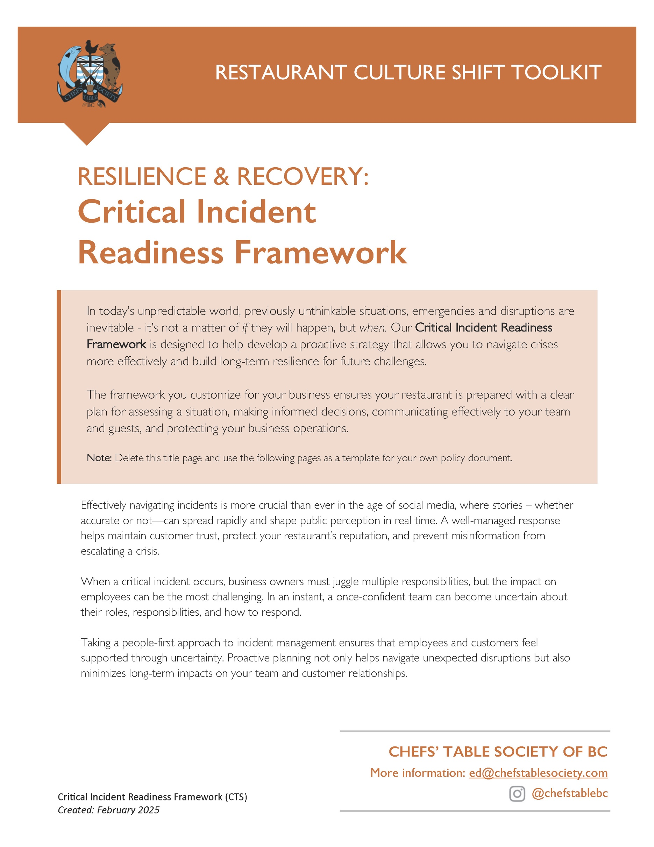

[Restaurant Name]
Critical Incident Readiness Framework

Created: _________________
Updated: _________________
The variety of emergencies that require crisis communications and strategic navigation for our business include: [pick those that apply]

• Workplace Incidents: Employee injuries, employees passing away, harassment claims, or violence in the workplace requiring immediate response and HR/legal navigation.
• Public Health Emergencies: Foodborne illness outbreaks or employee health crises that affect safety and reputation.
• Theft or Vandalism: Break-ins, employee theft, or property damage requiring police involvement and business recovery planning.
• Reputation Management Crises: Negative press, social media backlash, or customer complaints that could damage public trust.
• Leadership or Ownership Changes: Unexpected departure, illness, or incapacity of key leaders requiring swift operational adjustments.
• Supply Chain Disruptions: Sudden shortages of essential ingredients, labour strikes, or transportation breakdowns affecting operations.
• Power Outages & Utility Failures: Loss of electricity, water, or gas, impacting food safety, operations, and customer service.
• Cybersecurity Breaches: Data hacks, ransomware attacks, or payment system breaches that compromise customer and business information.

1. BUSINESS RESPONSE

PRIMARY POINT PERSON
Crisis Point Person | Name:
Crisis Point Person | Title:
Crisis Point Person | Number:

HEALTH & SAFETY
H&S Lead (Internal) | Name:
 | Number:
WorkSafeBC
Claims Assistance | 1.888.967.5377
Worksite Emergency | 1.888.621.7233
Crisis Support | 1.800.624.2928
Critical Incident Support | 1.888.922.3700
go2HR
Health & Safety | safety@go2hr.ca
Human Resources | hr@go2hr.ca
Mental Health | mentalhealth@go2hr.ca

2. PROFESSIONALS & PROBLEM SOLVERS
A best practice is to post in your business as well as including these in your resiliency binder.

 | Company | Contact | Phone / Email
Social Media Expert
Public Relations Firm
Crisis Communications
Restoration Company
Building Contractor
Company that takes food donations - Drop Off
Company that picks up food donations

3. DETERMINING THE RESPONSE

Do you have team members on staff who have expertise in the area of the incident?
What is the scope of your issue:  is this a staff facing incident, customer facing incident, community facing or social media triggered incident? | • Staff facing incident  • Customer facing incident  • Community Implications  • Social media triggered incident  Other: _______________
Upon determining the severity of the issue, what platforms will need to be part of your response? | • Social media  • Website  • Signage at business  • Press release  • Media Statement  Other: _______________
What external resources do you need to deploy to tackle the incident response?
Do you have budget constraints on hiring problem solving resources?

4. CRAFTING THE MESSAGE TO STAFF
In this section, there are questions that dig into your plan to support staff in the event of a critical incident.

Who will craft the message to staff?
How do you plan to keep staff informed of the situation?
Who will be the emergency contact for staff to contact to ask questions?
Where is your staff contact list stored?
Who has access to a current email list or What’s App group to contact staff?
What employee assistance programs are in place that you can connect staff with?

5. BUSINESS CLOSURE
In this section, there are questions should you have to close your business for a day or days.

If your business has to close for a day or days, or longer, what is your strategy for dealing with employees?
Do you have business interruption insurance that will pay staff while your business is closed?
What do you have to do to trigger this policy?

What is your plan for paying staff on the days that you are closed?
Are you able to pay for the first day(s)?
Do you have to consider temporary layoff? What do you have to do to trigger temporary layoff?
How will you communicate the plan to staff about the closure and how these days will impact their pay?

6. MANAGING THE MESSAGE
Who is the primary decision maker for your company messaging?
Who is the secondary decision maker for messaging?
Who will update your business website, phone/voicemail, Google listing if your hours are required to change?
What points do you want to cover in your message? Some options include:
· What is the issue?
· What percentage/number of employees are impacted?
· Is the business required to close?
· Is there set timing for opening/reopening the business?
What is your messaging for staff and who will prepare it?
What is your external communication plan for customers and who will prepare this message?
Do you have a customer list and where is it located virtually?
What is your messaging to suppliers and who will prepare this message?
What is your messaging to suppliers and who will prepare this message?
What is your messaging to stakeholders/shareholders and who will prepare this message?

