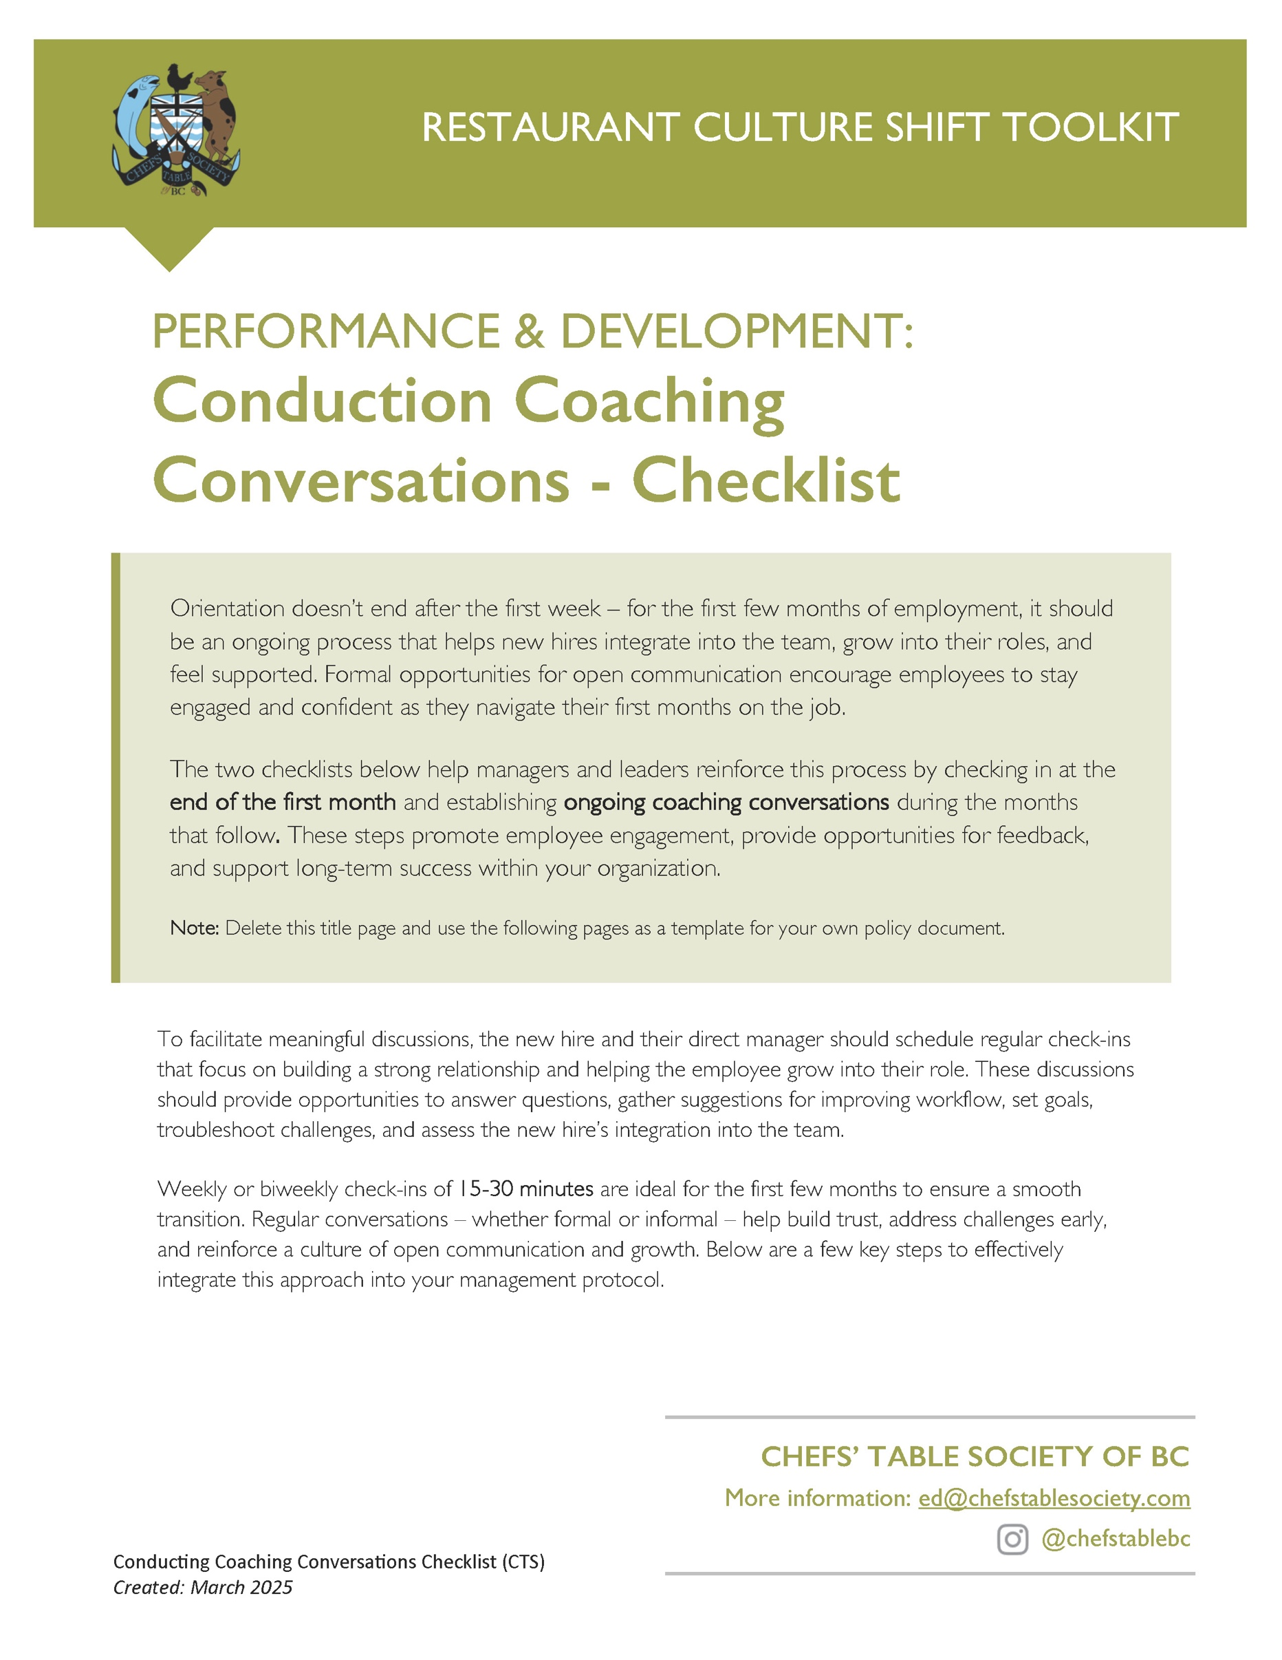

[Restaurant Name]
Conducting Coaching Conversations - Checklist
Created: ________________
Updated: ________________

MONTH 1 FOLLOW-UP & FEEDBACK

 Schedule a comprehensive check-in with the new hire to discuss progress and address any questions or concerns.
 Provide feedback on performance and areas for improvement.
 Acknowledge and celebrate any accomplishments over the first month.
 Encourage the new hire to provide feedback on the orientation process for continuous improvement.
 Set a series of achievable short-term and long-term goals.
 Outline any opportunities for training to help build on the new hire’s existing skills.
 Introduce opportunities for cross-training in other positions in your company.
 Check in on the employee’s integration into the staff team/workplace culture.
 Discuss work-life balance to make sure the employee’s well-being is on track.
 Clarify expectations moving forward and reinforce company values.
 Review scheduling and workload to ensure a sustainable pace.
 Encourage questions and maintain an open-door communication policy.
 Address any emerging challenges or barriers to success.

ONGOING EMPLOYEE CHECK-INS

Establish a Schedule
- Schedule check-ins more frequently during the first few months, and gradually decrease the frequency as the employee becomes more comfortable in their role.
- Ensure that these check-ins happen at regular intervals to provide a reliable support structure for the new employee.
- Schedule the time and keep the schedule (15-30 minutes).
- Focus on key points without overwhelming the employee or spreading the manager too thin.

During the meetings
 Review Progress & Recognize Achievements
Acknowledge successes, milestones, and improvements while identifying areas where additional support may be needed.
 Provide Actionable Feedback
Offer constructive feedback with clear suggestions, resources, and training opportunities to help the employee grow.
 Discuss Career Development
Explore the employee’s career aspirations and identify ways the company can support their professional growth.
 Identify Training & Advancement Opportunities
Highlight potential skill development, cross-training, or leadership opportunities within the company.
 Ensure Access to Resources
Confirm that the employee has the necessary tools, information, and support to perform their job effectively.
 Encourage Open Communication
Actively listen to the employee’s questions, concerns, and suggestions to foster a culture of trust and collaboration.
 Problem-Solve Together
Address any challenges or roadblocks the employee is facing and work collaboratively to find solutions.
 Gather Employee Feedback
Encourage input on their experience and use it to refine the onboarding process for future hires.

Document and Follow Up
Documenting and following up during the initial stages of employment are crucial for setting a solid track record for both employer and employee with regards to long-term performance and development. It demonstrates to the employee that their input is valued and their development is a priority. Additionally, it helps create a transparent track record, which can be beneficial for addressing any potential challenges that may arise down the line.

 Record Key Takeaways
Document the key points from each check-in, including achievements, challenges and feedback.
 Note Any Agreed-Upon Goals or Next Steps
Clearly outline any actions resulting from the meeting including sales goals, training plans, performance expectations or developmental milestones.
 Track Issues and Solutions
Document any concerns raised by the employee and the steps taken (or planned) to address them.
 Confirm Follow-Up Actions
Set a timeline for revisiting unresolved issues or checking in on progress toward goals.
 Schedule the Next Check-In
Determine the timing for the next discussion to maintain engagement and ongoing development.
 Ensure Accountability
Assign ownership for action items, whether it’s the employee, manager, or another team member responsible for follow-up.
 Encourage Continued Communication
Remind the employee that they can reach out at any time with additional questions or support needs.

More Support with Performance and Development
Note: We have three additional tools that will follow up in this area: a New Hire Performance Assessment Template, a Manager/Leader Self-Assessment Template and our Employee Personal Growth Plan Template.

