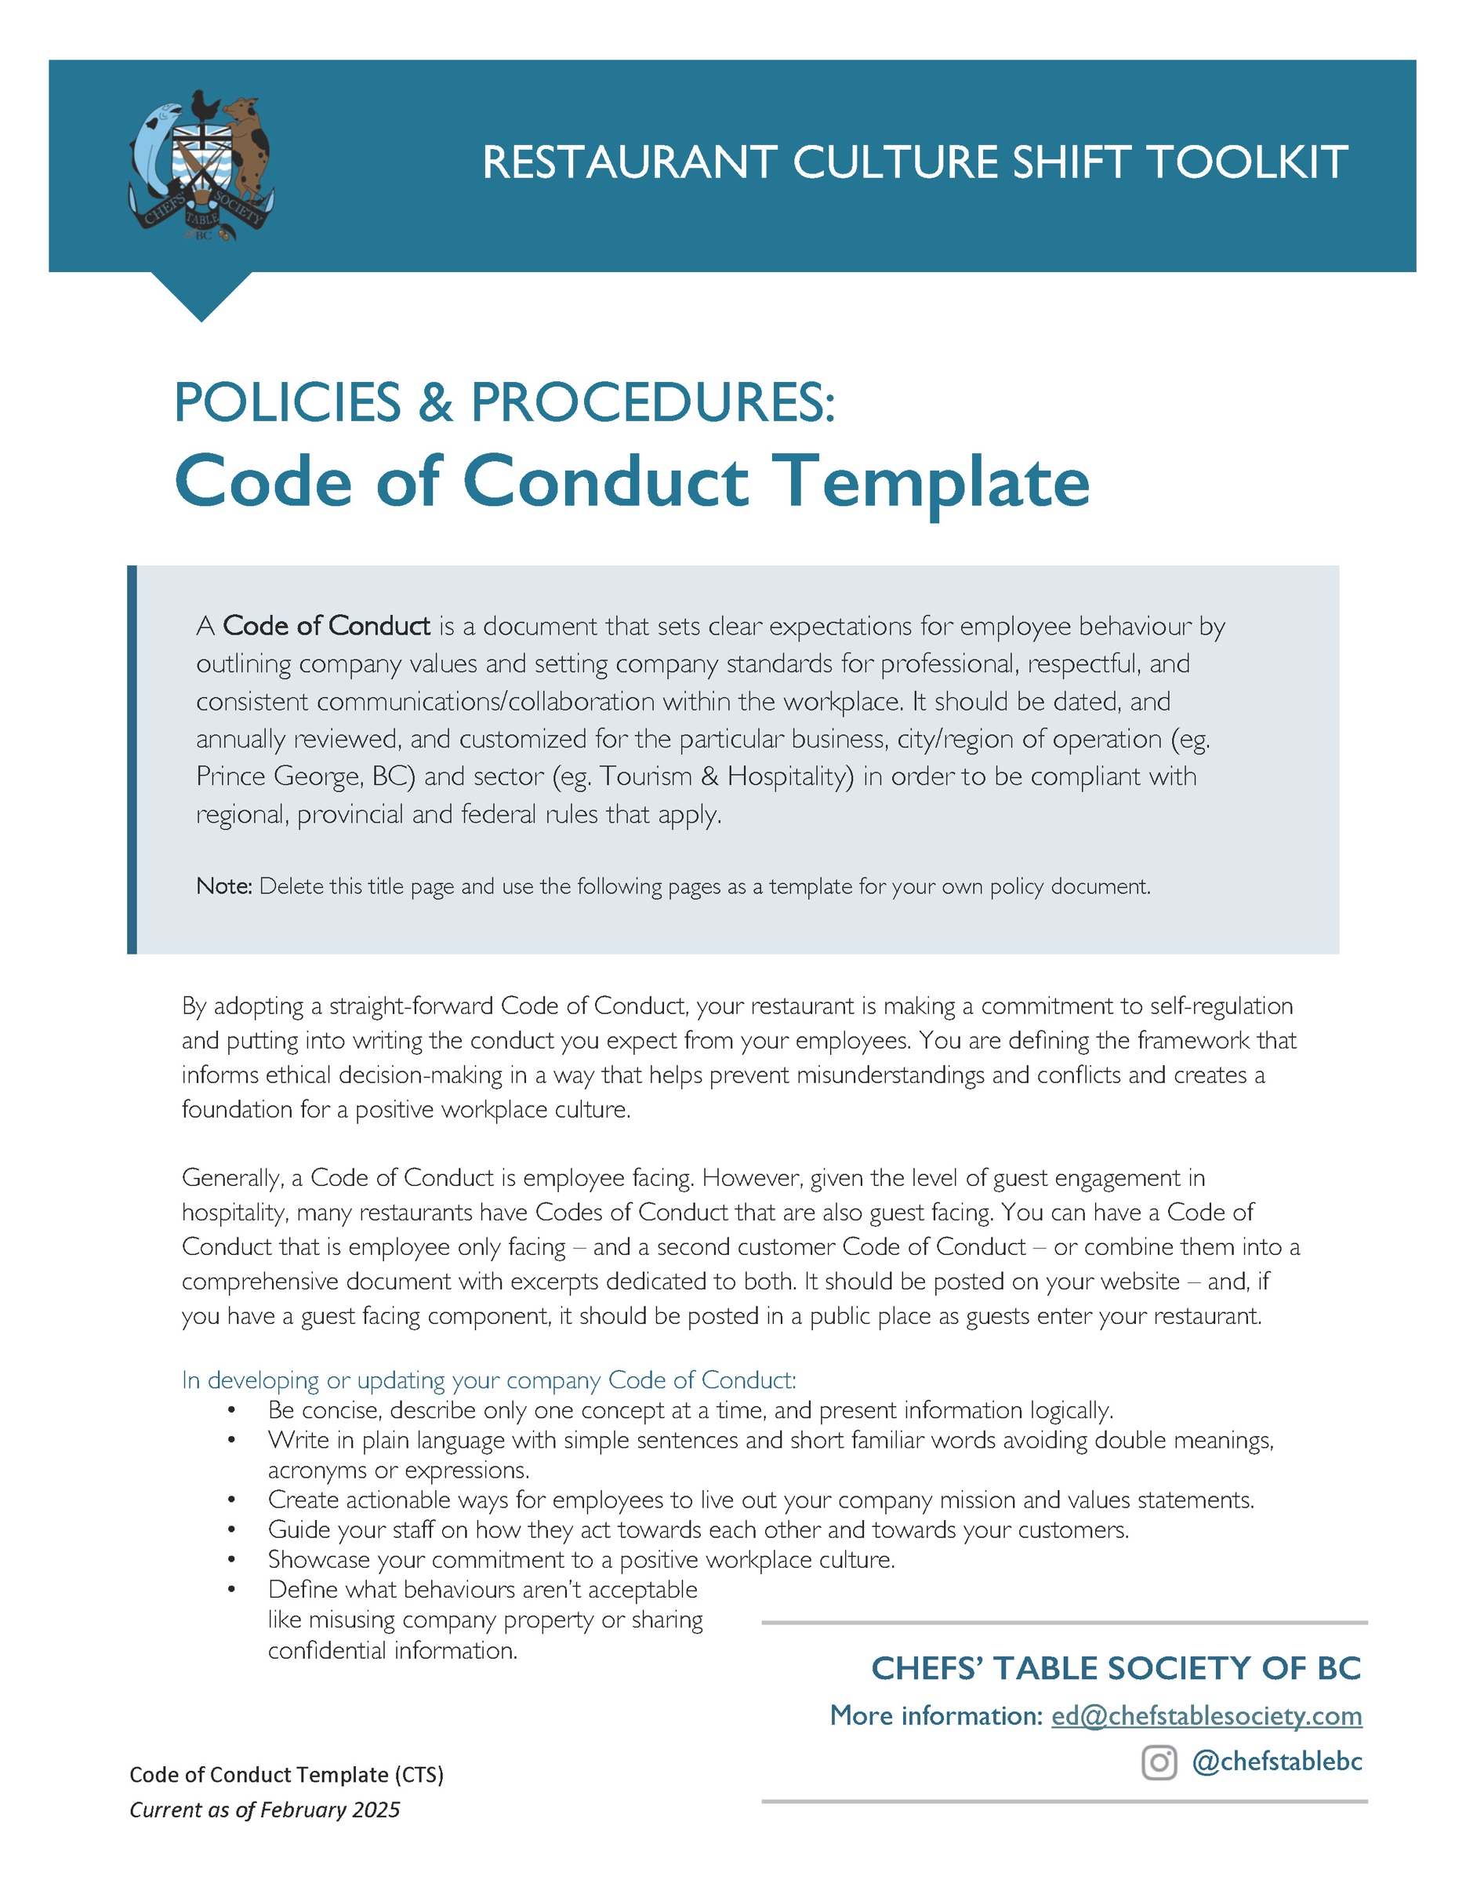

[Restaurant Name]
Code of Conduct
Created: ________________
Updated: ________________
What is the purpose of this Code of Conduct?
This code provides guidance for all [Restaurant Name] employees about what our company believes in and what the legal standards are for our workplace. As an employee, this document is the place to go for guidance if there is a question about a decision or an action.
Who is required to follow this Code of Conduct?
This code applies to all employees of [Restaurant Name], regardless of job title or how long they have been with the company.
What are the responsibilities of an employee under this Code of Conduct?
Every employee is responsible to read, understand and comply with everything included in this Code of Conduct. New employees will be required to sign a confirmation that they will follow the standards of conduct outlined in our Code of Conduct.
What is the process for violations?
In the event of a violation or potential violation of the Code of Conduct in the workplace, employees are responsible to speak up and report to their manager. We ask that all staff not assume that someone else has reported a situation or that someone is doing something about it, but ask staff take the lead and to raise concerns or bring forward ideas that will help our whole team have a stronger workplace for everyone in it without fear of reprisal.
An investigation will be launched for any report of a violation to determine what, if anything, has taken place and what policies or procedures should be changed and if there should be consequences.
What are the consequences for not following the Code of Conduct?
Anyone who violates the Code of Conduct or any of the policies within it may be subject to disciplinary action escalating from verbal and written warnings to suspension and potential termination. The discipline applied in each situation will be decided based on a thorough review of the specific circumstances and the severity of the violation.
All employees of [Restaurant Name] must:
- Offer Excellent Customer Service.
Excellent service and providing a positive work environment for our employees drives our business. To achieve this, we support ongoing training to provide high-quality service and empower our employees that ensure our guests have a positive dining experience.
- Collaborate with others and be a team contributor.
Employees are encouraged to work together cooperatively, support one another, and contribute positively to the team dynamic. All employees must treat colleagues, customers, and suppliers with respect, courtesy, and professionalism at all times.
- Communicate openly and clearly.
Employees must communicate effectively and acknowledge and value other people’s perspectives. We encourage using concise, thoughtful language to ensure that orders, instructions, feedback, and concerns are understood by both colleagues and customers. This is essential to fostering a smooth and efficient work environment. In the case of difficult communications or challenging guests, please _________________ [Options include: “refer to our conflict resolution process” OR “refer to our customer de-escalation training”].
- Act with integrity.
Employees are expected to act with integrity, be truthful in all communications, and avoid any actions that could be considered dishonest or fraudulent.
- Respect others.
In our workplace, all people must be treated with dignity. We respect chosen names for all employees. Legal names will be used for payroll and contractual purposes, but we will use your preferred name everyday: whether it is a nickname, a middle name, an Canadianized name, or a chosen names. [Option: Include whether you have nametags and whether you include preferred pronouns.]
- Be timely.
Employees are provided their schedule [XX days] in advance and should adhere to their schedules, arrive on time for work, and should notify management by text and phone promptly if they are unable to work a scheduled shift for illness or emergency.
- Dress professionally.
Employees must maintain a clean and professional appearance and adhere to the restaurant’s dress code and hygiene standards. [Option: Include any dress code information].
- Refuse to engage in discrimination, bullying and harassment and report any situations of the same.
We maintain a zero-tolerance policy towards discrimination, bullying and harassment to ensure a safe and inclusive environment for all employees and customers. If any employees engage in or witness situations of discrimination, bullying and harassment, these should be reported immediately to [managers/owners] and the incident will be thoroughly investigated and consequences determined.
- Respect privacy.
We respect the privacy of our employees and customers by protecting their personal information and ensuring interactions remain confidential. Employees are asked to keep confidential details of the restaurant’s operations.
- [Option] Refrain from using cellphones at work.
Cellphones are allowed to be used during breaks but should not be visible to guests.
- Follow health and safety protocols.
Our orientation includes health and safety training for all new hires. Those people involved in preparing and serving food must follow health and safety regulations, including proper food handling and cleanliness. Reporting any unsafe conditions or incidents to management immediately helps us to ensure a safe workplace for everyone.
- Value sobriety at work.
Drinking or consuming alcohol or marijuana at work or coming to work under the influence of any substances is not allowed. Violation of this policy will result in immediate disciplinary action, up to and including termination.
- Comply with workplace laws.
All employees are required to comply with regional, provincial and national laws, including labour laws, health codes, and licensing regulations.
- Speak up.
Our workplace relies on people working together with a mind to physical and mental wellness. If you see someone or a situation that is unsafe, in violation of this Code of Conduct, or breaks any regional, provincial or federal laws, this should be reported immediately.
[Option to speak specifically to manager/leader role in Code of Conduct]
Our managers and leaders must lead by example.
This means that managers and leaders are also accountable to all the expectations above. They must treat all team members with whom they work with respect and fairness. They will seek to inspire success in others and be thoughtful about removing barriers to innovation and creativity.
Managers/leaders should build relationships of trust with their team members and identify opportunities to help them set goals and grow within the company. Managers/leaders should be open to receiving feedback with a goal of learning from the information and making the company better.
[Option to speak specifically to customer role in Code of Conduct]
Our customers must be respectful of our staff members and other customers.
Our employees are the heart of our operation. Our customers must be respectful towards employees and other patrons, including being polite, showing patience, and adhering to our restaurant’s zero-tolerance for bullying and harassment.
Customers must refrain from abusive language or actions towards employees or other patrons. Customers who violate of our Code of Conduct may be asked to leave the restaurant. If required, our team will call for assistance from local police.
This Code of Conduct was last updated: ______[Date]_______
Note: All new employees are required to sign and date a confirmation that they have read and understood the expectations laid out in our Code of Conduct.
Questions about this Code of Conduct should be addressed to:
________[Person]________
_______[Contact]________

