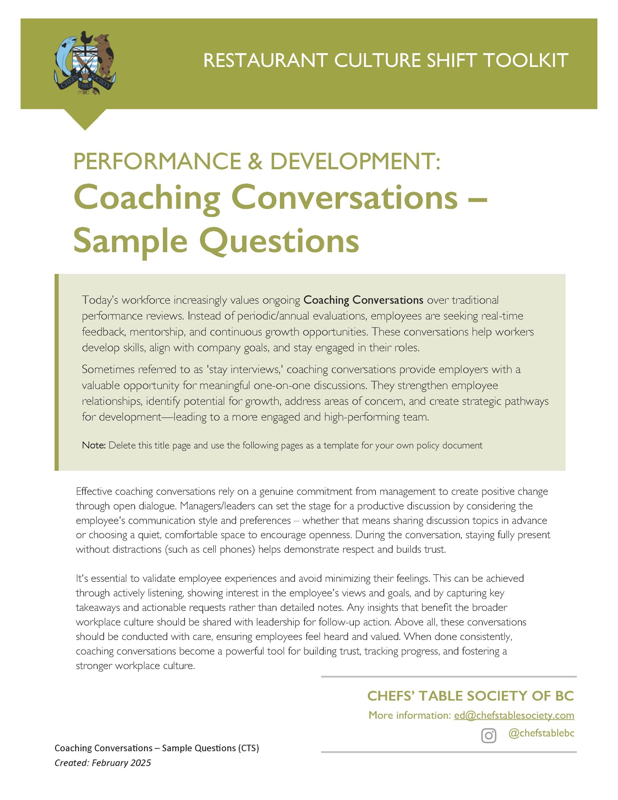

CHOOSE YOUR COACHING CONVERSATION QUESTIONS:
We have created a list of possible questions that are open to your customization. We recommend you select the 5-7 questions that are most appropriate for the workplace and the specific employee’s role.
A few things to consider when conducting a coaching conversation:
- Be informal and conversational. Focus on gaining the employee’s perspective.
- Build trust and be open to honest feedback.
- Ask questions that gather feedback without “digging” or “questioning”.
- Act on feedback whenever possible to demonstrate that the process is meaningful.
- Set a clear window of time for the process and keep to your time schedule (suggested 15-30 minutes).

The questions are organized into theme headings.

Benchmark what is Working Well
- What do you enjoy most about working here?
- What makes for a great day at work?
- Which parts of your job make you feel the most motivated or engaged?
- What about your job makes you excited to come to work?
- What’s one thing you look forward to when coming to work?

Identify Challenges
- What do you think about on your way to work?
- What’s one thing we could do differently to make your job more enjoyable/satisfying/rewarding?
- What about your job keeps you up at night?
- What bothers you most about your job?
- Is there anything you’d like to change about your job?
- Is there anything about your role or the workplace that’s frustrating or challenging?
- Do you feel you have the tools and support you need to do your job effectively?

Position the Employee for Career Growth
- How can we work together to make your work more meaningful?
- What skills would you like to develop or improve?
- What is your dream job? How can we support your progress toward it?
- Are there any roles or opportunities you’d like to explore within the restaurant?
- How can we support you in your career goals?
- How can I support you with opportunities to grow and develop as a person and as a professional?
- Are their training and development opportunities that you are considering that we can help you with/support you on?
- Is there anything that would help progress your career development that you are reluctant to ask about?
- What do you see as the next step in your career, and how can we help you get there?
- What areas of your work do you need more support or training?

Consider Skills and Talents
- How does your current position utilize your talents?
- Can you tell me ways your role could expand to use more of your skills and interests?
- What talents, interests or skills do you have that are not being used at your current role?
- What part of your role are you the most passionate about and why?
- What areas of your work do you feel you perform most successfully?
- How do you like to be recognized?

Gather feedback on Workplace Culture/Environment
- What type of feedback would you like to receive about your performance that you are not receiving now? From me? From coworkers?
- Do you feel your hard work and contributions are recognized?

Seek Feedback on Leadership and Team Dynamics
- What do you consider to be the strong points of our company leadership?
- Is there anything you would suggest to senior leaders/managers to help you and your colleagues?
- What can I do as a manager to best support you?
- What can I do more of or less of as your manager?
- What could leadership do differently to better support the team?
- Do you have suggestions about how we can improve as an organization?

Provide an Opportunity to Discuss Work/Life Balance
- What kinds of flexibility would be helpful to you in balancing your work and home life?
- What, if any, changes in availability do you have coming up that we should know about?
- Do you have any new commitments outside of work that we need to work with you on to ensure work-life balance?

