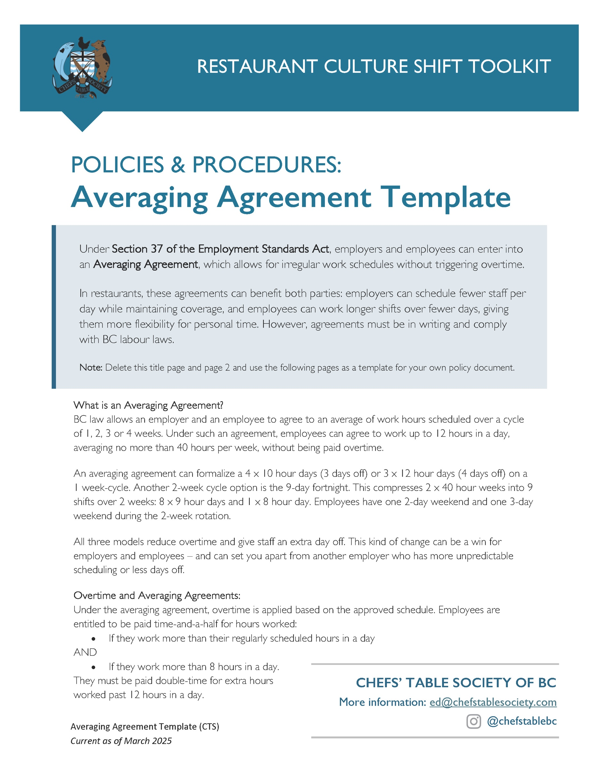

If the cycle specified in an averaging agreement is more than 1 week, the employer must either
ensure that for each week covered by the agreement, the employee has an interval free from work of 32 consecutive hours. Any time worked during the 32-hour rest period must be paid at time-and-a-half.
What do you need to include in an averaging agreement?
An averaging agreement must be made in writing and signed by the employer and employee before the start date. It must:
- Be a written agreement between the employer and the specific employee;
- Provide the number of weeks (one to four) over which hours will be cycled/averaged;
- Outline the work schedule for each day covered by the agreement;
- Commence the week schedule on Sunday 12:01 am and end on Saturday at midnight;
- Provide for a start date and an expiry date and the number of cycles that the agreement applies for. For example, if the cycle is a 1-week cycle. You could agree in writing to have 52 cycles and have the agreement in place from January 1 to December 31 of a given year.
NOTE: Verbal agreements are not valid.
The employee (s) must receive a copy before the agreement takes effect. There is no restriction on how long (e.g. how many “periods”) the agreement to average may be in place.

Changing an averaging agreement
Employees can make a written request to change to their averaging agreement schedule as long as the total hours scheduled in the agreement remain the same.
Getting paid for statutory holidays
An employee qualifies for statutory holiday pay if they have been employed for 30 calendar days and have worked under an averaging agreement within the 30 days before the statutory holiday.
Approval Process:
There is no requirement to notify the Employment Standards Branch when the parties enter into an averaging agreement. However, as of 2021, Employers must retain the agreement for four years after the expiry of the agreement or any agreed upon extension of the agreement.
For a more detailed view of the averaging agreement provisions see Section 37 of the ESA.
DELETE FROM HERE UP.

[Restaurant Name]
Averaging Agreement

This agreement is made between [_____________] (the “Employer”) and [_____________] (the “Employee”) with the understanding that the Employee may be required to work more than 8 hours per day averaging no more than 40 hours per week, scheduled over a period of 1-4 weeks, without being paid overtime.

This agreement will apply over the course of [X] weeks and may be repeated [Y] times, starting on ______[DATE include year]_______. and ending on ______[DATE include year]_______.

The work schedule for each week covered under this agreement is set out below. Changes may be required to fulfill the operational needs of the Company in which case a revised schedule will be provided with notice.
The Employee’s regular schedule shall be as follows: [Adjust # of weeks in the table as needed]
Week | Sunday | Monday | Tuesday | Wednesday | Thursday | Friday | Saturday
1
2
3
4

This agreement may be terminated by the Employee upon providing [Restaurant Name] with 2 weeks’ written notice. The Company may cancel this agreement by providing the Employee with reasonable notice.

Acknowledgment and Signatures
I agree to work more than 8 hours per day, or more than the number of hours in my established regular workday, up to a maximum of [Z] hours per day per the schedule above.
I acknowledge that I have read, understood, and agree to the terms and conditions of this agreement.

Employee Name |  | Employee Signature |  | Date
Employer Name |  | Employer Signature |  | Date

